棠外附小2020-2021学年度下期期末测评卷

二年级英语

听力部分

听音，选出你所听到的单词n Listen and choose.（每题1分）-

学校： 班级： 姓名： 考号:

密 封 线 内 不 要 答 题.......

|  |  |  |  |  |
| --- | --- | --- | --- | --- |
| ( | ) | l.A.log | B. dog |  |
| < | ) | 2. A. hot | B.logu |  |
| ( | ) | 3 .A.rod | B.dot | ♦ |
| ( | ) | 4.A.pat | B . fo gu |  |
| ( | ) | 5.A.job | B.jog |  |
| ( | ) | 6.A.fox | B. box^-1 |  |
| < | ) | 7. A. top | B. hop |  |
| ( | ) | 8,A.rob | B . *md+-'* |  |
| ( | ) | *9.A.ox* | B.mop | p |
| ( | ) | 10.A.cap | B. coV |  |
| ( | ) | 11. A. sun | B. s ub | ♦ |
| < | ) | 12.A.rub | B. cub4 |  |
| ( | ) | 13. A.hug | B“hum | p |
| ( | ) | 14.A.bug | B. bun。 |  |
| ( | ) | 15. A.hut. | B. cut | p |
| ( | ) | 16. A. up | B. nuh-1 |  |
| < | ) | 17.Agum | .B. pup |  |
| ( | ) | 18.A.bud | B. bug^1 |  |
| ( | ) | 19.A.pup | B. up | p |
| ( | ) | 20 Amud B. mug+J  棠外附小2020-2021学年度下期期末测评*英语*共18页 | | |

B, The dog is on the log, J

B. The men hop in the fbg.+J

B. The dog is on the cot.」

B, Theoxis mad, -1

B. The ox has a red mop.+J

B. The tops are inthebex*

B .A rat and a dog rob *

B, The dog is not hot」

B .1 can see a sad nun.

B .I can see a wet deg*

B . A nun is in a hut#

B, The wet bug is in a tub *

B.Abird is on a bun, n1

B. The cub has a mug*

B, Thenunis in the

B.I causes a hotdog.+J

B.I can see a wet cat. >

B . Aman has a hut*

B,Aman sells bells*

B .Anim sleeps in a hut, p

( )1, A, The dog has a rod.

( )2. A, Themenjoginthefog.

( )3. A. The pot is on the cot.

( )4. A, Theoxis sad.

( )5. A, The fcx has a red mop,

( )6. A. The tops are in the big box.

( )7. A. A Tat and a catiob.

()8. A. The dog is hot.

( ) 9. A, I can see a red bug.

()10. A. I can see *a* wet sub.

( )11. A. A nunis on a rug.

( )12. A, The wet fox is in a tub.

( )13, A.Abug is on a bun.

( )14. A. The cub has a bun.

( )15. A, The nun has a mug.

( )16. A,I can see a hot cup,

( )17. A.I can see a wet pup.

( )18. A Anunhasahut

( )19. A, Aman sells nuls.

( )20. A Anunsits inahut.

A. grapes B. oranges+J

2. I have 1 ().

A. pear B. peachy

3. I have7 ()

A. oranges B. pieces，

4. Welcome to my (

)stand. A. firuit B. apple

5. Here come 2

). A. sheep B.horses 1

6. Now there are 3

).A. chickens B. horse

7. This is my

A. school B. farrn+J

8. He is a

)■

A. baby

B. boy+J

9. She is

A. 5

B.心

lO.Howold is

? A. he

B. she

1. I need (

)■

A. clothes

B. books

2. The ()

are 3 dollars.

A. boots B.

socks 1

3. Let's (

). A. shop

B. niriQ

4. I hear with my ( )

A. nose B.

ears

5.1( ) withmynwuth,

A. taste B.

touche

6. It tastes ( ) . A. bad

B. good

7. My tail is ( ) . A. soft B. big

8. My ( ) are large. A. nose B. eyes

9.1 see a ( ) . A. box B. pizzas

10 .My ( ) are strong.

A. legs B. teeth+J

|  |  |  |
| --- | --- | --- |
| 四.听录目\选择正确的单词。Listen and choose.*（每题［分）* | | |
| 1.( | *)A.* family | B. five |
| 2.( | )A. smile | B. stone |
| 3.( | )A. photo | B. picture+J |
| 4.( | )A. homework | B. sciences |
| 5.( | )A. drink | B. behind |
| 6 .( | )A. sad | B. kid， |
| 7.( | )A. catch | B. beach+J |
| 8.( | )A. dragon | B. draw+J |
| *9.(* | )A. tidy | B.talk+J |
| 10.( | )A. secret | B. sleeps |

**五,听录音，选择正确的单词。**Listen and choose.**（每题**1**分）**

|  |  |  |
| --- | --- | --- |
| 1.( | )A. photo | B. those |
| 2.( | )A. play | B. game |
| 3.( | )A. family | B. tidy^ |
| 4.( | )A. dragon | B. sleeps |
| 5.( | )A. room | B. beach+J |
| 6.( | )A. talk | B. picnic |
| 7.( | )A. sad | B. cameras |
| 8.( | )A. skip | B. catch**。** |
| 9.( | )A. draw | B. radio+J |
| 10.( | )A. late | B. kid |

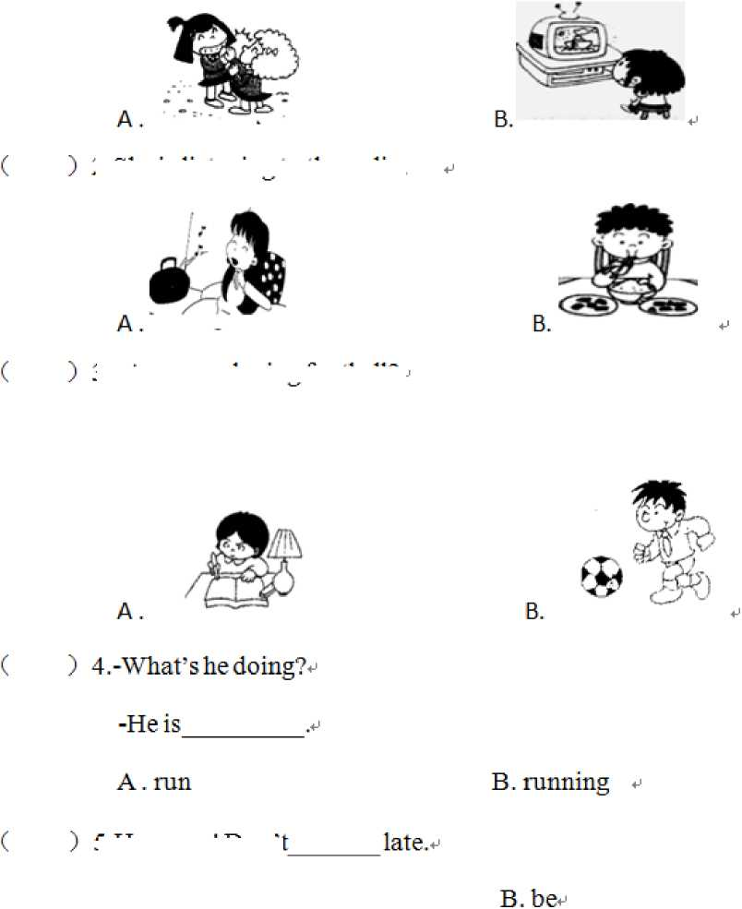

)1. They are p laying dapp ing games. 1

5 ,Huiryup! Don t

A. is

)

6. Sam is saying a

-Yes, Mum*

笔试部分

七.读一读，选一选.（每题1分）〃

2. She is listening to the radio.

3Are you playing football?卩

A.poem

B. dragon

)7. - What are they doing?^

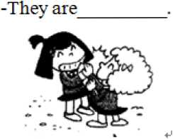

A. playing five-stones

B. playing clapping games #

)lO.Itis

today*

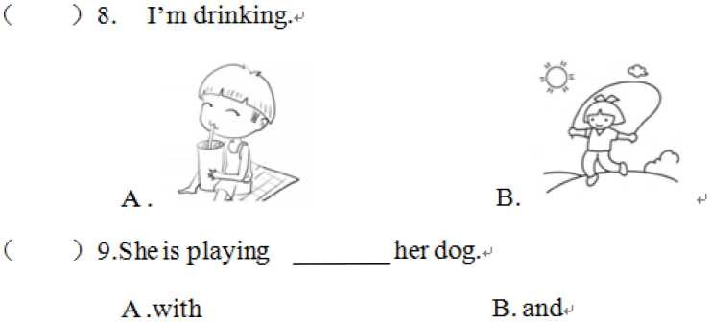

A .Children's Day

B . Child's Da火

八.读一读，选一选.（每题1分）。

( )1,—What are the kids playing?。

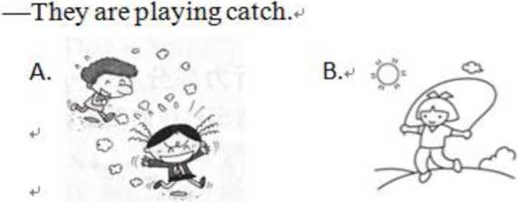

( )2.Darning and Sam are playing hide-and-seek.p

)4.Those girls are playing clapping games*

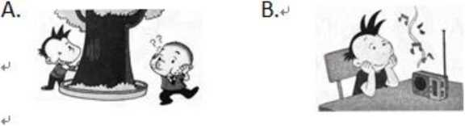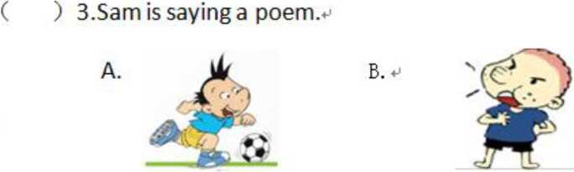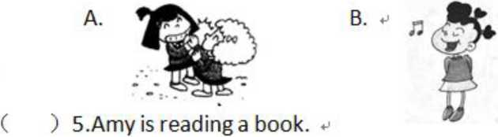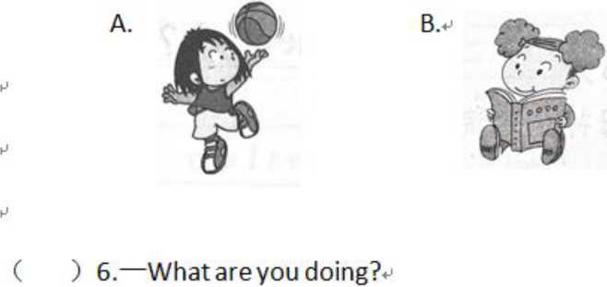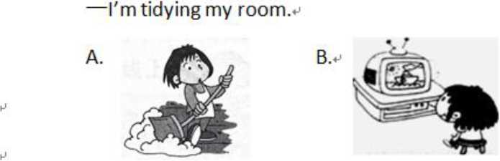

)7.We are having a picnic*

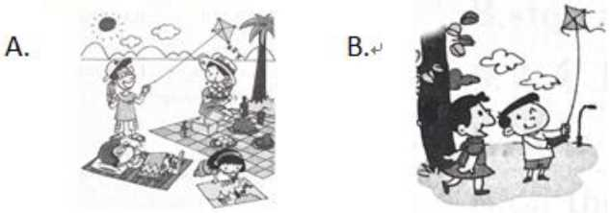

)8**.当你想问对方是否在做作业时，你会说：。**

A. What are you doing?#

B. Are you doingyour homework?**。**

)9.今天是儿童节，你会说：。

A. It's Children's Day today.**。**

B. It**怎** Sunday*

)10.主持人介绍大明正在和同学进行一场演出，他会说：♦

A. He is doing a play with some children*

B. He is singing a song*

九.*读一读,*选一选，填一填n (每题1分)P

1.11 (like/likes) swimming.^

2.She is (listens/listening) to the radio*

1. LinglingJ s (w atch es/w atching) *TV.^*
2. No one is (playing/doingjwith me. 1
3. Darning is hiding. Sam is (seeking/catching).+J
4. (IHow/What) are you doing?**」**
5. Look! They're (doing/skipping) a dragon dance.
6. What's th at (noise/nose)?**」**

9.I'm (flying/opening)the door. ■

10. My father is (looking/watching) TV**。**

十，读一读，选一选，填一填° (每题1分)。

1. The girl is (singing/playing) a song.
2. Samis (saying/ea1ing)apoem.
3. Amy is (dance/dancing).
4. Thoseboys are (catching/playing) five-stones.
5. What's he (do/doiug)?**卩**
6. I'm at the beach (with/fbi)my family.^
7. Fm (drawTug/wTLtnig) a picture.
8. Some children (is/are) doing a dragon dance*
9. Is he (tidy/tidymg)his room?**」**
10. The weather is good. It's sutrnyand (cold/warm),.

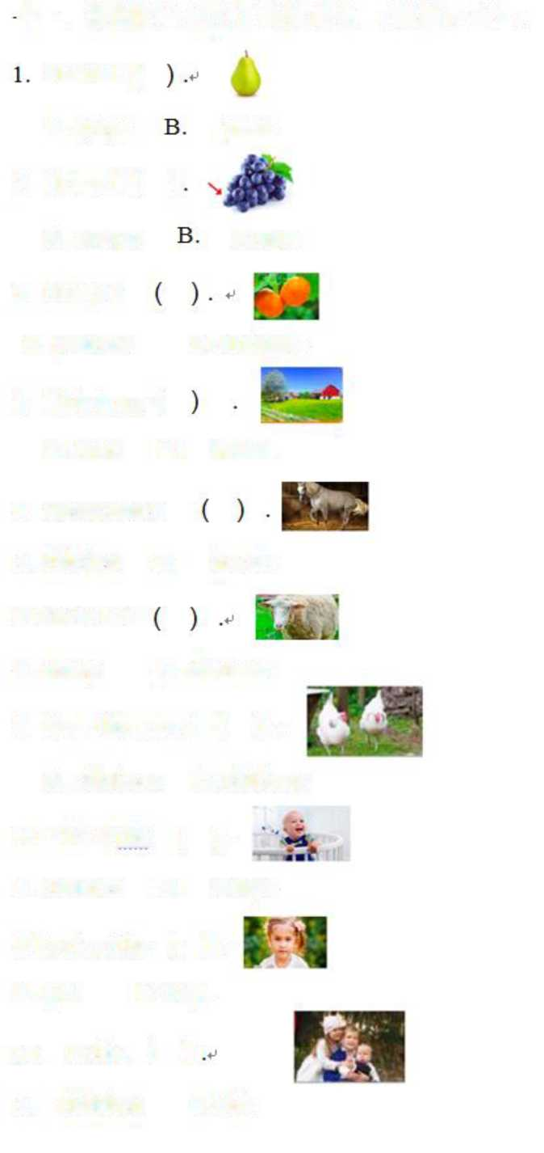

I have 1 (

A. children B.old。

**卜一.根据图片选出正确的单词。（每题**2**分）。**

A. sheep B. chicken。

7. Now there are *2 ( ) \**

A. chickens B. chicken#

3. I have2

A. peaches

B. oranges#

A. farm B.

horse#

5. Here come 1

A. chicken B.

horse。

6. There is 1

8. Look at the ( ) . •

A. children B. baby。

A. orange

grape#

A. grape

pear。

2. I have 1

()

A. girl B.boy。

10. Hello,()

4. This is my (

9. Look at the ( )*

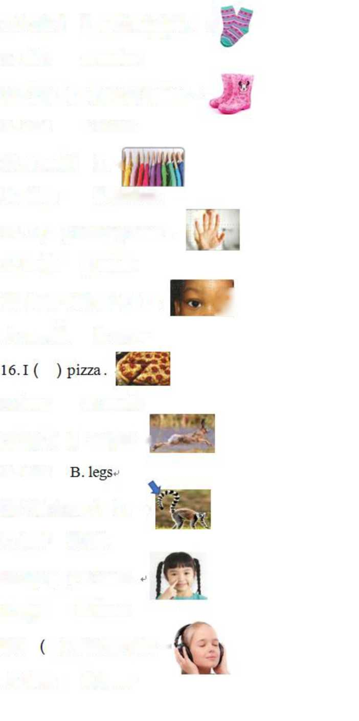

)is small

11. The ( ) are 10 dollars. °

A. shirt B. socks。

A. coat B. boots。

12. The ( ) are 15 dollars, -p

A. shop B. clothes。

14. I ( ) with my hand .

A. mouth B.eyes+，

A. touch B. smelk

A. foot

B. tail。

A. eyes

B. nose-'

20.1

)with my ears.。

A. taste

B. hear。

A. hear

17. My (

B. smell。

)are fast. .

13. I need (). <

15. I see with my ( ) . G

A. ears

18. This is my ( ) . °

19. My (

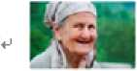

十二.圈出正确的单词，并把句子工整地抄写在横线上□ Cirle and write.

(每题2■分)卜

1. How(old/at)is she?

2. Look (at/ on) the girl!

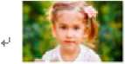

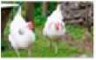3 He (is/are) 1.

1. 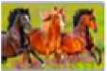Here(there/come)2 chickens, q
2. There are 3 (sheep/horses), q
3. There is 1 (sheep/ chicken).
4. Welcome to my (fruit/animal) stand.
5. have 11 (pieces/ oranges) of fruit.

9. I have 1 (pear/peach).

1. 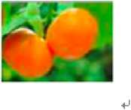(have/ am) 2 oranges. +j
2. (see/ hear) with my eyes.

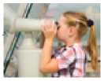12.It (tastes/ smells) good!+J

1. 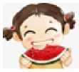(see /touch) with my hand.』

14. Let's (shop/eat).



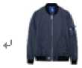

15.The (socks/jacket)is 20 dollars.

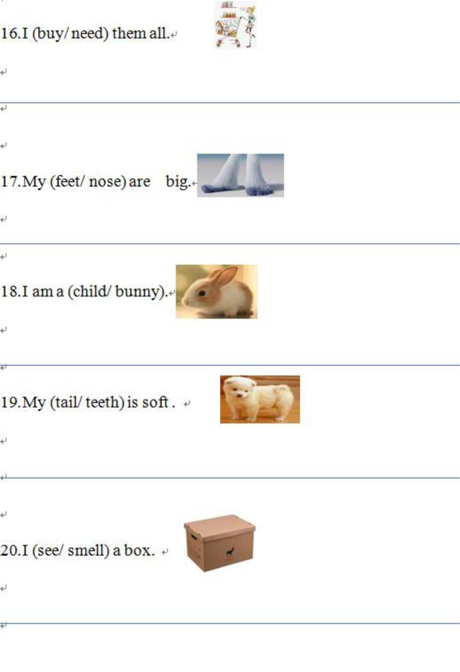

十三,圈出和左图单词押韵的单词。（每题1分）4

棠外附小2020-2021学年度下期期末测评*英语*共18页

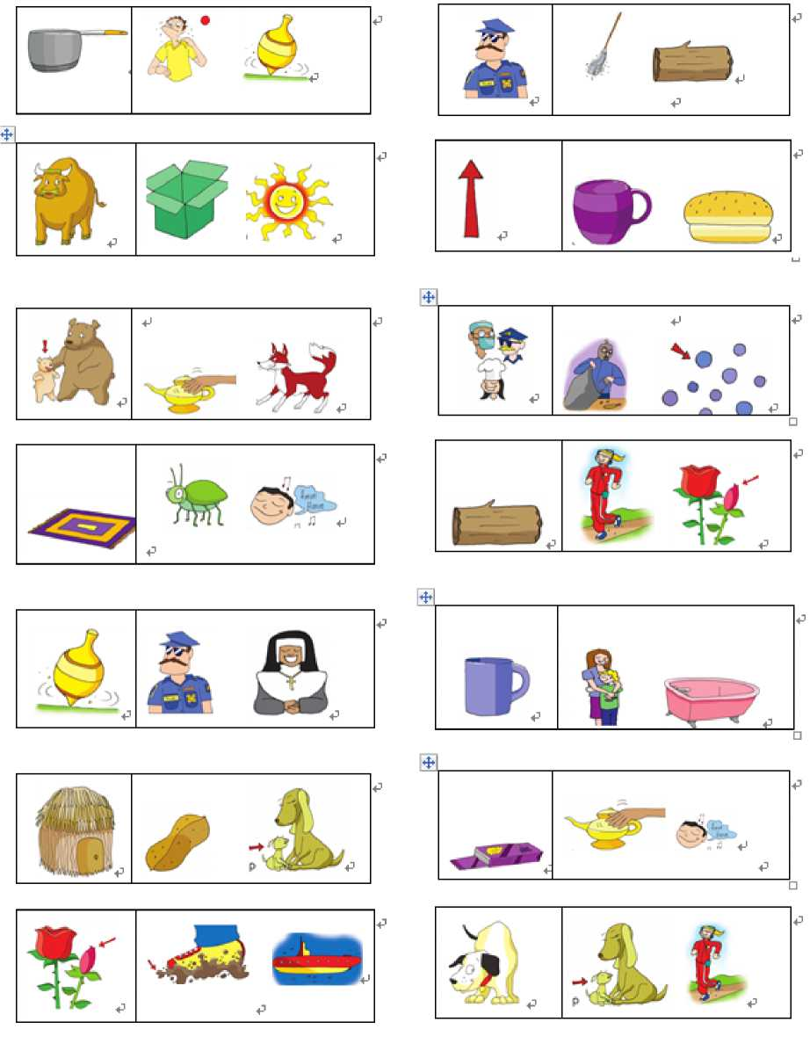

棠外附小2020-2021学年度下期期末测评*英语*共18页