外研版三年级下学期英语阅读理解知识点专项练习

班级：__________ 姓名：__________

1. 阅读短文，判断正误，正确的用T表示，错误的用F表示。
My name is Lily. I’m eleven. This is my family. I have a twin sister. She’s Lucy. She’s nice. This is my grandpa. He has a big farm. The ducks and chickens on his farm are lovely. The old woman in red is my grandma. She likes red. This is my mother. She’s beautiful. She often makes ice cream for me. This is my father. He works(工作) in a library. This is me. I love my family.
( ) 1. Lucy is eleven.
( ) 2. Lily’s grandpa likes red.
( ) 3. There are (有)five people (人) in Lily’s family.
( ) 4. The chickens and birds on the farm are lovely.
( ) 5. Lily’s father has a library.
2. 阅读短文，选择正确的答案。
Hi, my name is Tom. I’m 9. I like English very much. My sister is Amy. She’s 5. My father is 39. My mother is 37. They love me. I love my family.1
［1］My name is _______.( )
A. Mike B. Tom C. Amy
［2］My sister is ______.( )
A. 9 B. 5 C. 39
［3］My mother is _______.( )
A. 37 B. 39 C. 5
［4］I like _______. ( )
A. Beijing B. China C. English
［5］I love________.( )
A. cake B. my family C. dog
3. 读短文，判断句子的正(T)误(F)。
Hello! I''m Larry. I can sing. I like musi C.My mother can dancE.My father can play Erhu. My brother can jump. My sister can sing and dancE.What can you do?
( ) 1.Larry can dance.
( ) 2.Larry’s mother can sing.
( ) 3.Larry’s father can play Erhu.
( ) 4.Larry’s brother can’t jump.
( ) 5.Larry’s sister can sing and dance.
4. 读对话，判断句子正误。
M=Mike L=Liu Tao W=Waitress (女服务员)
M: Would you like a hot dog?
L: Yes, Please. How about you, Mike?
M: I''d like an egg and a pie.
W: OK! Here you are.
M: Wow! A red egg.
L: Yes, and a green pie.
W: And the hot dog is orange. It''s nice.
( ) （1）Mike would like a hot dog.
( ) （2）Liu Tao would like a cake and an egg.
( ) （3）The egg is red.
( ) （4）The pie is blue.
( ) （5）The hot dog is orange.
5. 看图回答问题。
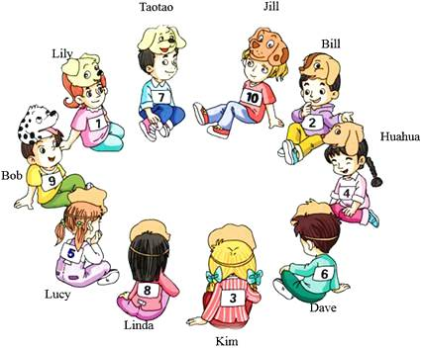
（1）How old is Jill?( )
A.Ten B.Nine
（2）Who is four years old?( )
A.Taotao B.Huahua
（3）Is Bob nine years old?( )
A.Yes, he is. B.No, he isn''t.
（4）How old is Taotao?( )
A.Seven B.Six
（5）Who is eight years old？( )
A.Linda B.Kim
6. 阅读短文，判断正误。
Hello, I''m Xiaoyong. I''m a clever (聪明的) boy. I''m ten. I like football and basketball. I don''t like swimming or skipping. I like riding bikes. I have got (有) two toy cars. One is blue. The other one (另一个) is yellow. I like them very much (非常).
( ) （1）Xiaoyong is a girl.
( ) （2）Xiaoyong likes football and basketball.
( ) （3）Xiaoyong doesn''t like skipping or riding bikes.
( ) （4）Xiaoyong has got two toys—a car and a ship.
( ) （5）Xiaoyong likes the toy cars very much.
7. 根据短文内容填空。
The cat and the bird
This is a beautiful garden. There is a cat and a bird in the garden. They are very small. The bird is sitting in the tree.
It is singing. The cat is under the tree. It is looking up at the bird. The cat is very happy with the bird''s sings. The cat and the bird are very happy to meet each other. They become good friends.
each other 相互 become 成为 under 在……下方
（1）There is a bird and a cat the garden.
（2）The cat is looking the bird.
（3）The cat is very happy the bird''s songs.
8. 阅读判断。
This is my room (房间).I have a new desk and a chair.The book is on the desk.The ruler is under the book.My eraser is in the pencil box.My bag is on the chair.Where''s my cat? It''s under the chair.It''s sleeping (睡觉).
( ) （1）I have a desk and two chairs.
( ) （2）The book is in the bag.
( ) （3）The ruler is under the book.
( ) （4）The bag is on the desk.
( ) （5）My cat is under the chair.
( ) （6）My cat is playing with me.
9. 阅读判断。
Hello，I''m Lucy.I''m from the USA.I''m a student.I have a sister.She''s a student，too.I like apples and oranges. I don''t like pears and grapes.My sister likes apples and pears. She doesn''t like oranges and bananas.
( ) （1）Lucy is from the USA.
( ) （2）Lucy is a student.
( ) （3）Lucy''s sister is a teacher.
( ) （4）Lucy likes apples and oranges.
( ) （5）Lucy doesn''t like pears and oranges.
( ) （6）Lucy''s sister likes apples and bananas.
10. 根据图片，判断正误。
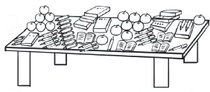
( ) （1）I see fourteen apples.
( ) （2）I see thirteen pencils.
( ) （3）I see twelve books.
( ) （4）I see nine pens.
11. 阅读短文，根据短文内容选择正确内容。
It’s eight o’clock. The children(孩子们) go to school by car every day. But they are walking to school today.
It’s ten o’clock. Mrs. Green usually(通常) stays at home in the morning. But she is going to the shops this morning.
It’s nine o’clock. Mr. Green usually reads his newspaper at night(晚上). But he is reading an interesting(有趣的) book this evening.
( ) 1.When do the children come to school?
A. At 8:00. B. At 7:00. C:At 9:00.
( ) 2.How are they come to school today?
A. By car. B. By bus. C:Walking
( ) 3.When is Mrs. Green going to the shops?
A. At 8:00. B At 10:00. C:At 9:00.
( ) 4.When does Mr. Green read his newspaper?
A. At 8:00. B .At 7:00. C:At 9:00.
( ) 5.What is Mr Green do this evening?
A. Reading a books. B. Writing a letter. C. Watching TV.
12. 阅读短文，判断对错。
Tm and John are good friends. Tom is twelve years old. John is thirteen years old. They are good students. They like to eat hamburgers. Miss White is their English teacher. She likes them very much.​
( ) （1）Tom and John are good friends.
( ) （2）Tom is twelve years old.
( ) （3）John is twelve years old.
( ) （4）Tom likes to eat hamburgers.
( ) （5）Miss White thinks they are good students.
13. 阅读短文，判断正误。
This is Jim''s bedroom. It''s new and nice. A bed and a chair are in it. A desk is on the floor. Some flowers are on it. A bookshelf is behind the bed. Some English books are on the bookshelf. A picture is on the wall. Some people are in the picture. The man is his father. The woman is his mother, who is the boy? Do you know?
( ) （1）Jim has an old and nice bedroom.
( ) （2）Some flowers are on the bookshelf.
( ) （3）The man in the picture is Jim''s brother.
( ) （4）The boy in the picture is Jim.
14. 读对话，选择正确的一项。
Amy: I''m Amy. I like table tennis. I often play table tennis after school.
Sam: It don''t like table tennis. I like football. I have three footballs.
Lingling: I like morning exercises. I do morning exercises every day.
Daming: I basketball.
（1）Amy喜欢的活动( )
A. B.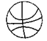 C.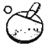D.
（2）Sam喜欢的活动( )
A. B. C.D.
（3）Lingling喜欢的活动( )
A. B. C.D.
（4）Daming喜欢的活动( )
A. B. C.D.
15. 短文阅读。
Hi! I''m Sam. I love animals very much. Look at my dog. It has two big eyes. It''s black. This is my cat, Mimi. It''s one years old. It''s very cute. I have four fish. Oh! Mimi likes (喜欢) the fish. And I have a bird, Woody. It''s so beautiful!
( ) （1）Sam has a cat and four fish.
( ) （2）The dog is black, and it has big ears.
( ) （3）The cat is four years old.
( ) （4）Woody is a bird.
( ) （5）Sam has a big family.
16. 阅读短文，判断正误。
Mike has (有) a yellow pen. John has a black pencil box. Chen Jie has a blue ruler. Wu Yifan has a white flower. Bai Ling has a red bag.
1. Mike has a yellow pen. ( )
2. John has a green pencil box. ( )
3. Chen Jie has a blue ruler. ( )
4. Wu Yifan has a brown flower. ( )
5. Bai Ling has a red bag. ( )
17. 阅读，判断句子正（T）误（F）。
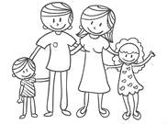
Dalong is ten. He likes swimming. This is his father, He likes basketball. This is his mother. She likes table tennis and skiping. This is his sister, Lanlan, She likes skipping and swimming. She doesn''t like football.
( ) （1）His father likes football.
( ) （2）His mother likes table tennis and skipping.
( ) （3）Dalong and Lanlan like swimming.
( ) （4）Lanlan likes skipping.
( ) （5）Lanlan likes football.
18. 阅读短文，在相应的栏中打“√”。
Tom likes kites and robots. John likes toy trains and cars. Peter likes toy bears and bikes. Mary likes toy bears and kites. Bill likes balls and kites.
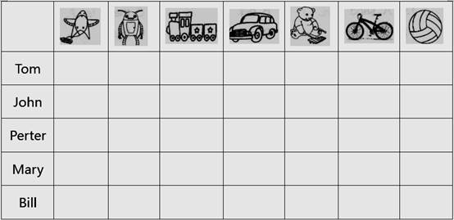
19. 阅读短文并根据内容，判断句子的正误。
Hello. I''m May. I''m a girl. I''m ten. I have a happy family. There are four people in my family. My father, mother, brother and me. My father is a teacher. He likes playing balls. My brother likes swimming. My father and mother go to work by car. I love my family.
（1）May is a boy.( )
（2）May is nine.( )
（3）May''s father is a teacher.( )
（4）May''s father and mother go to work by bus.( )
（5）May''s brother likes swimming.( )
20. 阅读短文，判断正误。
Sam: Mum, I''m hungry! I''d like some eggs and milk.
Sarah: Mum, I''d like some bread,
Mum: OK! Here you are.
Sarah & Sam: Thank you!
Sarah: Mum, can I have some juice, please?
Mum: Sure. Here you are.
Sarah: Mum, have some bread and juice!
Mum: No, thank you. I''d like some bread and milk.
Sarah: Oh, it''s 7:30. Let''s go to school!
Sam: OK!
（1）Sam is hungry.( )
（2）Sam would like some bread.( )
（3）Sarah would like some bread and juice.( )
（4）Mum would like some bread and milk.( )
（5）Sarah and Sam go to school at 7:30.( )
21. 根据短文内容，判断正误。
My name is Betty. I am 14 years old.
My father and mother are workers(工人). They come home late. They are tired(累的).
I do housework(家务) for my mother and father. I like cooking(做饭).I can cook many things. I can cook rice, noodles, eggs and sandwiches. Cooking is fun.
I love my mother and father. I am helpful(有用的) to my family.
（1）My father and mother come home at 7:00.( )
（2）I can do housework for my parents.( )
（3）I can cook many things for them.( )
（4）I don''t like cooking.( )
（5）I am helpful to my family.( )

