M4U2 What’s he doing?教学设计
第 4周 第 2 课时

课题 | M4U2 |  |  | 内容 |  | 教材23—25页内容 |  | 课型 |  | 新授
教学  目标 | - 能听会说，会读stone,behind hide等单词;能熟练掌握句型：What’s he/she doing?He’s/She’s ..~ing.What are they doing? They’re ~ing  - 2.能运用句子What’s he/she doing?He’s/She’s ..~ing.What are they doing? They’re ~ing.”询问别人正在做什么，并作答。  3.培养学生主动用英语与他人交流和与他人共同合作，共同完成学习任务的精神。  4.培养学生热爱生活的美好情感。
重点 | What’s he/she doing?He’s/She’s ..~ing.What are they doing? They’re ~ing |  |  |  | 难点 | Enable students to use the drills fluently and correctly. | 关键 |  | 乐于模仿，敢于开口，积极参与，主动请教
教学  准备 | 教师 | Computer, pictures , book , PPT
教学  准备 | 学生 | books
环节  时间 | 教学内容 |  | 师生活动 |  |  |  |  |  | 复案
一、3  自主感受  二、15  自主理解  三、15  自主感悟  四、7’  自主升华 | 导入  新授  拓展  回顾 |  | 一、Warming-up  1.Sing song.  2.Play a game  A:What are you doing?  B:I’m ~ing.  Describe pictures  Presentation  导入：由What’s the bear doing? He’s running引出本课新授，板书标题  Teach words:there,five-stone,behind,hide and seek  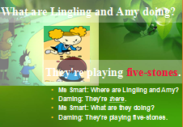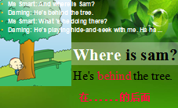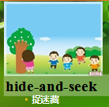  2Read follow recorder and answer questions  .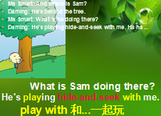  Extend:  behind/in/on/under  三、Practice  1.Gessing game:  A:What’s he/she doing?  B:He’s/She’s ~ing.  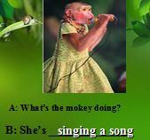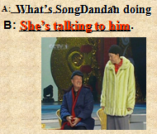  2.Ask and answer:    Chant:  Extend the knowledge:  A:What are they doing?  B:They’re ...  5.Do dialogue  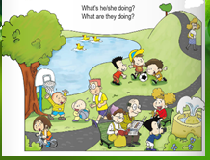  四、Summary  1. 问学生今天学习什么了？ 学生试着总结， 教师最后归纳。  2.Homework |  |  |  |  |  | 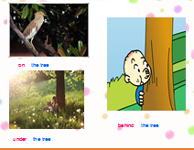  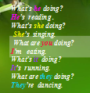
板书设计 | Moudle4 Unit2  What is he/she doing? He’s/She’s ~ing  What are you doing? I’m ~ing.  What are they doing? They’re ~ing.
课后反思

