棠外附小四年级英语阶段性测试
Class_________ Name________
- Listen and tick or cross. 听音判断正误，打√或×。
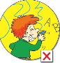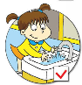
（ ） （ ） （ ） （ ） （ ）
二、Listen and choose. 听音，选择你所听到的单词或者句子。
1. ( ) A. machine B. expensive C. lesson D. nervous
2. ( ) A. proud B. special C. surprise D. message
3. ( ) A. guitar B. month C. cheap D. sheep
4. ( ) A. Is it lunch time? B. Is it dinner time?
C. It is breakfast time. D. Where is it?
5. ( ) Ａ. Point to the west. B. Point to the east.
C. Point to the south. D. Point to the north.
三．Listen and choose.听问题选择正确的图片或句子。
- （ ）What’s he doing? 2. （ ）What did she do yesterday?
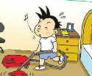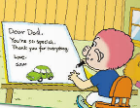
A B A B
3.（ ）Did Yuanyuan go skating yesterday?（ ）4 What will Sam do?
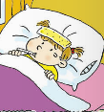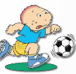
A B A B
5.（ ）How much is it？

A B
6.（ ）A. I helped my mum on Mother’s Day.
B.I went swimming on Father’s Day.
7.（ ）A. I will cut the paper.
B. She will fly a kite.
8.（ ）A. He’s running on the grass now.
B. He ran to the Village.
9.（ ）A.It’s 10:00 pm.
B. Amy goes to bed at 10:00 pm.
10.（ ）A. It’s 100 yuan.
B.I love music.
四、Listen and number. 听音排序。
（一）

（ ） （ ） （ ） （ ） （ ）
（二）
（ ）There is a park next to our school.
（ ）Let’s have fun this Saturday!
（ ）See you there!
（ ）We can play games in the west of the park.
（ ）Let’s meet there at 9 o’clock.
五、Reading 阅读：读一读，做一做。（每小题2分，共20分。）
A．读下列短文，判断句子正误。正确的写“T”，错误的写“F”。
An old lion lives in the forest(森林). He doesn’t want to look for food. He wants other animals to give him something to eat.
He sees a monkey and says to him, “I’m hungry, monkey. Go and give me something to eat.” “Oh, lion,” says the monkey, “I can’t do that now. There is another lion over there. He wants something to eat, too. He won’t let me give any food for you. I’m afraid（害怕） of him.” “ What? Where is it? I must see him.” “ Come with me.” Says the monkey. The monkey and the lion go to a bridge. “ Now, look down at the river. Do you see it?” “Yes, I do. I must eat him!” Then the lion jumped into the river.
（ ） 1. The lion looks for food himself.
( ) 2. The lion tells (告诉) the monkey to look for food for him.
( ) 3. The monkey tells the lion that there is another lion in the forest.
( ) 4. The monkey and the lion go to a house.
( ) 5. The lion falls into the river.

B． 阅读短文，选择正确答案。
This is a picture of my family. These are my grandparents. They are sitting on the chairs .They are old, but they weren’t old thirty years ago (以前). They were young then. The young man and the young woman are my parents (父母). They are very nice. The little boy is me. I was fat then. But now I’m thin and tall. We have a happy family.
( ) 1. Who are sitting on the chair?
A. My parents B. My grandparents
( ) 2. My parents _______ old thirty years ago.
A. weren’t B. wasn’t
( ) 3. I was ________ then. But now I’m _______ and tall.
A. thin, fat B. fat, thin
( ) 4. This is a picture of ________.
A. my family B. my friend
( ) 5. There are _______ people in my family.
A. three B. five

六、Read and choose. 选词填空。
feed play talk write grass

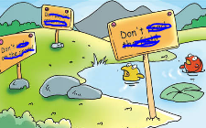
Don’t ______ the fish!
Don’t walk on the_____!
Don’t _____ ball games here!

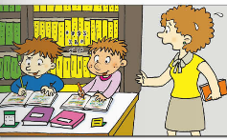
Don’t _____ loudly!
Don’t______ on the books!

七．Look and match. 连线题。

What are you doing? It's six o'clock..

What's the time? I'm drawing the picture.

What will you do? It’s in the north of China.

What did you do? I will go to school.

Where is Beijing? I bought an ice cream.

