**三年级上Module 1至Module 2 复习**

**姓名：_________**

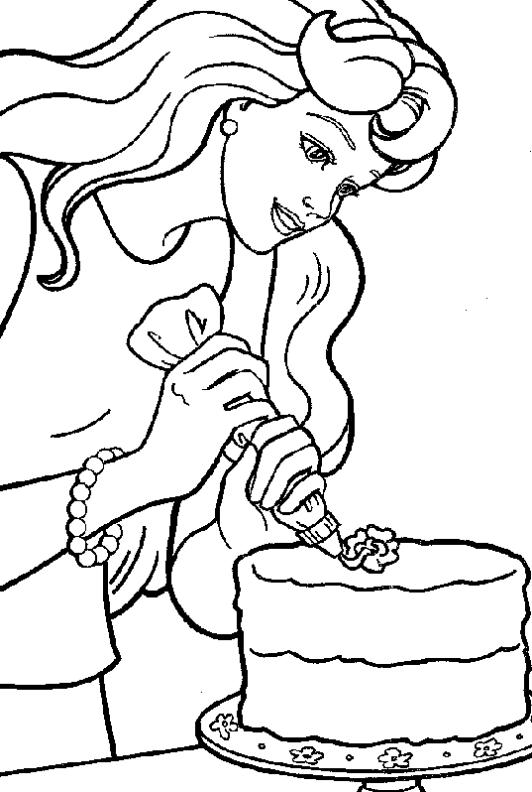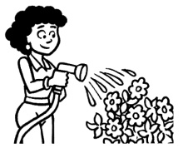**1. Listen and match the words with pictures（听音，将图片与单词配对）:**

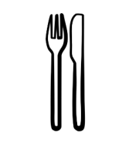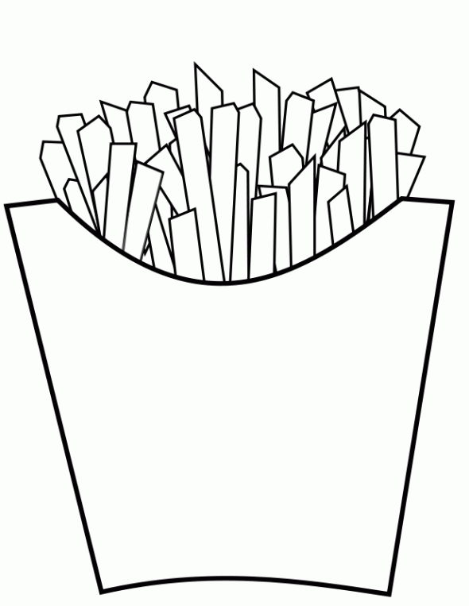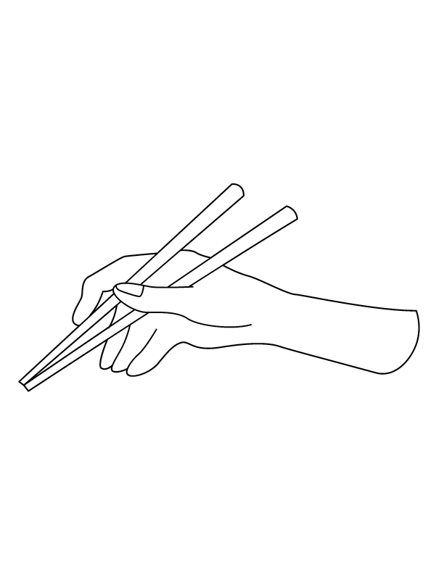

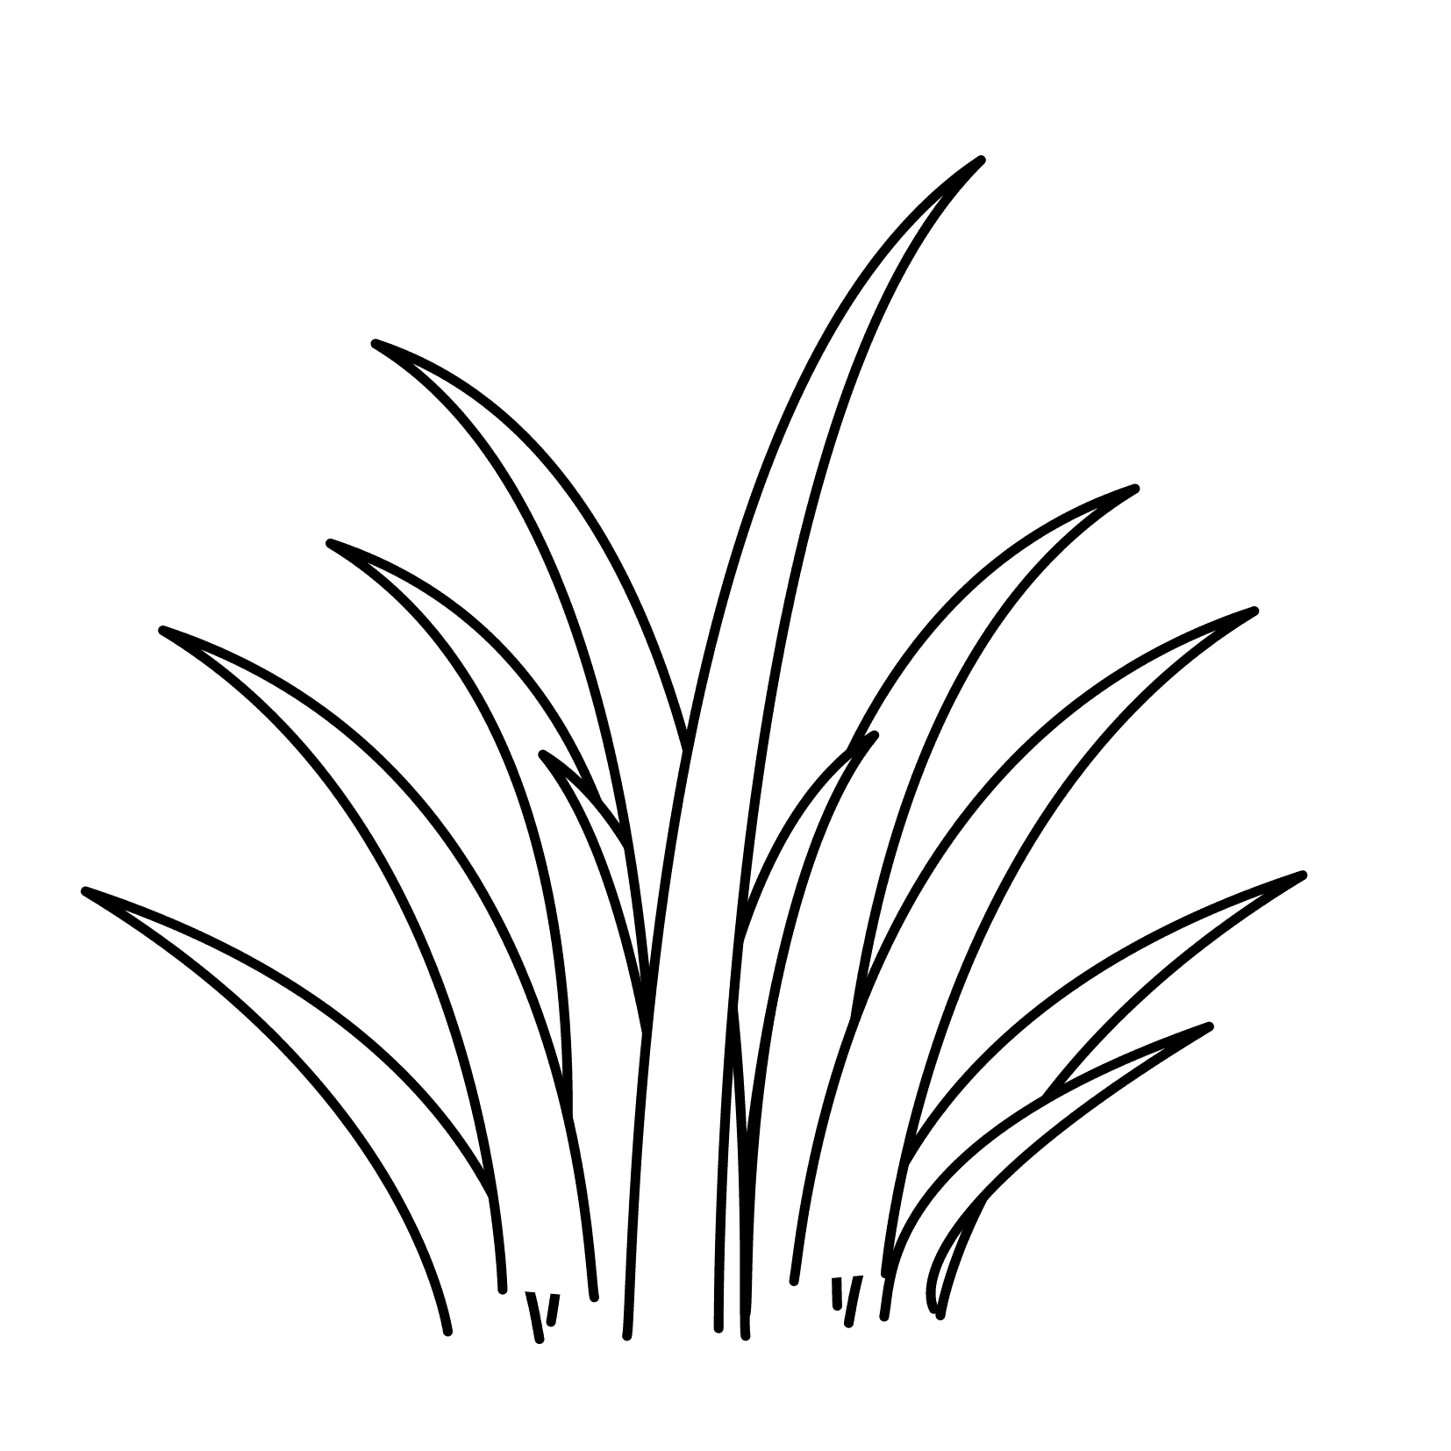

1 2 3 4 5 6

A. knife and fork B. chips C. make a cake D. grass E. use chopsticks F. water the flowers

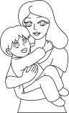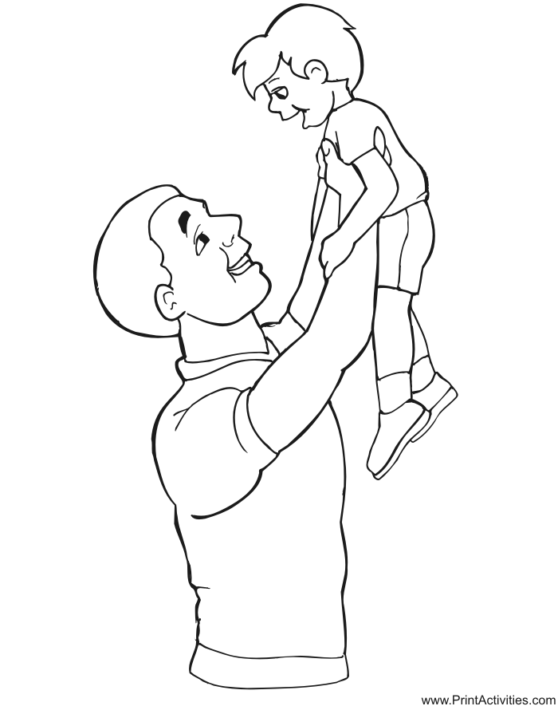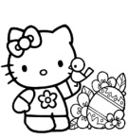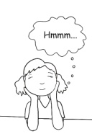**2. Listen and write down the missing letters（听音，填出空缺字母）：**

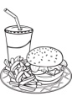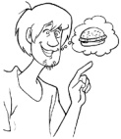

1. hungry 2. f__ __d 3. m___m 4. d___d 5. l___vely 6. w___nt

**3. Read and match the questions with answers（将正确的提问与回答连起来）:**

1. Do you use chopsticks in the UK? A. I’m eating noodles.

2. Do you want hamburger? B. Yes, I do.

3. What are you eating? C. Yes, I am.

4. Are you eating noodles? D. No, I don’t.

5. Is Sam watering the flowers? E. Yes, she is.

6. Is Amy eating chips? F. No, he isn’t.

**4. Read and finish the conversation（选出对话中空缺的单词或短语）:**

A

Word bank

A. easy

B. hard

C. chopsticks

D. a knife and fork

E. hungry

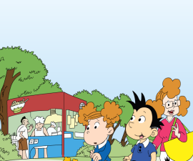**Amy**: I’m 1. ___E____ .

**Sam**: Do you want noodles?

**Amy**: Yes, please.

**Amy**: Mm. The noodles are good.

**Mum**: Oh no! Look at the mess!

**Sam**: Do you use 2.________ in the UK?

**Amy**: No, we don’t. It’s 3._____ for us. We use 4.________. It’s 5. ______ for us.

B

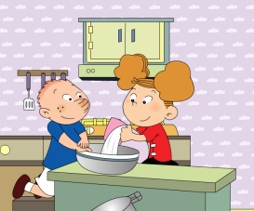**Amy**: Let’s make a cake for Mum and Dad!

**Sam**: Yes. Good idea!

**Dad**: What are you doing?

**Sam and Amy**: We are 1._________.

Word bank

A. making a cake

B. reading

C. working

D. playing the piano

E. playing the drums

F. quiet

**Dad**: Please be 2._______. I’m 3.________.

**Mum**: What are you doing?

**Sam and Amy**: We are making a cake for you, Mum.

**Mum**: Thank you. But please be quiet! I’m 4.________.

**Mum and Dad**: Children, please go to your room!

**Mum**: Oh no! Amy’s 5.________. And Sam’s 6.________.

**Dad**: Please stop! Go and make your cake.

**Sam and Amy**: Yes!!

**5. Write the sentences conrrectly (请正确书写以下句子)：**

1. Do you use chopsticks in the UK?

2. We use a knife and fork.

3. What are you doing?

4. We are making a cake.

5. Please be quiet!