**三年级上Module 3至Module 4 复习**

**姓名：_________**

**1. Listen and match the words with pictures（听音，将图片与单词配对）:**

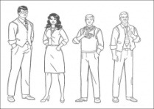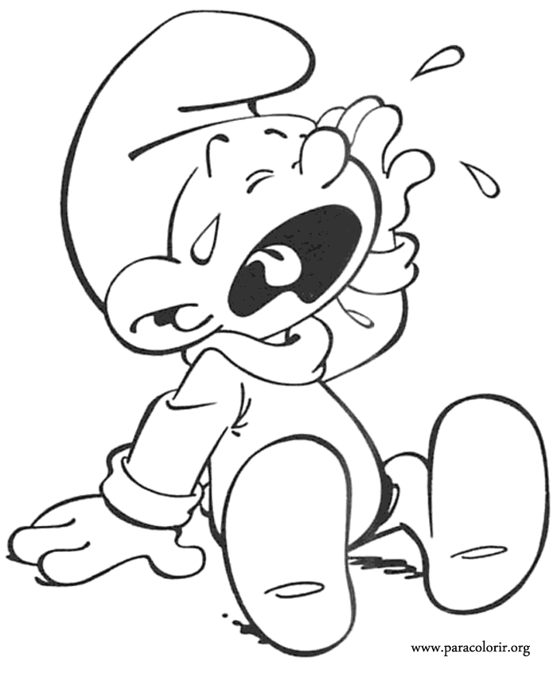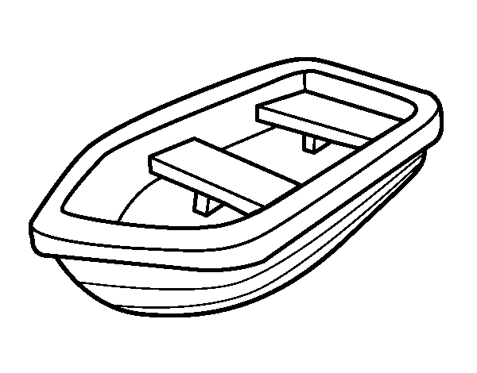

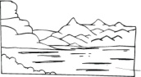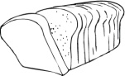

1 2 3 4 5 6

A. people B. bread C. lake D. cry E. fly F. boat

**2. Listen and write down the missing letters（听音，填出空缺字母）：**

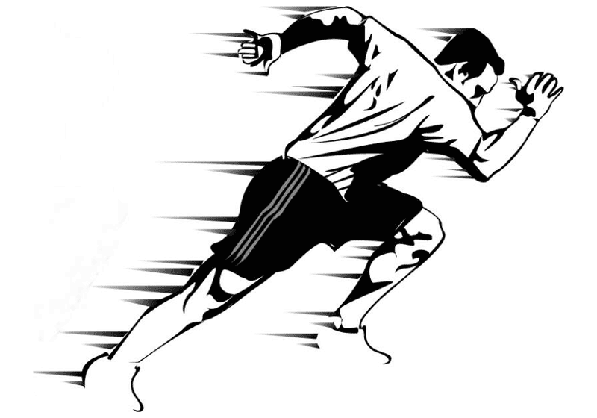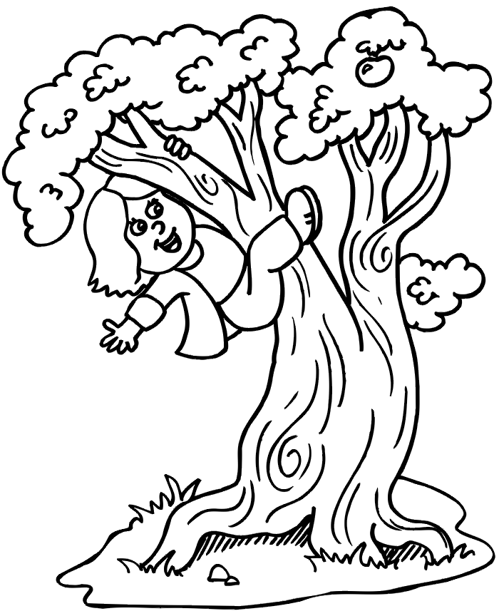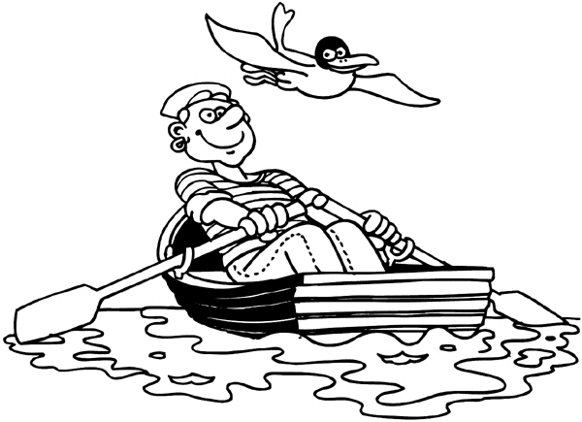

1. boat 2.r_ _ 3. f_ _d 4.cl_ mb 5. sl_ _ 6. f_ _

**3. Read and match the questions with answers（将正确的提问与回答连起来）:**

1. What are those? A. I can see a bird.

2. What are these? B. Yes, he can.

3. What are they doing? C. These are dragon boats.

4. Can you run fast? D. They are playing hide-and-seek.

5. Can Sam jump far? E. No, I can’t.

6. What can you see? F. Those are ducks.

**4. Read and finish the conversation（选出对话中空缺的单词或短语）:**

A

Word bank

A. dragon boats

B. feed

C. naughty

D. bread

E. ducks

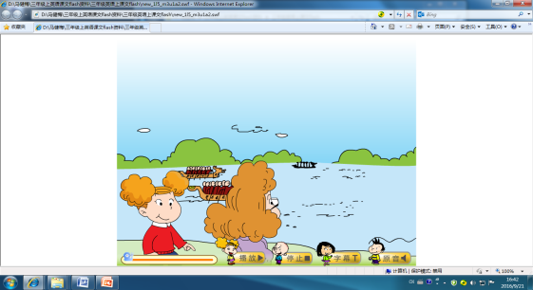**Amy**: Look, Mum. What are those?

**Mum**: They are 1._________.

People row on this lake.

**Sam**: Please, Mum?

**Mum**: OK. Let’s row.

**Amy**: Look at those 2._______ over there!

**Sam**: Let’s 3._______ the ducks. Where is the 4.________?

**Mum**: Here it is.

**Sam**: The ducks are coming now. They’re 5._________.

**Mum**: Oh, no! These ducks are very naughty!

**Sam**: Get out! Get out!

**Amy and Mum**: Ha ha…

B

**Sam**: Amy, can you run fast

Word bank

A. can

B. swim

C. fast

D. jump far

E. winner

F. Can

**Amy**: Yes, I 6._______.

**Sam**: Aah! I’m the winner. You can’t run 7._______. You are slow.

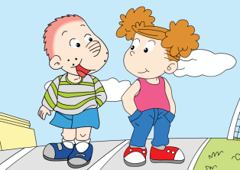**Sam**: I can 8. ________.

**Amy**: Let’s see.

**Sam**: I can’t jump far.

**Amy**: Ha! I’m the 9._________.

**Amy**: 10._______ you jump far?

**Sam**: No, I can’t. But I can 11._______ here!

**Amy**: Ha ha…

**5. Write the sentences correctly (请正确书写以下句子)：**

1. What are those?

2. These ducks are very naughty.

3. Can you run fast?

4. I can’t jump far.

5. I can see a koala. It can climb.