Module 10 Unit 1 It’s next to the park.（第一课时）
主备人：彭华 使用者：
一、教学目标
【知识目标】 1．1.能在文本语境中准确理解和认读单词：cousin, next to , in front of, wrong, way, well
2.能在文本语境中理解句型：Where’s…? Turn…It’s next to …. It’s in front of ….
【能力目标】 1.了解与实际生活相关的地点单词park, zoo, station, school, hospital, supermarket并能基本认读。
2.说会认lost, Turn left. Turn right. Go straight on.对Where’s…句型有了一定的了解。他们基本能听方向类指令做动作。
【情感目标】1.通过表演等活动挖掘课堂中的“兴奋点”，培养学生乐于用英语表达的能力。
二、教学重点
能在文本语境中理解句型：Where’s…? Turn…It’s next to ….It’s in front of ….（本课重点）
三、教学难点
能够准确运用Excuse me. Where’s…please? Turn …It’s next to….It’s in front of ….进行地点的询问与路线的描述。（本课难点）
四、教学资源
互动教学系统，点读笔，PPT，人物头饰，花朵磁铁
五、教学过程

教学环节 | 教学活动具体描述 |  | 教学资源
Step 1 warm-up | 1. T greets the Ss, trying to use “Nice to meet you.”  2.T chants with the Ss.
Step 2  Lead-in | 1. T leads Ss to go to look at some pictures about places.  T: While you’re marching, what can you see?  2. Then lead Ss to look at the screen and say.  3. T leads Ss to talk about the bears.  What colour are they?  Guess:  What are they doing? | PPT第2-4页
Step3  Presentation  Text Learning | 1. Lead Ss to watch the video without the words, answer the question: What are they talking about?  2. Lead Ss to watch the video again with the questions ‘Where’s the white/brown bear’ s home?’ and understand the phrase: next to  3. Lead Ss try to ask and answer with “Where’s…? It’s next to the…”  Then practice with Ss’ seats.  “Where’s…? He’s/She’s next to …”  4. T: Where’s Sam?  Where’s Daming? Lead Ss to look at the first picture of the main dialogue and talk about it.  T: What are they doing? Guess.  5.Lead Ss to watch the whole movie with two questions:  How many people are there in the story?  Who are they?  6.Lead Ss to watch movie again with another two questions:  Where’s the supermarket?  What does Dalin do? | 互动教学系统M10U1活动1的动画  PPT第5、6页  PPT第7-10页  互动教学系统M10U1活动2的动画  PPT第11-14页
Step4  Blackboard Design | Module 10 Unit 1 It’s next to the park.  Excuse me. Where’s the…?  Turn…  It’s …

Module 10 Unit 1 It’s next to the park.（第二课时）
主备人：彭华 使用者：
一、教学目标
【知识目标】 1．1.能在文本语境中准确理解和认读单词：cousin, next to , in front of, wrong, way, well
2.能在文本语境中理解句型：Where’s…? Turn…It’s next to …. It’s in front of ….
【能力目标】
说会认lost, Turn left. Turn right. Go straight on.对Where’s…句型有了一定的了解。他们基本能听方向类指令做动作。
【情感目标】培养学生乐于助人的良好品质。
二、教学重点
能在文本语境中理解句型：Where’s…? Turn…It’s next to ….It’s in front of ….（本课重点）
三、教学难点
能够准确运用Excuse me. Where’s…please? Turn …It’s next to….It’s in front of ….进行地点的询问与路线的描述。（本课难点）
四、教学资源
互动教学系统，点读笔，PPT，

教学环节 | 教学活动具体描述 |  | 教学资源
Step 1 warm-up |  | 1. T leads Ss to go to look at some pictures about places.  2． Review Excuse me.  Where’s…please?  Turn … It’s next to…. It’s in front of ….
Step 2  Practice |  | 3. T: Let’s look at picture1. Daming is saying…  T leads Ss to understand the meaning of “cousin” according to card and know about “Nice to meet you.” Then listen and imitate.  4. Show picture 2.  ①T leads Ss to guess. What is the grandma saying? What is Daling saying?  ②Lead Ss to understand the words, phrases and the route by the map and playing games.  ③T gives a model and have Ss act.  ④Have Ss listen and imitate.  5. Show picture 3.  T: Please guess. What is the man saying?  Have Ss listen and imitate. |  | 互动教学系统M10U1活动1的动画  PPT第5、6页  PPT第7-10页
Step4  production |  | 6. Show the picture of activity 4, have Ss speak out the places.  Lead Ss to work in pairs to act how to ask the way and how to answer.  7.Show picture4  T: Daming is laughing.  Why?  T leads Ss to answer the question and makes sure that Ss can know about it. |  | 互动教学系统M10U1活动2的动画  PPT第11-14页  PPT第15-25页
Classroom Assessment |  | 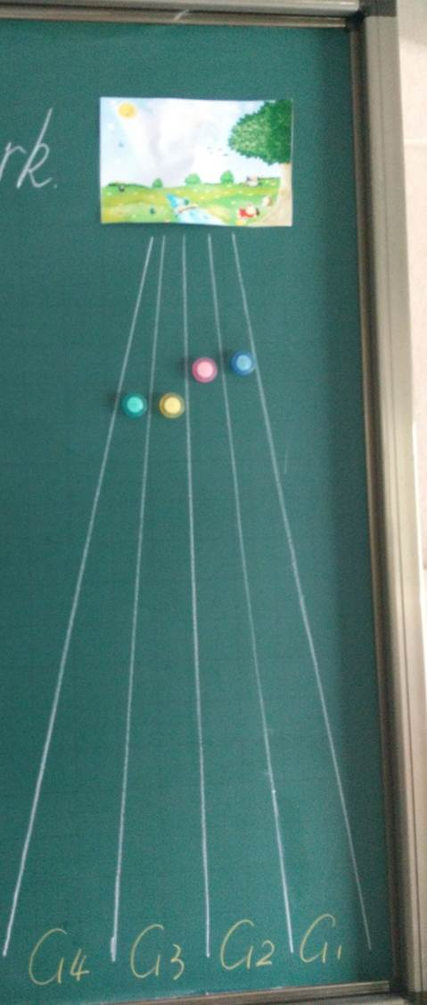 采用个人评价与小组评价相结合的方式。小组评价中将学生分成四组，分别在一条路口，通过教学活动进行小组评价，确定各组向上走的步数，哪组能最先到达Park，哪组就是winner.这种方式能有效提高学生参与课堂教学活动的积极性。

