棠外附小三年级下册英语阶段测试

A． Listening Part听力部分（50分）
I．Listen and choose the word(听音选出你所听到的词)(10分)
( )1.A.nice B.shy C.new
( )2. A.twenty B. sixteen C. thirteen
( )3. A.lion B. pig C. tiger
( )4. A.fruit B. pear C. peach
( )5. A.old B. long C. round
II. Listen and choose. (听音选择听到的句子)（10分）
( ) 1.A. She’s very nice B. She’s very loud
( ) 2. A .It’s very long. B It’s very old
( ) 3.A. This river is very wide. B. This house is very old.
( ) 4.A.I’ll pick apples. B. We’ll pick some oranges.
( ) 5.A. Will you take your ball? B. Will you take your kite?
III. Listen and choose.( 听音选择相应的图片并填序号)（10分）
（ ）1. | A.  | B.  | C. 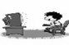
（ ）2. | A. 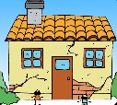 | B. 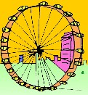 | C. 
（ ）3. | A.  | B.  | C. 
（ ）4. | A.  | B.  | C. 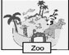
（ ）5. | A. 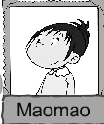 | B. 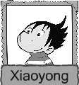 | C. 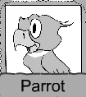
IV. Listen and order.(听音给图片排序)（10分）


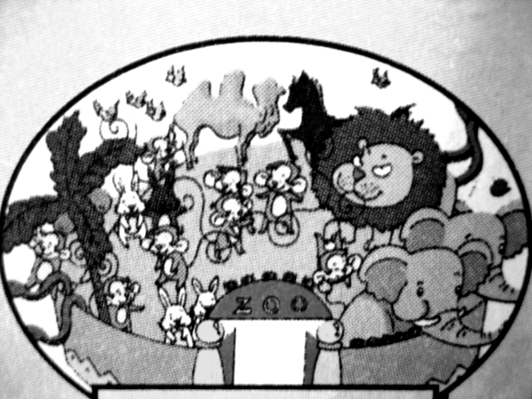
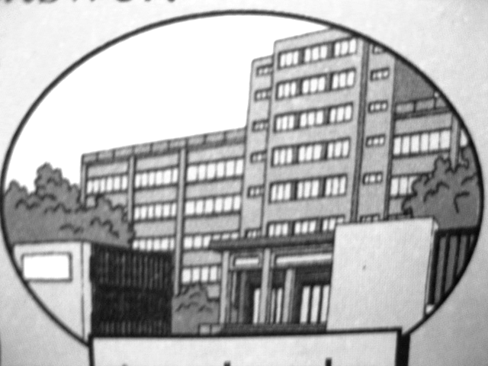


( ) ( ) ( ) ( ) ( )
V. Listen and Match(听音选择正确的图片填序号)（10分）
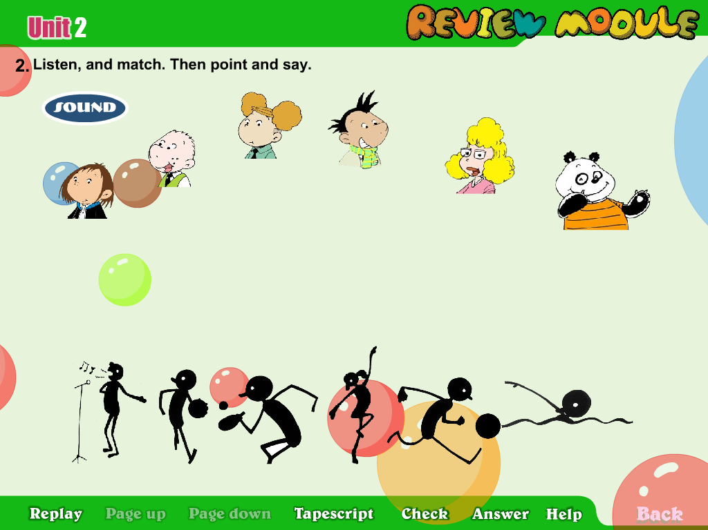
( ) 1. A. go swimming. .

( ) 2. B. see lions and tigers

( ) 3.. C. watch TV.

( ) 4.. D. see lots of pigs.


( ) 5. E. go to the countryside

B． Written Part笔试部分（50分）
I．Read and number.（读一读将句子序号填到正确的图片下）（10分）
1. There are fourteen. 2. We’ll pick fruit this weekend.
3. This house is very old. 4. You’ll see Tower Bridge.
5. She will read books on Saturday.

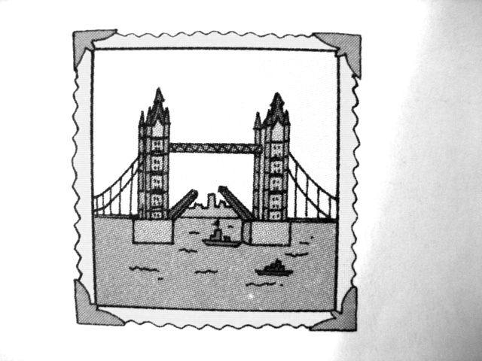
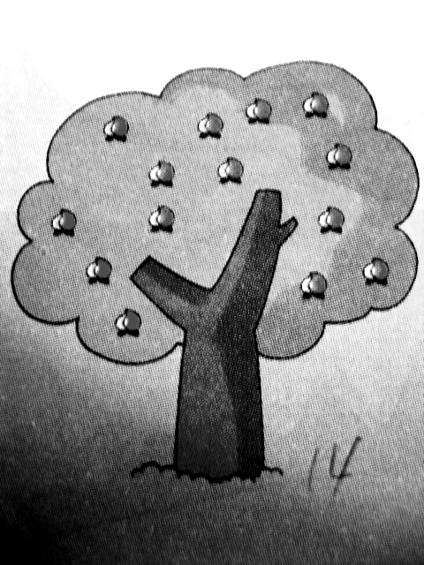
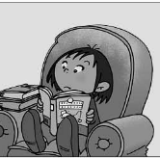
、
( ) ( ) ( ) ( ) ( )
II. Read, choose and write. （读一读，选一选，写一写）（10分）
wheel clever Maths wide pick

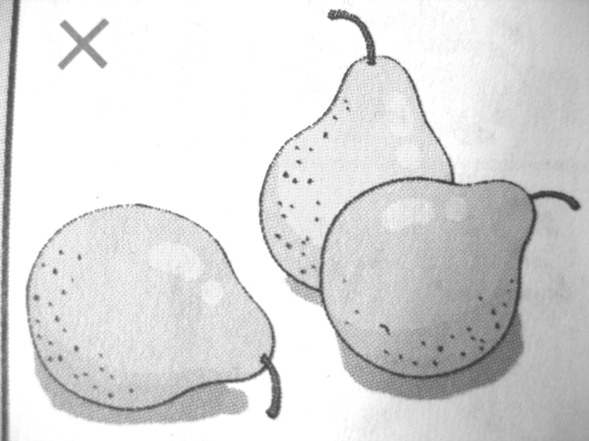
1. -Will we ____________ pears? -Yes, we will.
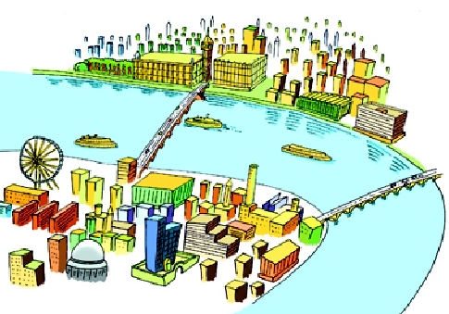
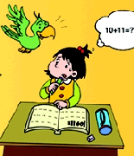
2.This river is very ________________

3. This little girl can’t do her _______________
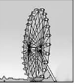
4. The London Eye is a big round _________________


5. Xiaoyong is very ________________ he can make e-card.
III.Read and write(规范正确地抄写一遍下列单词和句子) (10分)
nice people wide clock breakfast

On Monday, I’ll go to school.

IV. Read and choose (选择正确答案填序号) （10分）
( )1.Will you have a picnic tomorrow ? A.He’ll see some pigs.
( )2. What will Daming see? ? B.Yes, I will.
( )3. Do you want to visit London? C.I’ll go to the zoo.
( )4. Will Amy go to the park? D.Yes, I do.
( )5. What will you do this weekend? E.No, she won’t
V. 阅读理解（读短文并根据内容选择正确答案填序号）(10分)
Daming’s grandpa lives in the countryside. He has got a farm. He has got lots of pigs, and many chickens. Daming likes to go there. He likes the cows. And he likes to ride the horse. Grandpa has twenty horses. But there isn’t a phone and TV. Daming likes to watch TV very much, so he doesn’t like living in the countryside.
1. ( ) Where does Daming’s grandpa live?_______
A He lives in the city B He lives in the countryside.
2. ( ) Is there a phone?_______
A Yes, there is B No, there isn’t
3 ( ) What are in the farm? _______
A pigs, chickens and cows B pigs, cows and tigers
4 ( ) Daming doesn’t like ______
A the cows B living in the countryside
- ( ) Has grandpa got a TV?______________.
A Yes, he has. B No, he hasn’t

