新标准英语五年级下期半期考试
班级_________姓名_________总分___________

听力部分（共40分）
一、看谁的耳朵灵，仔细听，选出你所听到的单词。（10分）
( )1.A. class B. pass C. bus
( )2.A.where B. their C. chair
( )3.A. high B. night C. like
( )4.A.boat B.coat C. got
( )5.A.book B.look C. cook
( )6.A.all B. tall C. autumn
( )7.A.field B.fire C.fly
( )8.A.excited B.email C.egg
( )9.A.taught B.teach C.try
( )10.A.round B.radio C.room
二、听句子，给下列图片排序(10分)
AB. C.D.E.

1.( ) 2.( ) 3.( ) 4.( ) 5.( )

三， 听对话，选出与对话内容相符的图片。（10分）
1.（ ）A B
2 （ ）A. B
3. （ ）A B
4.（ ）A B
5.（ ）A B
四，听录音，根据所听内容选出相应的序号。（10分）
( A.taught B.was C.learning D.hard E.retired )
Ten years ago , Mr. Li ______ a teacher. He______ Chinese. Chenhai was a pupil in his class, Now, Mr. Li is _________, he’s _________ English. Chenhai is an English teacher.Mr. Li studies very ________.

笔试部分（共60分）
一.选出下列单词中不同类的一项。(5分)
( )1.A.zoo B.library C.book
( )2.A.about B.where C.what
( )3.A.good B.computer C. nice
( )4.hamburger B. sandwich C. tonight
( )5.A.heavy B.light C.T-shirt
二、选出与图片内容相符的句子。(5分)
( )1. 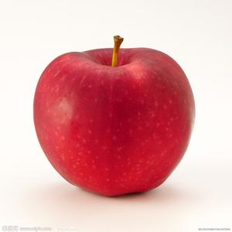 A.Here’s our new computer.
( )2. 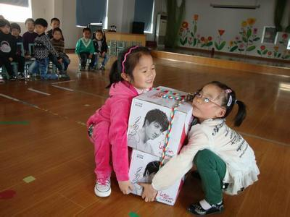 B.It’s round and red.
( )3.  C.I had hamburgers for lunch.
( )4. 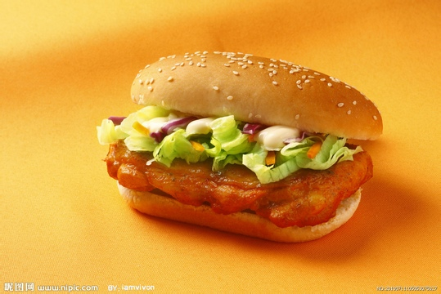 D.It’s too heavy for them.
( )5. 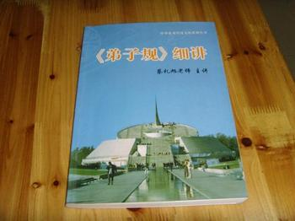 E.There is a book on the desk.

三.选择填空。(10分)
( )1.There ________ any cars or buses.
A. were B. weren’t C was
( )2. It’s big ________ you.
A. for B. with C with
( )3. She didn’t________ a radio.
A. had B. have C has
( )4.There are lots________ buses and cars.
A.off B.of C. on
( )5.Where are the books _________ computers?
A. at B.about C.for
( )6.Tom, look ______ this bag.
A. at B.on C. with
( )7.It’ll _____ easy for you.
A.is B. are C. be
( )8.You can’t ______ it to China.
A. takes B.took C.take
( )9.They had noodles ______ lunch.
A.on B. in C. for
( )10.-Are you good _______ English? - Yes, I am .
A. in B. on C. at
四. 用备选单词把对话补充完整。（10分）
( e-card bought find nice library at)
1.Look, Lingling. Here’s our new computer. Mum ________it.
2.Mmm, it’s very ______.
3.I want to make an ________for Mom. Can you help me?
4.Sorry, I’m not good _______ it.
5.Let’s go to the _______. We can ________a book about e-cards
there.
五、根据句意，选择正确的单词填空。（10分）
1.Thank you for (talked, talking) to us.
2.What are you going to (drink, drank) tonight?
3.He didn’t learn English before. But now he’s (learnt, learning) English.
4.Let’s (goes, go) to school.
5.Can I (have, has) a look at your photos?
六、根据问句选择正确的答句。（10分）
( ) 1. Did he go to the park yesterday? A .They are on Shelf F
( ) 2. Where are the books about animals? B. I ate an icecream
( ) 3.What did you do there? C .He had fish and chips
( ) 4. What did he have for lunch? D .There weren't any cars
( )5.How was the life many years ago? E. Yes,he did
七，阅读判断，与短文相符写T，不相符的写F。（10分）
Hi friends ,
I am from India . My name is Lancy. I am wearing traditional Indian clothes . I am nine years old . I like music and dolls . Yesterday , I played computer games . I finished my homework very late(迟) .
From ,
Indrani
1. She is from India . ( )
2. The girl’s name is Indrani ( )
3. She likes music and dolls . ( )
4. She is ten years old . ( )
5. She didn’t do her homework yesterday . ( )

