一起三下阶段性测试卷
一、听录音，判断正误(12分)
1.Amy will go to the zoo this weekend. √ ×
2.Amy will see pandas at the zoo. √ ×
3.Sam won’t go to the zoo. √ ×
4.Daming will go to the countryside. √ ×
5.Daming will visit his brother and sister. √ ×
6. Daming will see lions in the countryside. √ ×
二、听录音，标序号(8分)
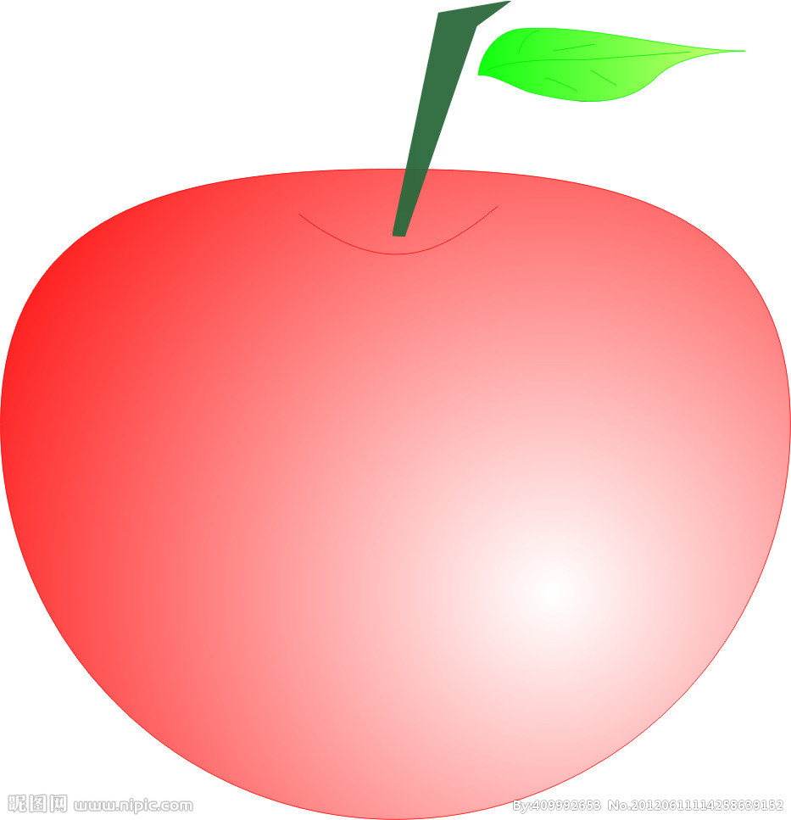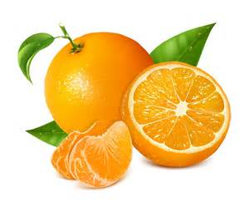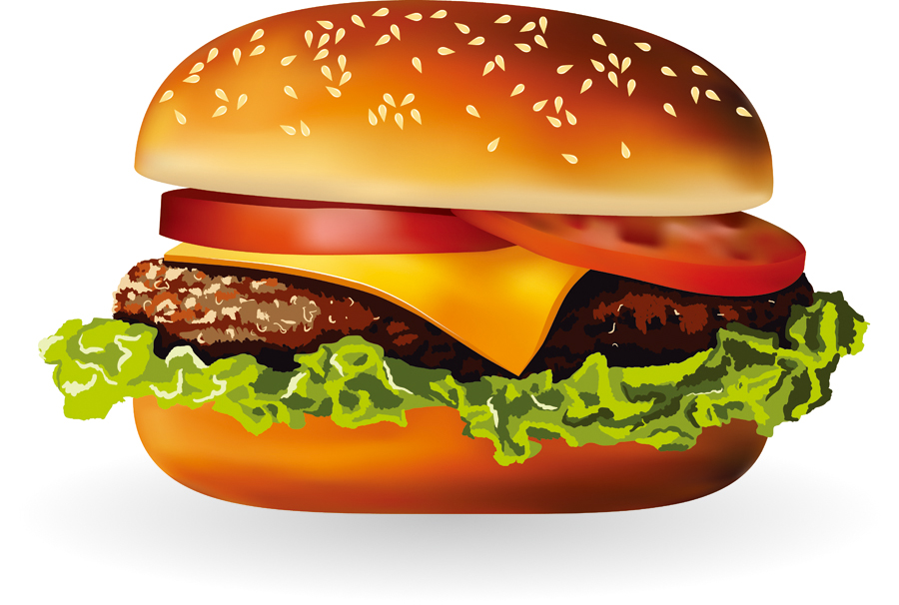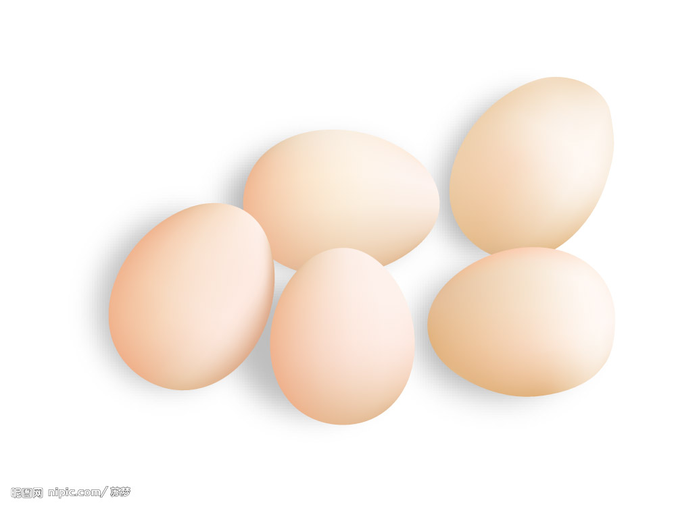
（ ） （ ） （ ） （ ）
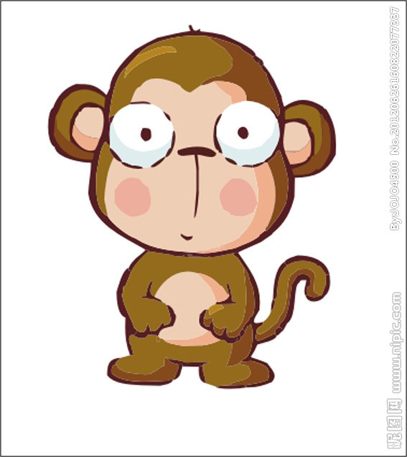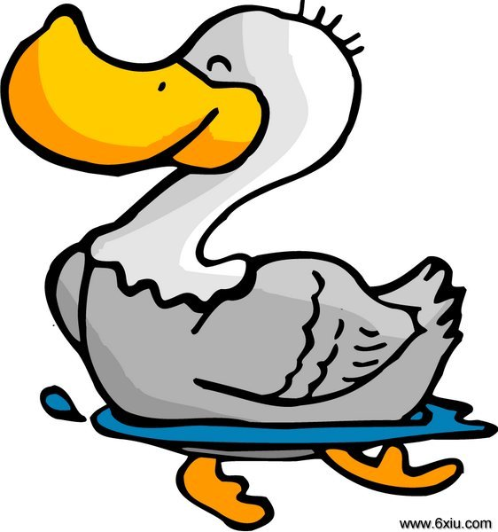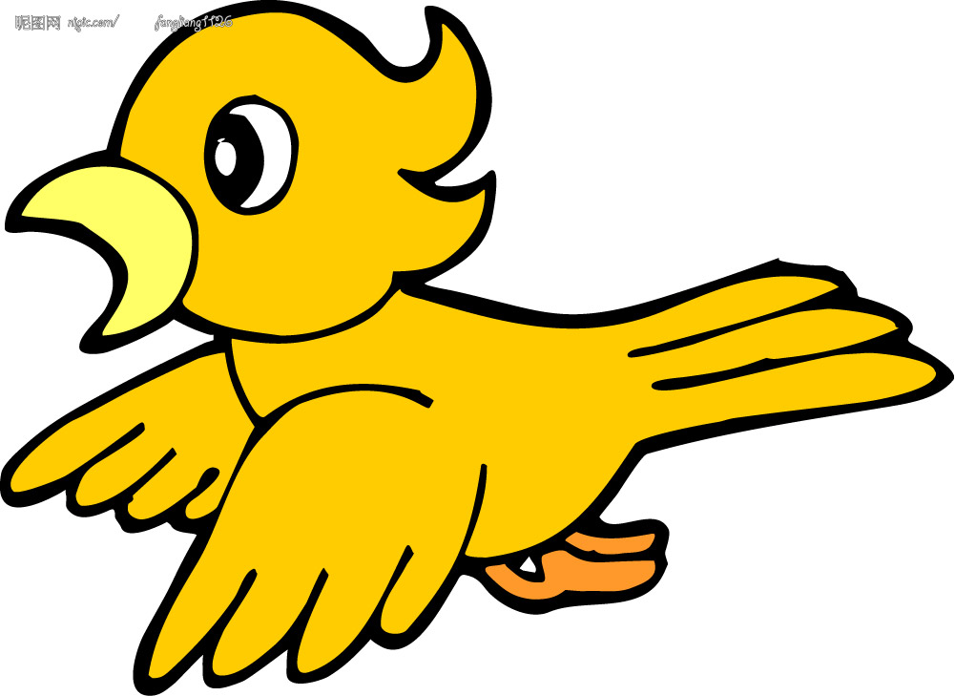
（ ） （ ） （ ） （ ）
- 听录音，选择(4分)
1.On Saturday, we’re going to have a ___________.
A. sports day B.party C.picnic
2.Will you take your _______ to the picnic tomorrow?
A.bike B.kite C.bag
3.Tomorrow is ___________.
A.Friday B.Saturday C.Sunday
4.We’re going on ____________.
A.Friday B.Saturday C.Sunday
四、看一看，写单词（9分）
h y s i c n e a a y w l s

t h a s m i v e r r o c l c k

f m r a r e e t a l i l w

五、读一读，根据发音规律，把这些单词分组（22分）

these hear June bedroom dear like yellow Chinese

she | clever | near | come

ruler fun flute airport music
sunny mat clever vegetable usually
test | June | cute | bus | driver

六、仿照例句，介绍你的朋友（15分）
Eg. Sam is clever. But he’s a bit shy.
1.__________ is ______________. But she’s a bit_______________.
2.__________ is ______________. But ________________________.
3._________ is not _____________. He is _____________________.

七、读一读，答一答（30分）
A
Amy will go to the zoo this weekend. She will see lions, tigers and pandas.Sam will go to the zoo, too. Maybe Daming will visit his grandpa in the country side. He will see lots of pigs.

1.Where will Amy go this weekend?
________________________________________________________.
2.What will Amy see?
________________________________________________________.
3.Where will Sam go this weekend?
________________________________________________________.
4.What will Daming do this weekend?
________________________________________________________.
5.What will Daming see?
________________________________________________________.
B
This weekend, we are going to a fruit farm. We’ll pick fruit. We’ll pick apples. Sam doesn’t like apples. We’ll also pick other fruit. We’ll pick pears, but we won’t pick oranges. There aren’t any oranges at the fruit farm. There are peaches at the fruit farm. Peaches are Amy’s favorite fruit.

1.Where are they going this weekend?
________________________________________________________.
2. Will they pick apples?
________________________________________________________.
3.Will they pick oranges?
________________________________________________________.
- What doesn’t Sam like?
________________________________________________________.
- What are Amy’s favorite fruit?
________________________________________________________.

