2016-2017学年度下期英语期中测试题
时间：60分钟 总分：100+20分

学校 班级 考号 姓名_________________
装订线内不要答题
装订线uuuuuuuuu
听力部分（80分）
一、听录音，选出与听到的内容相符的图片。（20分）
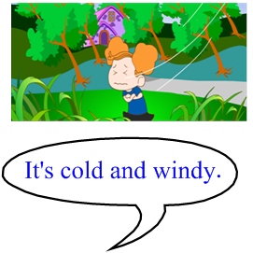
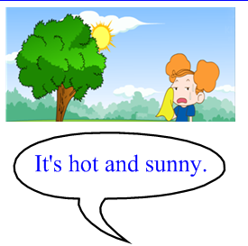
( )1. A B.



( )2. A B.



( )3. A B.

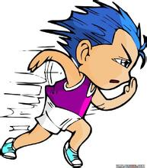

( )4. A B.


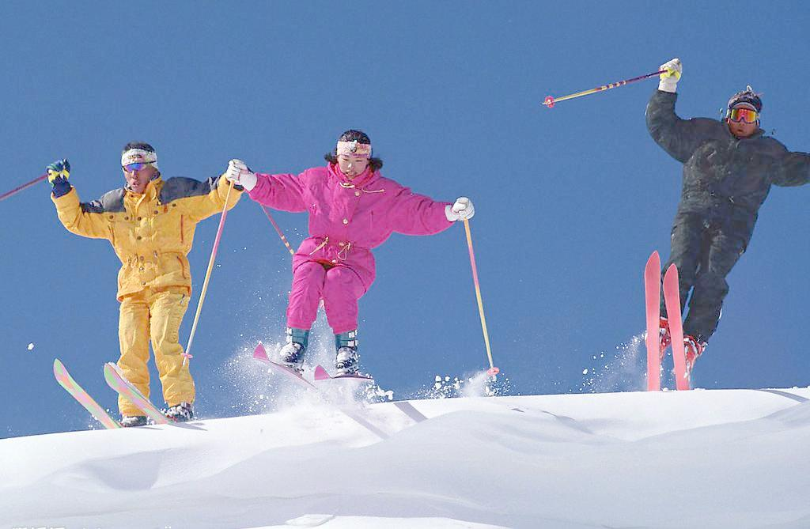
( )5. A B.

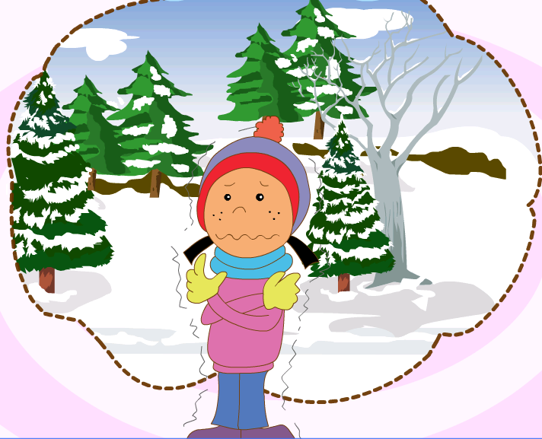


( ) 6. A B.



( ) 7. A B.



( ) 8. A B


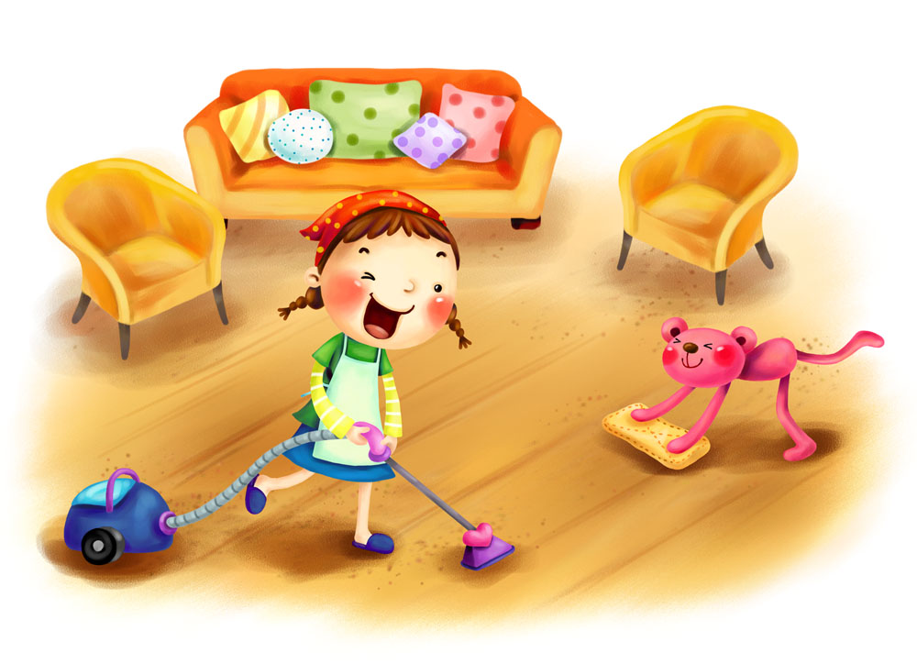
( ) 9. A B



( ) 10. A B

二、听录音，判断图片与听到的内容是“√”否“×”相符。（20分）
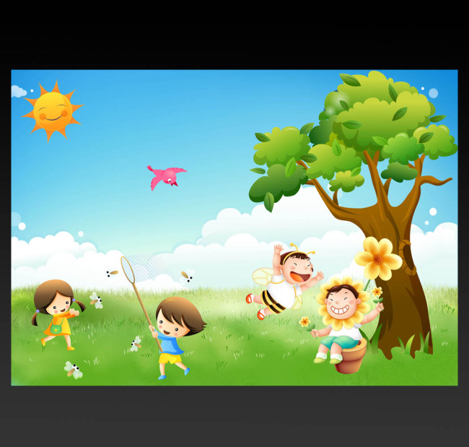
1. 2. 3.

( ) ( ) ( )
4. 5. 6.


( ) ( ) ( )
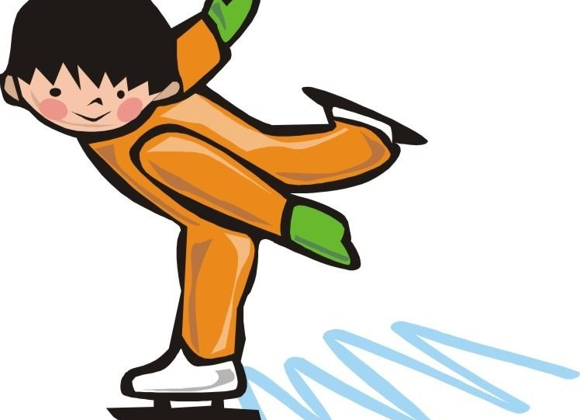
7. 8. 9.

( ) ( ) ( )
10.

( )
三、听录音，选出你所听到的句子（20分）
( ) 1. A It’s windy now .
B It’s raining now .
( ) 2. A I like swimming in summer .
B I like skiing in winter .
( ) 3. A What are you doing?
B What’s he doing ?
( )4. A I am watching TV .
B I am doing my homework.

( ) 5. A Tom is playing with his train.
B Tom is playing football .
四、听录音，连线。（20分）

Becky

Lingling

Tom


Amy


Daming

笔试部分（20分）
- 根据图片选择正确的单词填空。（20分）
talking swimming drawing clapping sunny

1.It’s and hot today .

2.We’re together.

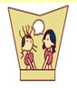
3.Amy is to Lingling.
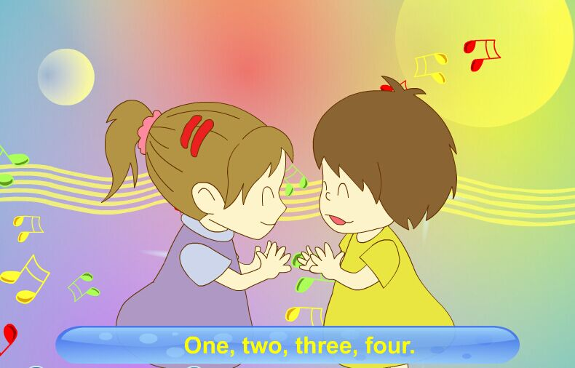
4.The girls are playing games.

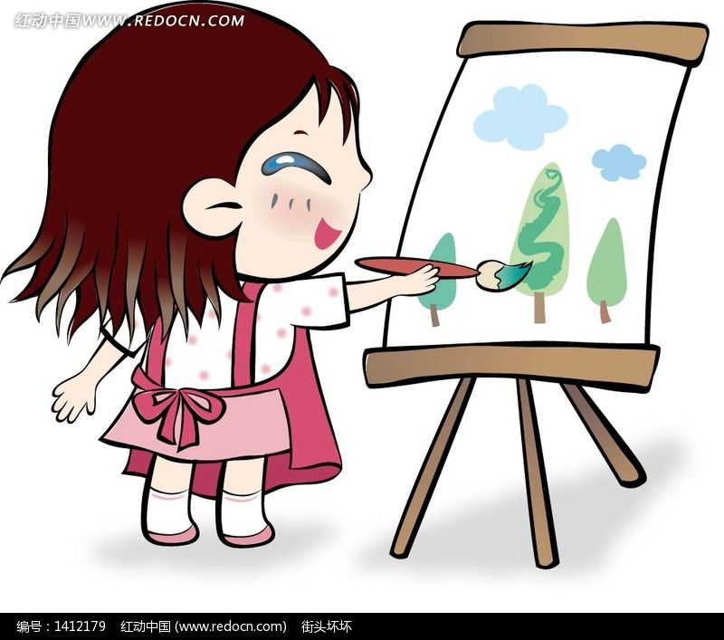
5.She is a picture. .

附加题:
请认真抄写下列单词。（20分）
Catch run clap seek letter

Sad drink skip hide talk

听力材料
一、听录音，选出与听到的内容相符的图片。（20分）
1.It’s cold and windy.
2.It’s a cap.
3.I like flying kites in spring.
4.What are they doing ? They are swimming.
5.They are skiing .
6.It’s raining .
7.He’s listening to music.
8.He’s playing basketball .
9.She’s tidying her room .
10.She’s listening to music.
二、听录音，判断图片与听到的内容是“√”否“×”相符。（20分）
- He is sleeping .
- It’s winter ,it’s cold .
- It’s spring , it’s hot .
- He is running .
- They are skipping .
- The boys are swimming.
- He is skiing.
- It’s windy.
- It’s rainy .
- He is flying a kite.
三、听录音，选出你所听到的句子（20分）
1.It’s windy now .
2. I like swimming in summer .
3. What’s he doing ?
4. I am watching TV .
5. Tom is playing football .
四、听录音，连线。（20分）
1.Becky is drawing a picture .
2.Lingling is writing a letter .
3.Tom is playing with his toy car .
4.Amy is flying a kite.
5.Daming is playing football.

