新标准五年级下册期末试卷

听力部分

姓名_____________ 班级_____________________
- 听录音，选出你所听到的单词或短语，每小题读两遍。(10)
( )1． A same B came C game
( )2. A miss B mouth C message
( )3. A got B ago C hot
( )4. A what time B what about C how about
( )5. A in the summer B in the evening C in two weeks

- 听录音，判断下列句子是否与录音内容相符，相符的打√，不相符的  打×，每小题读两遍。(10)
( )1．I want to take a present for my mother.
( )2．How about a dragon kite?
( )3．What did you have for lunch?
( )4．It’ll be easy for you.
( )5．Dad read a book about Chinese food.

- 听录音，选出你所听到的图片，每小题读两遍。(10)

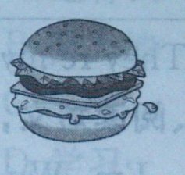
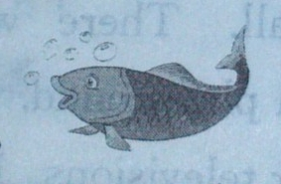
1.A. B. 

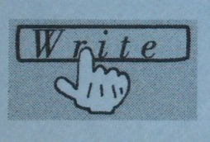
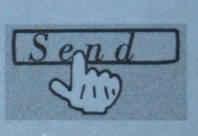
2. A. B. 

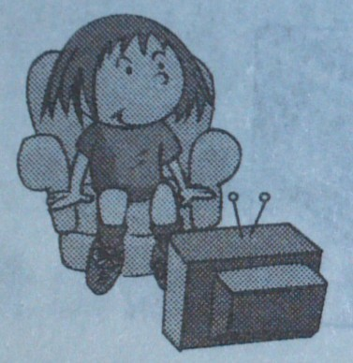


3. A. B. 

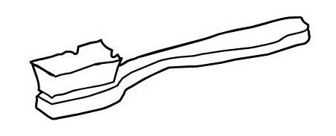
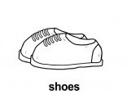
4. A. B. 

5. A. 9:00 B. 6:00

- 听录音，选词填空，每小题读两遍。(10)

went ate liked learnt drank

Dear Tina,

How are you? I ＿＿ to send emails yesterday. Last weekend I ＿＿ to a Chinese restaurant with Joy and Peter. We ＿＿ traditional Chinese food there. I think it’s delicious and I like it. Yesterday I went to Daming’s birthday party. We all ate a big birthday cake and ＿＿ some juice. I gave Daming a present. He ＿＿ it very much. How about your weekend?

Yours，
Mary

笔试部分

- 找出下列每组单词中不同类的单词。(10)

( )1. A heavy B light C where
( )2. A ate B drank C use
( )3. A computer B book C send
( )4. A short B long C made
( )5. A easy B nice C card

六、单选题。(20)

( ) 1.—＿＿did you do yesterday?
—I visited my grandpa.
A What B When C Where
( ) 2. Please give the apple＿＿Tom.
A to B from C for
( ) 3. —＿＿are you going to go home?
—At six o’clock.
A Where B When C What
( )4.He is＿＿English now.
A learn B learnt C learning
( ) 5.Thank you ＿＿your books.
A for B to C of
( )6. —＿＿are you from, Mike?
—I’m from America.
A What B Where C When
( )7.We can listen＿＿CDs in the evening.
A at B from C to
( )8.Her parents＿＿do some shopping next weekend.
A are B are going to C are going
( )9.I’ve got a letter＿＿a friend.
A from B to C about
( )10.We are going to see you＿＿two weeks.
A in B for C at

七、选词填空。(10)

1.Here is a card＿＿(for/at)you.
2.Let’s ＿＿(went/go)to park.
3.Yesterday I＿＿(eating/ate)a hamburger with my mother.
4.She is＿＿(drink/drinking)coffee now.
5.Did you＿＿(watched/watch) TV last night?

八、给下列的句子选择合适的答语。(10)

1. Did she learn English? A. Yes, I did.
2. What did you eat last night? B. Fish and chips.
3. Where are you going to go? C. In July.
4. When are you going to go there? D. No, she didn’t.
5. Did you go with your mother and father? E. Beijin.

九、阅读短文，选择正确答案。(10)

Dear Lingling,

Yesterday was Sunday. I didn’t go to school.

I always get up at eight o’clock from Monday to Friday. But, I got up at half past nine yesterday morning. I went to park at ten o’clock after breakfast. I played football with my friends. We had lunch at twelve o’clock. Then I visited my grandma with my parents at two o’clock. We ate noodles for dinner.

I was very happy yesterday.

With love,
Daming

( )1.Daming always gets up at＿＿o’clock.
A .nine B.eight C .three

( )2. What did he eat for dinner?
A .rice B.noodles C .sandwich

( )3. Yesterday was＿＿.
A .Sunday B.Monday C .Friday

( )4. Daming played football with＿＿.
A .Lingling B.his friends C .father

( )5.When did he visit his grandma?
A .one B.four C .two

