棠外附小六年级下期英语模拟考试（二）

卷面总分100分 | 总分 | 等级

温馨提示：同学们，冷静思考、细心作答，你一定能取得优异的成绩！
第一部分 听力试题（共六大题，满分47分）
一、听句子，选择相应的图画，将其序号填在左边的括号内。（6小题，共12分）
（ ） | 1. | A. | 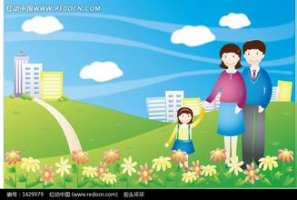 | B. | 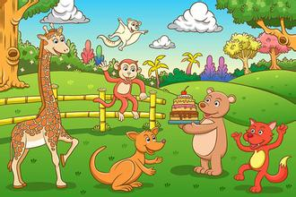 | C. | 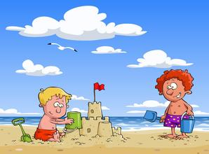
（ ） | 2. | A. |  | B. | 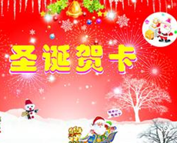 | C. | 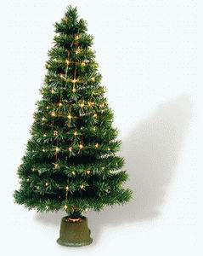
（ ） | 3. | A. | 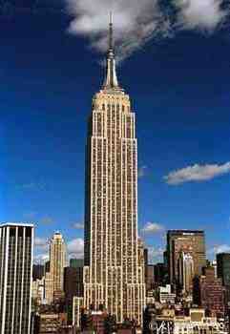 | B. | 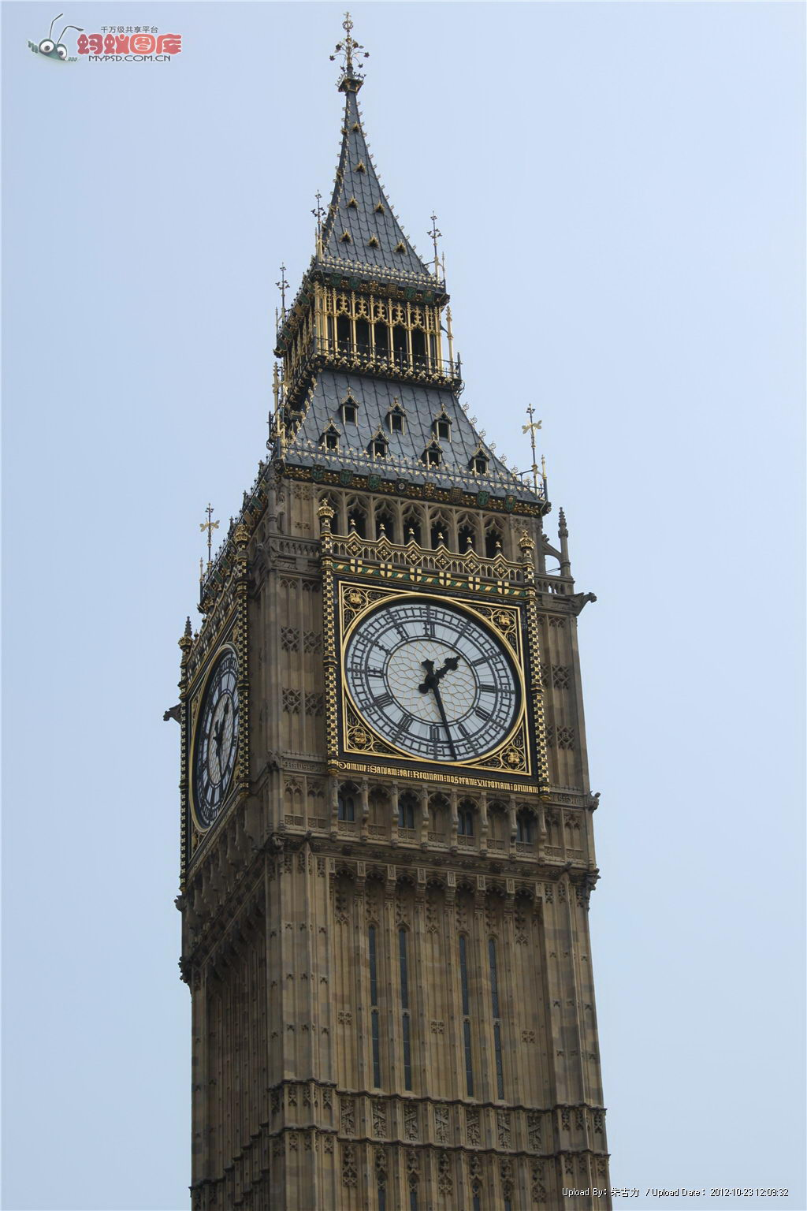 | C. | 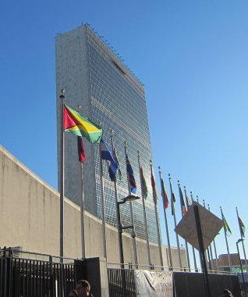
（ ） | 4. | A. | 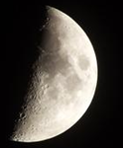 | B. |  | C. | 
（ ） | 5. | A. | 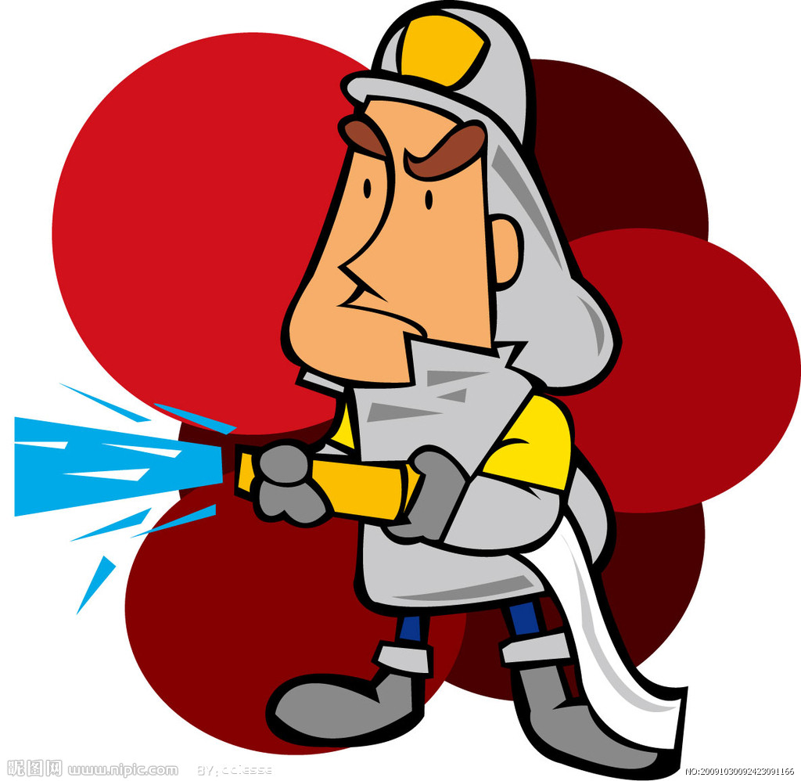 | B. |  | C. | 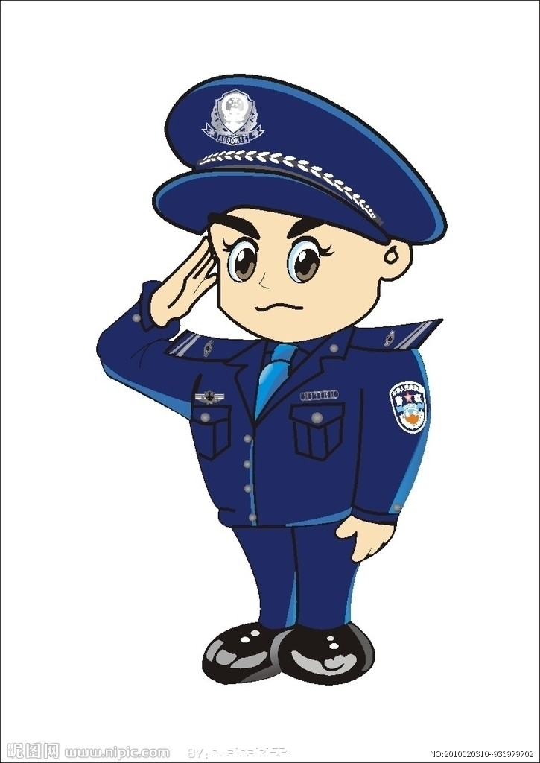
（ ） | 6. | A. | 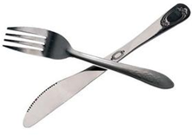 | B. | 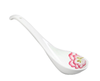 | C. | 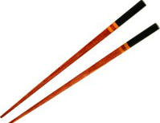
二、请问句，选择相应的答句，将其序号填在左边括号内。（6小题，共12分）
（ ）7.A. In autumn. B. On Sunday.
( ) 8.A. Yes, she does. B. No, she didn’t.
( ) 9.A. I’m going to Beijing. B. I’m from Beijing.
( )10.A. On the bike. B. By bike.
( )11.A. She’s reading. B. Because she is ill.
( )12.A. Yes, I do. B. No, I am not.
二、听简短对话，选择最佳答案，将其序号填在左边的括号内。（6小题，共6分）
 | （ ）13. | Peter is from_____ .
 | （ ）13. | A. | the US. | B. | the UK.
 | （ ）14. | Sam has got many Chinese_____ .
 | （ ）14. | A. | maps | B. | stamps
 | （ ）15. | James went to ________ yesterday.
 | （ ）15. | A. | Ming Tombs | B. | Chinatown
 | （ ）16. | Our city is _______ years old.
 | （ ）16. | A. | 200 | B. | 1200
 | （ ）17. | Lingling can speak _____ .
 | （ ）17. | A. | Chinese | B. | Chinese and English
 | （ ）18. | They are going to eat at_____.
 | （ ）18. | A. | half past eleven | B. | eleven o’clock

三、听对话，判断对话发生的情景，将图画的序号填在左边的括号内。（6小题，共6分）
（ ）19.  （ ）20.  （ ）21.  （ ）22.  （ ）23.  （ ）24. | A. | 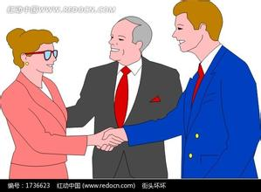 | B. |  | C. | 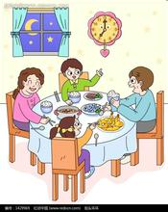
（ ）19.  （ ）20.  （ ）21.  （ ）22.  （ ）23.  （ ）24. | D. | 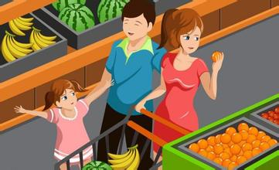 | E. | 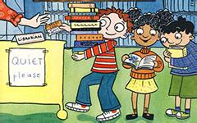 | F. | 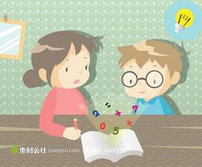
四、听谜语，选择正确谜底的图画，将其序号填在左边的括号内。（6小题，共6分）
（ ） | 25. | A. | 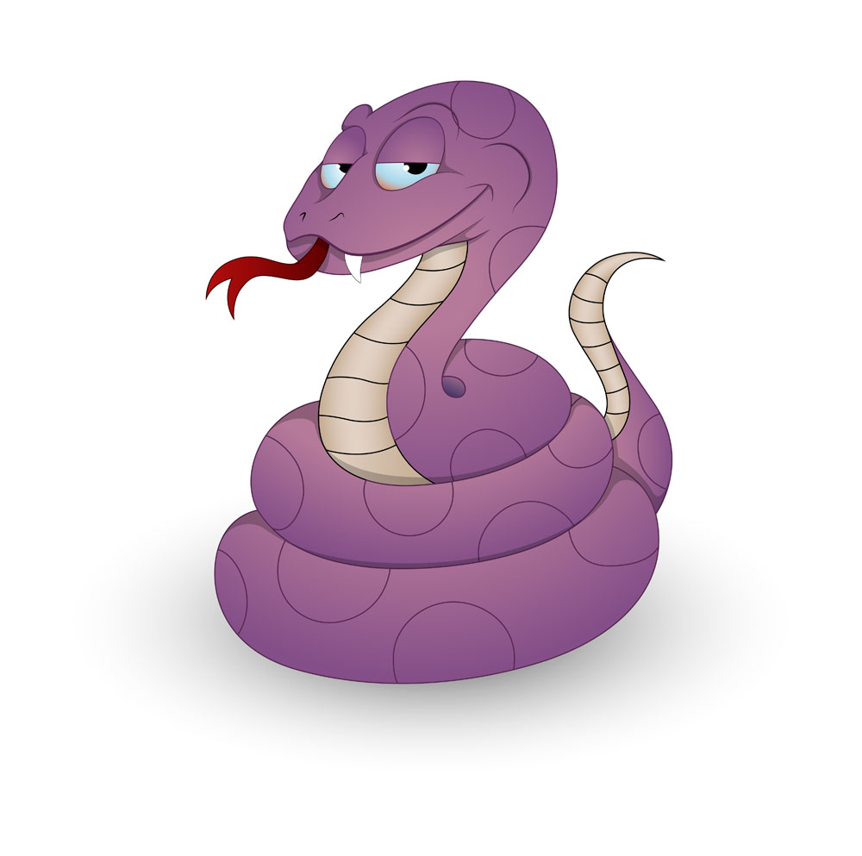 | B. | 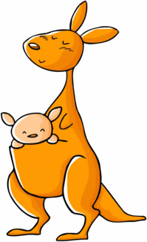 | C. | 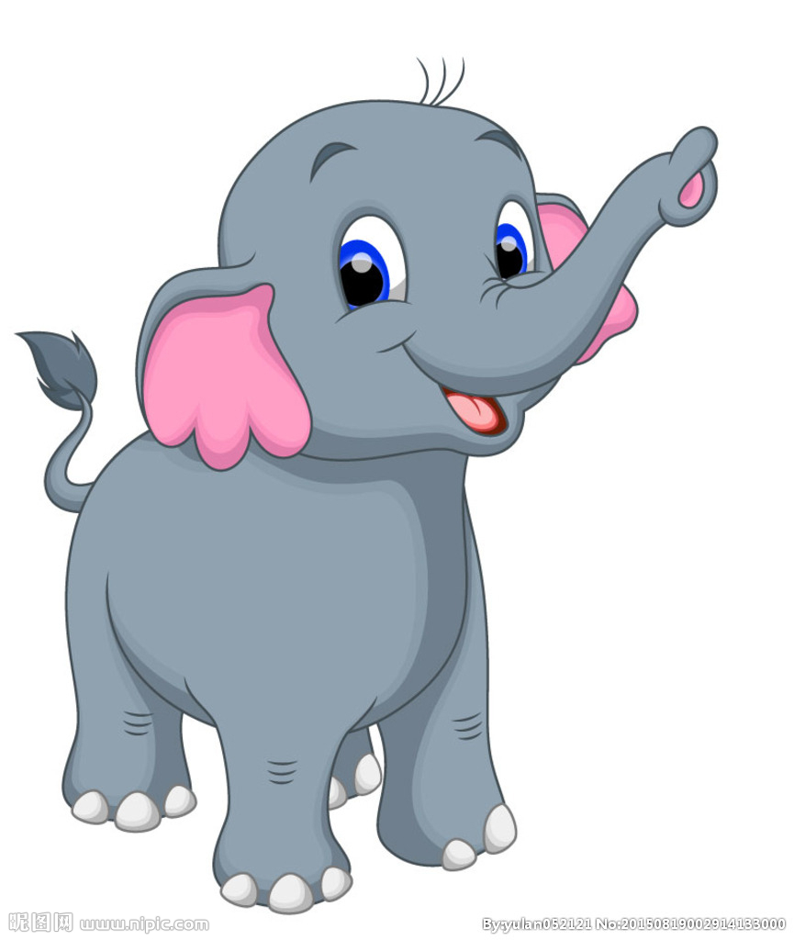
（ ） | 26. | A. |  | B. |  | C. | 
（ ） | 27. | A. |  | B. | 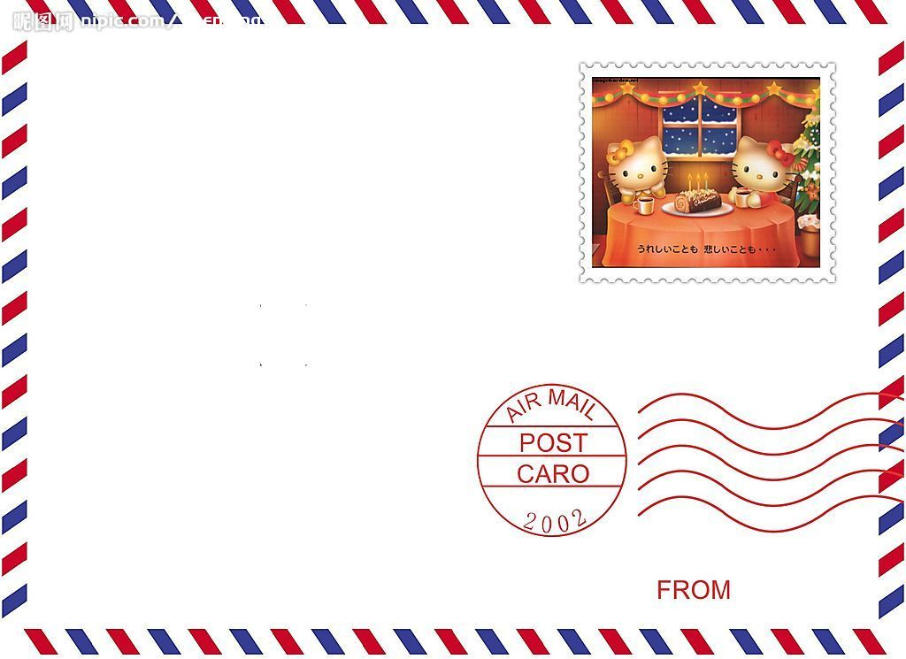 | C. | 
（ ） | 28. | A. | 国庆节 | B. | 母亲节 | C. | 万圣节
（ ） | 29 | A. |  | B. | 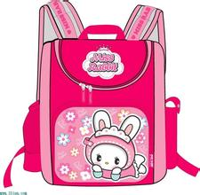 | C. | 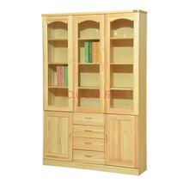
（ ） | 30. | A. | 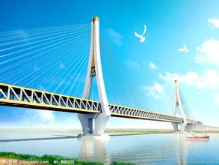 | B. | 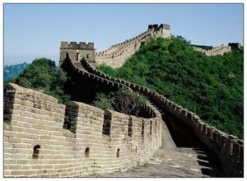 | C. | 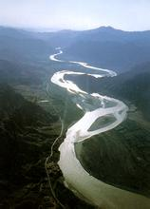
六、听一则短文，为问题选择正确的答案，将其序号填在左边的括号内。（5小题，共5分）
（ ） | 31. | The weather is __________ .
（ ） | 31. | A. |  | sunny |  |  | B. |  | raining
（ ） | 32. | Zara was ______.
（ ） | 32. | A. |  | sad | B. |  |  | happy
（ ） | 33. | Zara helped her mum_____ .
（ ） | 33. | A. |  | make a cake |  | B. |  | make sandwiches
（ ） | 34. | Zara was thirsty. She_______.
（ ） | 34. | A. |  | drank some milk |  | B. |  | drank some water
（ ） | 35. | The rain stopped. Zara _________at last.
（ ） | 35. | A. | watched TV |  |  | B. |  | went out to play

第二部分 读写试题（共六大题，满分53分）
一、看图，从所给的A、B、C三个句子中，找出符合图画意思的一项，将其序号填入左边的括号内。（5小题，共10分）
（ ） | 36. | 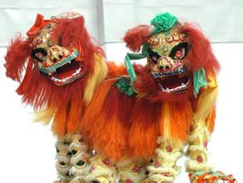 | A. | There is a dragon dance.
（ ） | 36. |  | B. | There is a lion dance.
（ ） | 36. |  | C. | There is a dragon boat race.
（ ） | 37. | 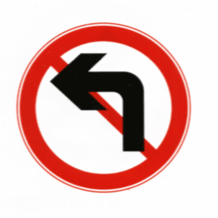 | A. | Turn left.
（ ） | 37. |  | B. | Don’t turn right.
（ ） | 37. |  | C. | Don’t turn left.
（ ） | 38. | 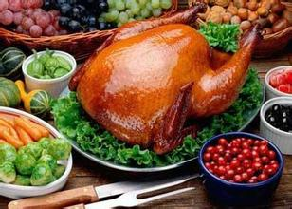 | A. | Thanksgiving is important in the US.
（ ） | 38. |  | B. | Christmas Day is in November..
（ ） | 38. |  | C. | Thanksgiving is important in China.
（ ） | 39. |  | A. | We can make snowman in winter.
（ ） | 39. |  | B. | We can go swimming in summer.
（ ） | 39. |  | C. | We can collect leaves in autumn.
（ ） | 40. | 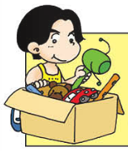 | A. | You should tidy your room.
（ ） | 40. |  | B. | You should tidy your toys.
（ ） | 40. |  | C. | You should tidy your bed.
二、（阅读所给的材料，选择正确答案，将其序号写在左边的括号内。）（8小题，共8分）
Tom: How long is the river?
Dick : It’s more than two thousand metres.

( ) 41. The river is more than . long
A. 2,000 km. B. 2,000 m. C. 20,000 li.
---------------------------------------------------------------------------------------------------------
Tina : Excuse me. How do I get to the zoo?
Lili: Go to the Short Road. Turn left at Red Street. The zoo is on your right. It’s next to the toy shop.

( ) 42. The zoo is on .
A. Short Road B. Red Street C. Green Street
Candy: What do you often do at the weekend?
Tom : I often play football. But this weekend,I won’t play it.
Because I will have a birthday party this weekend.

( )43. Tom will_________ this weekend.
A. play football B. have a birthday party C. I don’t know.
Jack : Hi, Mike. Where did you go last Saturday?
Mike : I went to the museum.
Jack : What did you see there?
Mike: I saw lots of stone animals.

( ) 44. Mike went to .
A.Stonehenge B. Ming Tombs C.the museum
Daming: What’s the matter with you?
Lingling: I am very hungry. I want to eat something.

( ) 45. Maybe Lingling wants to eat_________.
- hamburgers B. water C. drinks

Sam: Nick, I’m going to go to supermarket. Will you?
Nick: Yes. Let’s go together.

( ) 46. _______will go to the supermarket.
A. Nick B. Sam C.Sam&Nick
Potter: What’s you hobby?
Lisa : I like singing. How about you? Do you like singing, too?
Potter: No, I don’t. I like collecting stamps.

( ) 47. likes singing songs.
A. Potter B. Lisa C.Potter and Lisa。
---------------------------------------------------------------------------------------------------------
Lili: Mum. It’s 11 o’clock. Can we have our picnic now?
Mum: No, we will have our picnic at 12 o’clock.

( ) 48. Lili will have the picnic at .
A. eleven o’clock B. twelve o’clock C. ten o’clock
三、请为下面的图片配上适当的说明，将句子的序号填写在（ ）内。（6小题，共12分）
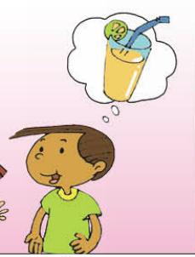  49.( ) | 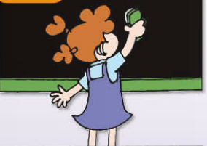  50.( ) | 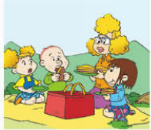  51. ( ) |   52. ( ) | 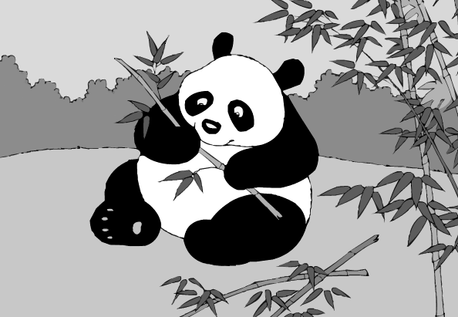  53. ( ) | 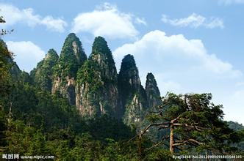  54 ( )
（A）Lili sometimes clean the blackboard for teachers at school.
（B）This Sunday, they will have a picnic at the park.
（C）My favourite animals are pandas, they love bamboo.
（D）He was thirsty. He wanted to drink some juice.
（E）It’s a picture of Hainan Island. We can see theFive-Finger Mountain in it.
（F）Kunming is a beautiful place. It’s got a beautiful lake.

四、阅读短文，选择正确答案，将其序号写在括号内。（5小题，共10分）
  1. These grapes are big and sweet. |  |  |  | 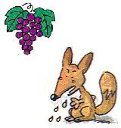  Oh! What nice grapes!  I really like them!  2. A fox is looking at the grapes. |  |  | 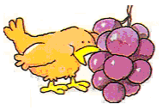  These grapes are so sweet!  I like them! Yummy!  3. A bird comes and eats the grapes.
4. The fox and the bird are arguing（争吵）. 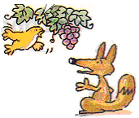  Don’t eat them!  Those are my grapes!  They’re not yours!  They’re mine! |  |  |  | 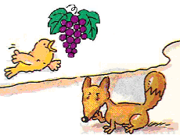  Oh, no! You bad bird!  5. The fox is angry. |  |  | 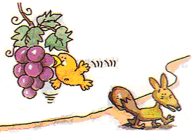  These grapes are not sweet!  I don’t like them!  6. The fox leaves.
（ ） | 55 | Are the grapes sweet?
（ ） | 55 | A. | Yes, they are. |  | B. | No, they aren’t.
（ ） | 56 | Does the bird like the grapes?
（ ） | 56 | A. | Yes, he does. |  | B. | No, he doesn’t.
（ ） | 57. | Does the fox like the grapes?
（ ） | 57. | A. | Yes, he does. |  | B. | No, he doesn’t.
（ ） | 58 | Does the fox eat the grapes?
（ ） | 58 | A. | Yes, he does. |  | B. | No, he doesn’t.
（ ） | 59 | Is the fox happy?
（ ） | 59 | A. | Yes, he is. |  | B. | No, he isn’t.
五、阅读理解（8小题，共8分）
1.阅读表格，把正确答案的序号写在（ ）里。（3小题，共3分）
Mr Li’s Clothes Shop
Clothes | Colour | Price
T-shirt | white, blue | ￥45
hat | yellow, red | ￥38
shorts | black, blue | ￥50
shoes | white, black | ￥60
( ) 60.You like blue and you only have 45 yuan. You can buy _______.
A. shoes B. shorts C. a T-shirt
( ) 61. A hat is 38 yuan. How much are two yellow hats? ____________.
A. ￥38 B. ￥76 C. $ 76
( ) 62. You can buy _______________ in this shop.
A. a white hat B. white shorts C. white shoes

2.阅读短文，判断正误。正确的写“T”，错误的写“F”。（5小题，共5分）

Mary comes from the United States. She is in Beijing with her parents now. Mary doesn’t know Chinese, but she is learning Chinese. She often speaks Chinese to her Chinese friends, but sometimes they don’t understand(明白).

One day, Mary is going to the zoo, she wants to see elephants and monkeys. She asks a Chinese boy how to get there, but the boy can’t understand her. Then Mary draws an elephant on a piece of paper, and shows the picture to the boy. The boy understands her, and shows Mary the way to the zoo.

( ) 63. Mary lives in the United States now.

( ) 64. Mary can speak Chinese very well.

( ) 65. One day, Mary wants to see elephants and monkeys.

( ) 66. Mary can draw an elephant.

( ) 67. Finally(最后), the Chinese boy understands Mary.
六、模仿例子，另选一个人做介绍，并写下来。写一句得一分，满分5分。
Name | Come from | Can speak | Hobby | Want
Lily | the US | English and Chinese | collecting stamps | a Chinese pen friend
Chen Qi | China | Chinese and English | watching films | a pen pal from the UK
Jim | London | English | listening to music | new friend in China
例子：This is Lily. She is from the US. She can speak English and some Chinese. She
likes collecing stamps. And she likes Chinese food. She wants a Chinese pen friend.
________________________________________________________________________________________________________________________________________________________________________________________________________________________________________________________________________________________________________________________________

