2018-2019学年度上学期
小学一年级上英语期末测试卷
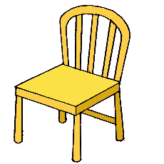
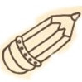
班级： 姓名：

听力部分（50%）
一、Listen and choose听音，选出与你所听到的单词相符的图片。（10%）
( ) 1、A  B
( ) 2、A  B
( ) 3、A 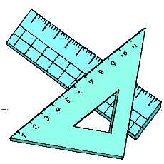 B
( ) 4、A  B 
( ) 5、A 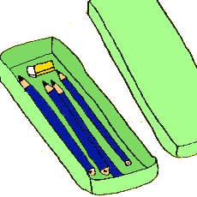 B 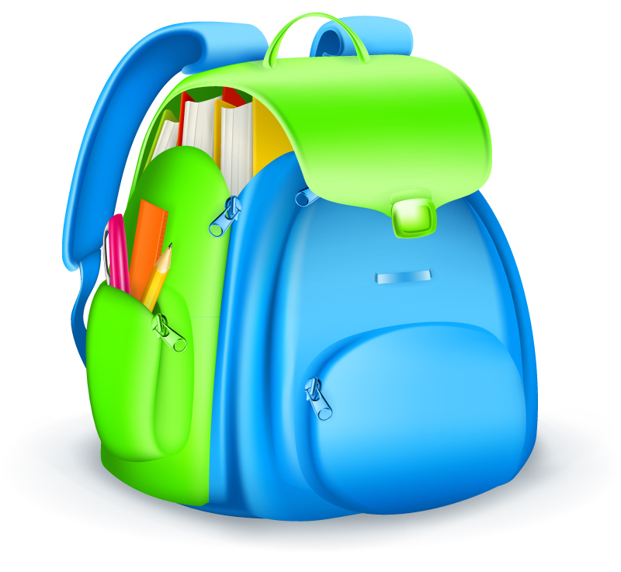

二、 Listen and number仔细听，给下列图片标号。（12%）

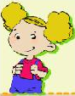 | 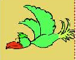 |  | 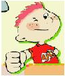 |  | 

( ) ( ) ( ) ( ) ( ) ( )

三、Listen and circle听音圈词。（28%）
1.This is my . (desk, pen )
2.That is a . (dog, cat)
3.This is our . ( classroom, book )
4.This is a . (dog, cat )
5.That is her . ( teacher, sister )
6.Pen pencil. (and, or)
7. It’s pen. (an, a)
8. It’s school bag. (my, I)
9. What’s ? (this, that)
10.It’s eraser. (a, an)
11. How old are ? (you, your)
12. birthday. (Happy, How)
13. A pen you. (for, to)
14. Stand , please? (up, down)

笔试部分：（50%）

- Look and colour 涂颜色（10%）

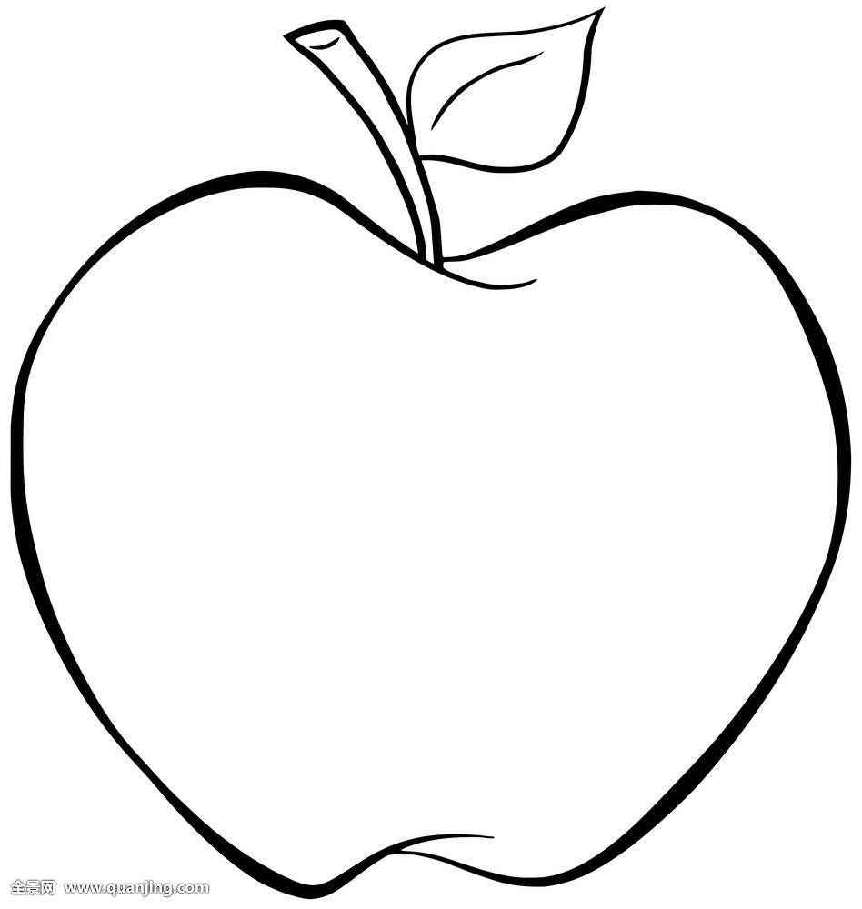 It’s blue. It’s yellow. It’s green. It’s red. It’s orange.

六、Count and match单词连连看。（10%）

six 

five 

seven 

nine 

eight 

七、Read and match读一读，连一连。（10%）

1.teacher 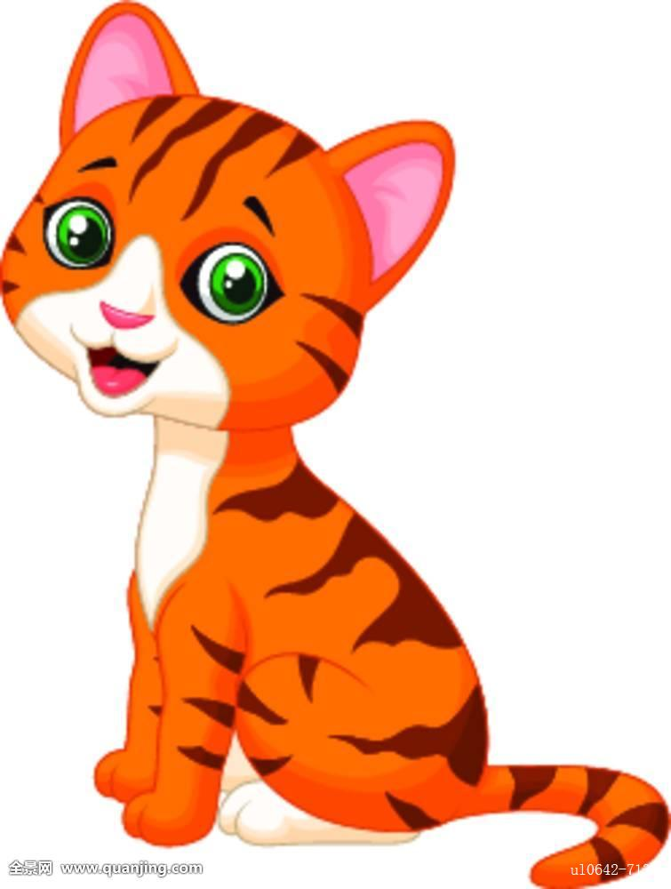
2.desk
3.monkey 
4.cat
5.chair 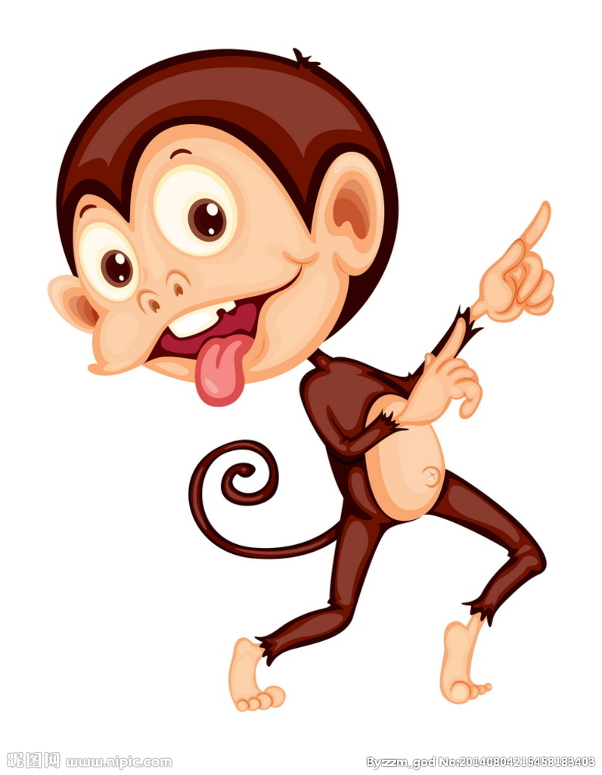
八、读一读，选一选 （20%）
1、Please open the window.
A. 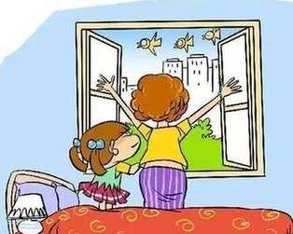 B. 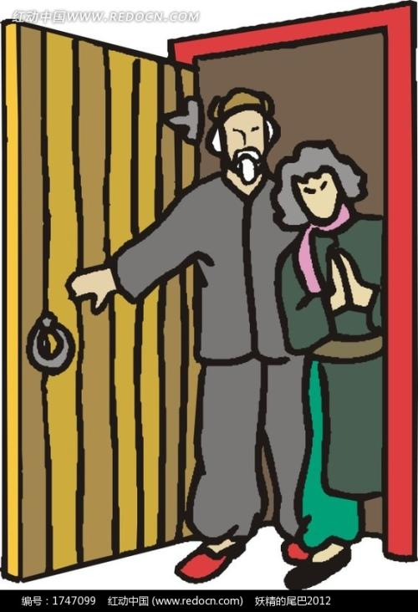

2、Please sit down.
A. 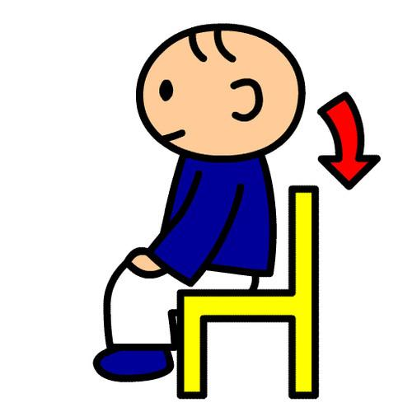 B. 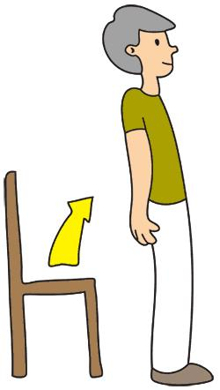

3、Goodbye.
A.  B. 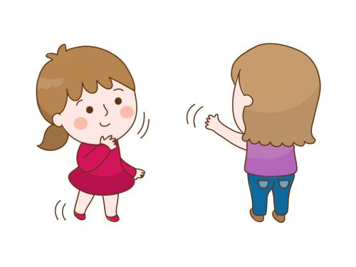

4、Stand up, please.
A. 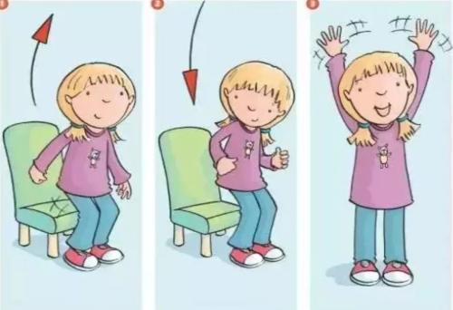 B. 
A.
5. That is a panda.

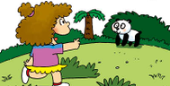

A.. B.

6. Is it a cat? Yes, it is.
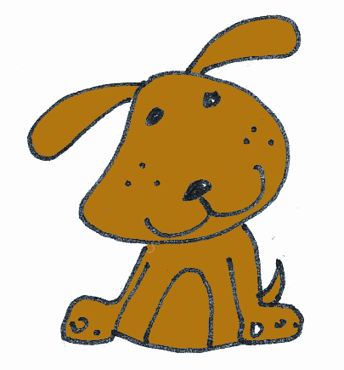
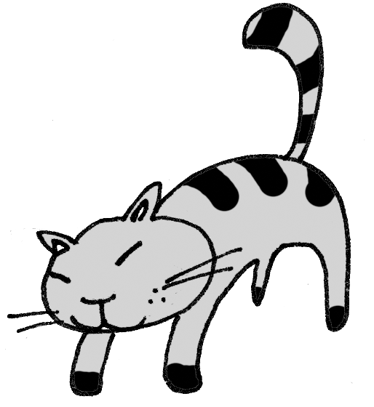

A .
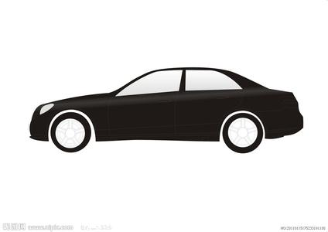
7. It’s a black car.
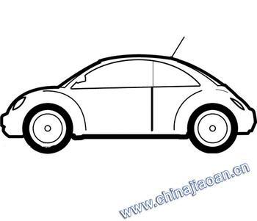
- B.

8. This is a kite.
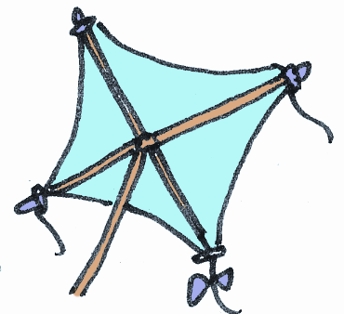
- BA.

9.This is my father.


- B.

10. It’s a house.

-  B. 