棠外附小六年级英语周末作业第三周
班级：________姓名：__________
- 听力部分
A photo of a family
- What is the mother's name?( )
A. Hanlei B. WangYing C. Han Ming DHanXiao
2. How old is the father?
A.38 B. 40. C.42. D.45
3 What does the mother do?( )
- a doctor B. a nurse C. a teacher D. a worker
4 Which school do their children study in? ( )
- No. 1 Primary school B. No.3 Primary Schoo I
C. No.6 Primary School D. No.6 middle school
- Are their children both good students?( )
A. Yes, they are. B. No, they aren’t.
Wei Fang
- Where does she live?
________________________________________
- What does she do at 7 o’clock?( )
A.She get up. B. She goes to school. C She eats her breakfast.
- How many classes does she have in the moming?
________________________________________
4. What's her hobby?( )
A. She likes singing popular songs.
B. She likes reading her English books.
C. She likes watching TV.
5.What is she doing now?( )
A.She is singing. B. She is reading. C. She is watching TV.

Members of my family
1.Who are in my family?(多选)( )
A father B. mother C. grandma D. grandpa E. aunt F uncle G. brother F sister
- What does my mother do?( )
A. a salesperson B.a teacher C. a cleaner D an engineer
3. Where does my father work? ( )
A. on a street B. in a book store C. in a company
4. What does my aunt do? ( )
A. a salesperson B.a teacher C. an engineer D. a cleaner
5. Where does my sister work?( )
A. at school B. in a company C. in a bank

Mr. White

- What is Mr. White’s job?
_____________________________________
- How does he go to Work? ( )
A.by car B. by bus C. by bike
3. How many classes does he teach every day?
A. two lessons. B. three lessons C.four lessons
4. What does he usually do after school?
A. He talks with his friend. B. He plays ball games with his friend.
C. He talks and plays ball games with his friend. D. He studies Chinese.
5.What does he want to be?
A. He wants to be a Chinese teacher.
B. He wants to be an English teachet.
C. He wants to be a ball player.

二、阅读部分 A
The Country Mouse and the City Mouse
One day, the City Mouse goes to the countryside by bus to see his cousin, the Country Mouse. He sees cows and horses in the fields. Hesees ponds and fences. The bus stops at a farm. the country mouse is waiting. "Hello, Cousin! I'm happy to see you, "says the Country Mouse. But soon the City Mouse is not happy. "I'm hungry, but you only have corn and potatoes! And it's cold in the barn, " he says. " Let's go to the city. You can live in my apartment. There's lots of yummy food and it's warm. "TheCountry Mouse touches his cold nose. Yes, lets go! "he says
The two mice take the morning bus to the city. They see a restaurant, a skating rink and a museum. The City Mouse says, ‘Here's our stop!’ They get off the bus in the evening and go into theapartment. There is milk, cheese, sausages and cake on a big table. The City Mouse and the Country Mouse are happy. But before they can eat anything, a big cat comes in. They run away. The cat wants to eat them! They have to hide behind the refrigerator. The Country Mouse says, " Now I'm hungry and a cat wants to eat me! I'm goingback to the country, because I am scared!
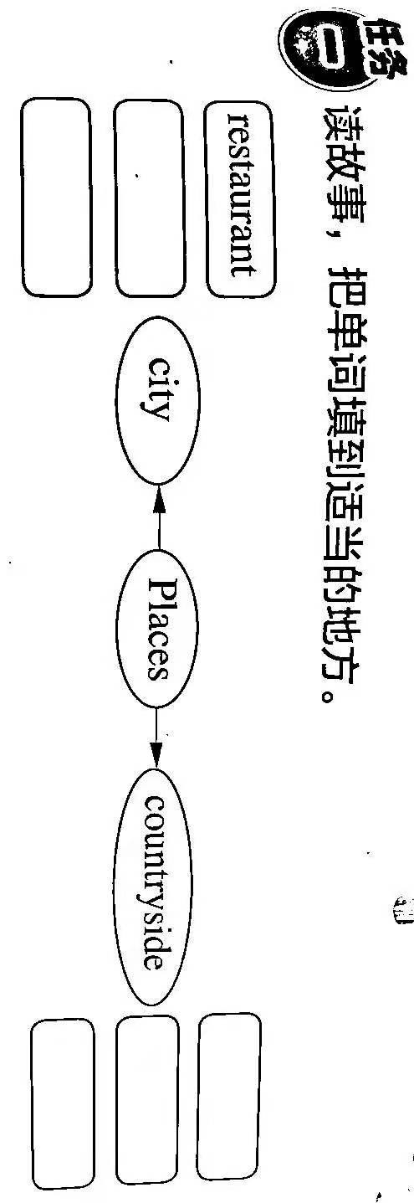
任务二、读短文,判断下列句子的正误。正确的用“√”表示,错误的用“×”表示。
( ) 1. The Country Mouse goes to the city to visit his cousin.
( )2. The City Mouse is not happy, because he is very hungry.
( )3. The City Mouse and the Country Mouse go to the city by train.
( )4. The Country Mouse feels scared in the city.
( )5. Both the City Mouse and the Country Mouse like eating.
B
Pyramids in Mexico
The people of Mexico also built pyramids.They didn’t build them for tombs. The pyramids of Mexico are not as high as those of Egypt, but they are big. Inside the pyramids there is nothing, only dirt and stones. The biggest pyramid in Mexico is almost 2, 000 years old. On the top of it they built a temple to the sun. The temple is no longer there but the people call it the Pyramid of the Sun. Near it is another huge pyramid, the Pyramid of the Moon.
How were the people of Mexico able to build the pyramids thousands of years ago? How did they carry and built huge stones? Each stone fitted so well, but they didn’t have our modern machines! Many people have studied the pyramids of Egypt and of Mexico, but nobody can tell how people built them.
根据短文内容,选择正确答案。
( )1. The pyramids of Mexico are________the pyramids of Egypt.
A bigger than B as high as C lower than D.as low as
( )2. What was once on top of the Pyramid of the Sun?
A. A temple B. Bodies of mexico kings C. A tomb D. Nothing
( )3.________know the people of mexico built their pyramids.
- Everybody knows B. Many scientists can tell C. Everyone of us can tell D. Nobody knows

三、写作部分
以下话题二选一，先在方框内粘贴或画出你的学校或社区，再用至少5句话来描述。
- My School 2. My Hometown

