棠外附小2018-2019上学年度小学英语六年级阶段性测试题

Part 1 Listening （40分）

Ⅰ.Listen and choose.(选出你所听到的单词。) 10分
( ) 1. A. beautiful B.fantastic C.interesting D.lucky
( ) 2. A.China B.America C.Canada D.Australia
( ) 3. A.photo B.phone C.picture D.present
( ) 4. A.English B.Chinese C.Japanese D.French
( ) 5. A.chopsticks B.knife C.fork D.stamp
( ) 6. A.festival B.letter C.postcard D.shop
( ) 7. A.hobby B.hobbies C.favourite D.strong
( ) 8. A.moon cake B.bread C.zongzi D.yuanxiao
( ) 9. A.dragon B.boat C.lantern D.flag
( ) 10.A.hundred B.thousand C.million D.twenty



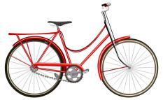
Ⅱ. Listen and number.(给下列图片排序。)10分



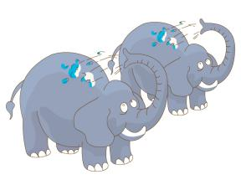
( ) ( ) ( ) ( ) ( )
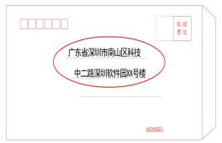
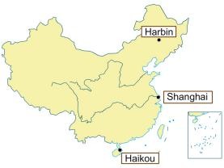
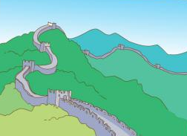

( ) ( ) ( ) ( ) ( )
Ⅲ. Listen and choose the right answer.(听录音选择合适的回答10分)
( ) 1 A. Yes,they are. B. Yes,it is. C.It’s very big.
( ) 2 A. I like it. B. Yes,I have. C.It’s very big.
( ) 3 A. Yes,she is. B. Yes,she has. C. Yes ,she does.
( ) 4 A. Of course. B. Sorry, I don’t know. C. Yes, I do.
( ) 5 A. No, they didn’t. B. Yes, they do. C. Yes, they can.
Ⅳ.listen and finish the story.（听录音将短文补充完整10分）
Simon and Daming are good 1._______. They are Chinese . But they are working in America. Sometimes they miss their 2.________. So they always go to the 3._________. There are lots of Chinese 4._________ and restaurants there. They go shopping there and eat 5. __________food there. You know, Simon and Daming really miss China and they both like Chinese food.

Part 2 Writing （60分）
Ⅰ.Read and choose.(单项选择10分)
( ) 1. He cleaned _________ bedroom last weekend. A. he’s B. his C. he
( ) 2.--_______ did you go there? I went there on foot. A. How B. What C. Where
( ) 3. The movie is very interesting ________ I like it very much. A. and B. but C. /
( ) 4. The Changjiang River is the ___________river in China. A. long B. longer C. longest
( ) 5. She likes _________ to music A. listens B. listening C.listen
( ) 6. I like _________. It’s cold,but I can make a snowman. A. summer B. autumn C. winter
( ) 7. --_______ the girl often ______ to school by bus? A. Does,go B. Do,goes C. Do,go
( ) 8. How many __________ are there on the farm? A. cow B. sheeps C. sheep
( ) 9. Which is ________, an elephant or a shark? A. heavy B.heavyer C. heavier
( ) 10. What would you like __________,sir? A. to drink B. drinking C. drink
Ⅱ.Choose the right answer.(选择正确的回答10分)
( ) 1. How do you usually come to school?
A. He’s fine.
B. No,I haven’t.
C. It’s cloudy.
D. By car.
E. She works in an office.
F

( ) 2. What’s the weather like today?
( ) 3. Where does your sister work?
( ) 4. How is your brother?
( ) 5. Have you got a bicycle?

Ⅲ. Unscramble the words.(连词成句10分)
1.are there of lots there and shops restaurants Chinese

?

2.got have bicycle of you any your photos

?

3.in English can I write emails and stories

.

4.tomorrow can come birthday you to my party

?

5.your pen does friend the in UK live

?
Ⅳ. Reading.(阅读理解20分）
A
Lucy is my friend. She lives in a small house near a park in Canada. I am ten, Lucy is ten , too. Lucy tells me more about Canada. I know Canada is such a big country. So I want to learn English. And I tell Lucy more about China. Lucy likes China and she wants to learn Chinese . We usually write emails to each other on Saturdays and Sundays.
( ) 1 How old is Lucy ?
A Ten B Eleven C Twelve
( ) 2 Does Lucy like China ?
A Yes, she does . B Yes, I do . C No, she doesn’t.
( ) 3 What do they write on Saturdays and Sundays ?
A Letters B Emails C Homework
( ) 4 Is Canada a big country ?
A Yes , they are . B Yes, it is . C No, it isn’t.
( )5 What language does Lucy want to learn?
A.English B. Chinese C.Canadian
B
Yesterday was Sunday. It was a fine day. The sun was shining. The sky was blue. Mike got up at six. He watered the flowers and did some exercise. Then he woke Helen up. An hour later, the went to the Beihai Park by taxi. The park was beautiful. They had lunch on the grass. Then they went boating. Mike rowed well, but Helen rowed faster than him. They rowed for a long time. They went back at 4:30. After they got home,they helped their mother with housework. They had a good time yesterday.
判断正（T）误（F）
( ) 1. Yesterday was a sunny day.
( ) 2. Helen got up earlier than Mike.
( ) 3. Mike and Helen went to the park by taxi.
( ) 4. Mike rowed as fast as Helen.
( ) 5. When they got home,they didn’t help their mother with housework.
Ⅴ. Writing 写作（10分）
以My Friend 为题，写一篇不少于5句话的作文。

