**棠外附小2019-2020上学年二年级阶段性测试**

班级：_______ 姓名：_______

**Part 1 Listening**

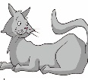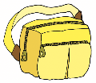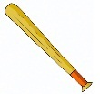一、Listen and circle. 听音，圈出你所听到的单词。（2×6=12）

1. 2.

bat cat bag sad

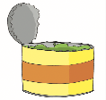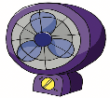

3. 4.

can fan cap dad

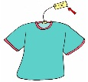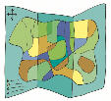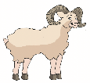

5. 6.

ram mad map tag

二、Listen and choose. 听音，选出你所听到的字母组合。（2×4=8）

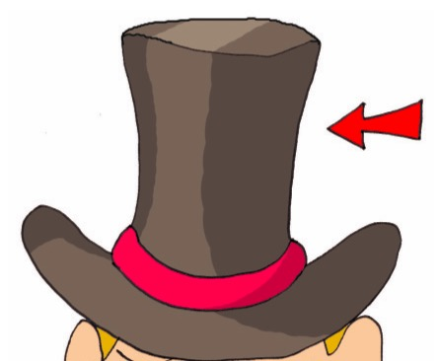

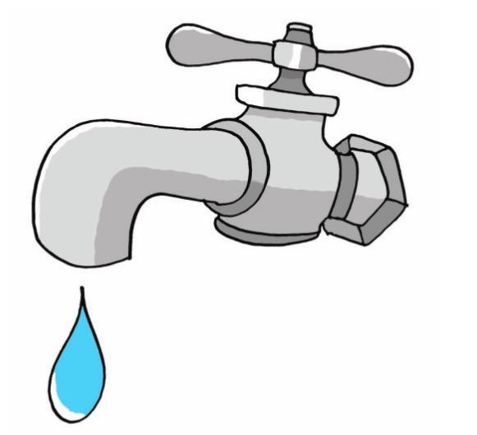

1. ( ) t___ A. ap B. am 2. ( ) h___ A. am B. at



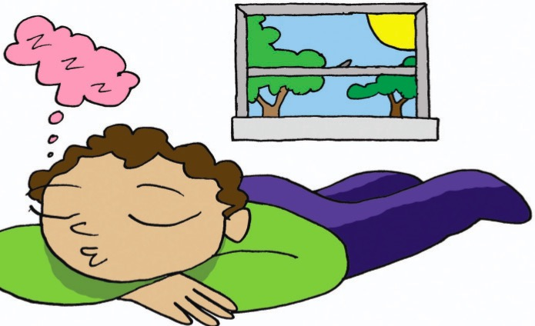

3. ( ) n___ A. an B. ap 4. ( ) j___ A. ad B. am

三、Listen and circle. 听音，圈出你所听到的图片。（2×5=10）

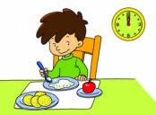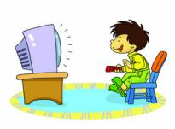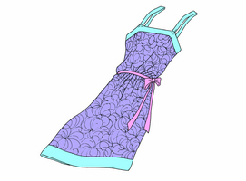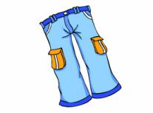

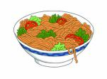

1. 2. 3.

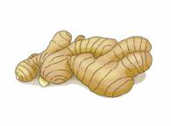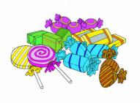

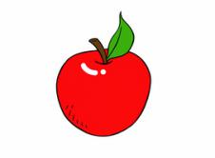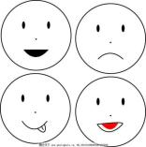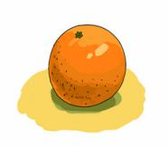

4. 5.

四、Listen and number. 听录音，给下列图片排序。（2×5=10）

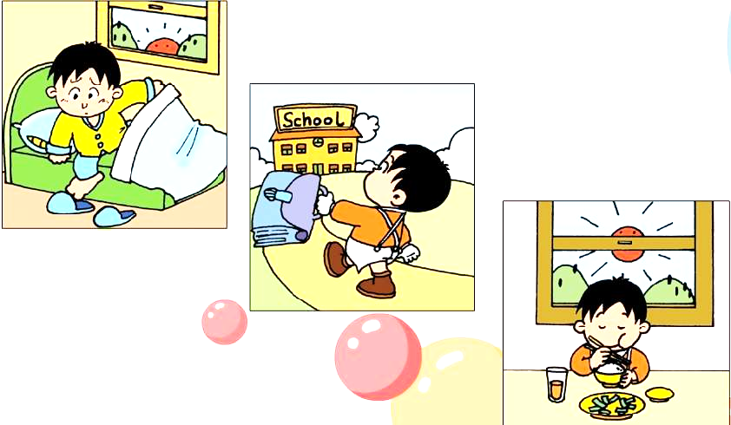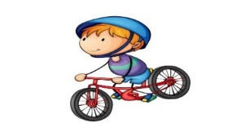[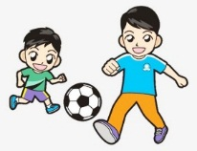](http://image.baidu.com/search/detail?ct=503316480&z=null&tn=baiduimagedetail&ipn=d&word=%E8%B8%A2%E8%B6%B3%E7%90%83%E5%8D%A1%E9%80%9A&step_word=&ie=utf-8&in=&cl=2&lm=-1&st=-1&hd=null&latest=null&copyright=null&cs=1792365983,4271541279&os=1316415169,2388752242&simid=3293864015,3856999706&pn=14&rn=1&di=56760&ln=511&fr=&fmq=1572944207162_R&ic=null&s=undefined&se=&sme=&tab=0&width=null&height=null&face=undefined&is=0,0&istype=2&ist=&jit=&bdtype=0&spn=0&pi=0&gsm=0&objurl=http://bpic.588ku.com/element_origin_min_pic/17/03/09/65a29d654c1a28806ec0cc4223f65ca0.jpg&rpstart=0&rpnum=0&adpicid=0&force=undefined)

( ) ( ) ( ) ( ) ( )

五、Listen and judge .判断图片与听力内容是否相符，相符的打 √，不相符的打 × 。（2×5=10）

[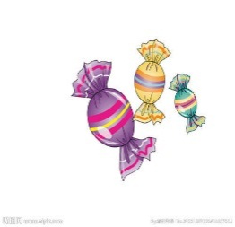](https://image.baidu.com/search/detail?ct=503316480&z=null&tn=baiduimagedetail&ipn=d&word=%E7%B3%96%E6%9E%9C%20%E7%AE%80%E7%AC%94%E7%94%BB&step_word=&ie=utf-8&in=&cl=2&lm=-1&st=-1&hd=null&latest=null&copyright=null&cs=1796092143,3130446148&os=34188568,169757697&simid=4213851330,547320927&pn=18&rn=1&di=100870&ln=455&fr=&fmq=1572943870350_R&ic=null&s=undefined&se=&sme=&tab=0&width=null&height=null&face=undefined&is=0,0&istype=2&ist=&jit=&bdtype=0&spn=0&pi=0&gsm=0&objurl=http://pic36.nipic.com/20131207/4499633_223411027312_2.jpg&rpstart=0&rpnum=0&adpicid=0&force=undefined)[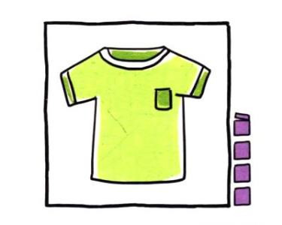](http://image.baidu.com/search/detail?ct=503316480&z=null&tn=baiduimagedetail&ipn=d&word=%E7%9F%AD%E8%A2%96%E7%AE%80%E7%AC%94%E7%94%BB&step_word=&ie=utf-8&in=&cl=2&lm=-1&st=-1&hd=null&latest=null&copyright=null&cs=1789150014,1081409584&os=4032760659,2019840507&simid=3517886434,537573849&pn=11&rn=1&di=14740&ln=492&fr=&fmq=1572944450168_R&ic=null&s=undefined&se=&sme=&tab=0&width=null&height=null&face=undefined&is=0,0&istype=2&ist=&jit=&bdtype=0&spn=0&pi=0&gsm=0&objurl=http://uploads.5068.com/allimg/171120/1-1G120155442-51.jpg&rpstart=0&rpnum=0&adpicid=0&force=undefined)

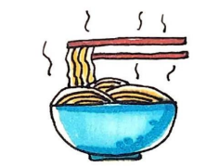[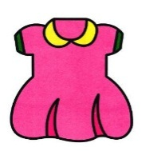](http://image.baidu.com/search/detail?ct=503316480&z=null&tn=baiduimagedetail&ipn=d&word=%E8%BF%9E%E8%A1%A3%E8%A3%99%E7%AE%80%E7%AC%94%E7%94%BB&step_word=&ie=utf-8&in=&cl=2&lm=-1&st=-1&hd=null&latest=null&copyright=null&cs=2100648873,2070637588&os=3065804471,1678282500&simid=3339946661,3848767900&pn=63&rn=1&di=48070&ln=409&fr=&fmq=1572944280784_R&ic=null&s=undefined&se=&sme=&tab=0&width=null&height=null&face=undefined&is=0,0&istype=2&ist=&jit=&bdtype=0&spn=0&pi=0&gsm=0&objurl=http://uploads.5068.com/allimg/1809/196-1P921142001.jpg&rpstart=0&rpnum=0&adpicid=0&force=undefined)

( ) ( ) ( ) ( ) ( )

六、Listen and choose. 听音，选出你所听到的句子。（2×5=10）

1. ( ) A. Noodles for you, Tom. B. Rice for you, Amy.

2. ( ) A. I don’t like onions. B. He doesn’t like ginger.

3. ( ) A. Do you like milk? B. Do they like apples?

4. ( ) A. Amy, here’s a dress for you. B. Tom, here’s a T-shirt for you.

5. ( ) A. I have lunch at 12. B. I watch TV at 7.

**Part 2 Writing**

[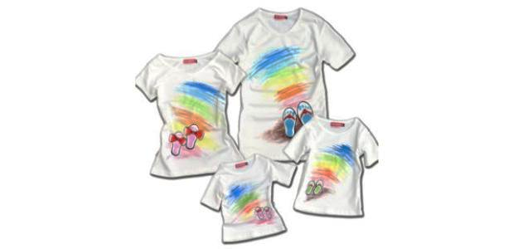](http://image.baidu.com/search/detail?ct=503316480&z=0&tn=baiduimagedetail&ipn=d&word=%E4%BA%94%E4%BB%B6%E7%9F%AD%E8%A2%96%E5%8D%A1%E9%80%9A&step_word=&ie=utf-8&in=&cl=2&lm=-1&st=-1&hd=0&latest=0&copyright=0&cs=3431436688,3604419339&os=1070054771,6978341&simid=0,0&pn=143&rn=1&di=179080&ln=1504&fr=&fmq=1572945835538_R&ic=0&s=undefined&se=&sme=&tab=0&width=&height=&face=undefined&is=0,0&istype=2&ist=&jit=&bdtype=0&spn=0&pi=0&gsm=0&objurl=http://img.mp.sohu.com/upload/20170614/b5d6c5c381c94037b27f81cf04580aaf_th.png&rpstart=0&rpnum=0&adpicid=0&force=undefined)一、Look and choose. 看图选择正确的句子。（2×5=10）

1. ( ) A. Sam likes T-shirts.

B. Amy likes dresses.

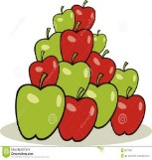

2. ( ) A. I like meat.

B. I like apples.

[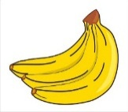](http://image.baidu.com/search/detail?ct=503316480&z=undefined&tn=baiduimagedetail&ipn=d&word=%E9%A6%99%E8%95%89%E5%8D%A1%E9%80%9A%E5%9B%BE%E7%89%87&step_word=&ie=utf-8&in=&cl=2&lm=-1&st=undefined&hd=undefined&latest=undefined&copyright=undefined&cs=3954553194,695219307&os=3462353655,910536917&simid=0,0&pn=6&rn=1&di=6981700&ln=549&fr=&fmq=1572946841189_R&fm=&ic=undefined&s=undefined&se=&sme=&tab=0&width=undefined&height=undefined&face=undefined&is=0,0&istype=0&ist=&jit=&bdtype=0&spn=0&pi=0&gsm=0&objurl=http://pic.90sjimg.com/design/02/03/48/08/5a44f685f3519.png&rpstart=0&rpnum=0&adpicid=0&force=undefined)

3. ( ) A. Do you like bananas?

B. Do you like sweets?

[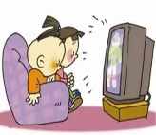](http://image.baidu.com/search/detail?ct=503316480&z=null&tn=baiduimagedetail&ipn=d&word=%E5%B0%8F%E6%9C%8B%E5%8F%8B%E7%9C%8B%E7%94%B5%E8%A7%86%E5%8D%A1%E9%80%9A&step_word=&ie=utf-8&in=&cl=2&lm=-1&st=-1&hd=null&latest=null&copyright=null&cs=3898740318,3213135418&os=2624479785,2373198817&simid=0,0&pn=54&rn=1&di=87450&ln=818&fr=&fmq=1572947102393_R&ic=null&s=undefined&se=&sme=&tab=0&width=null&height=null&face=undefined&is=0,0&istype=2&ist=&jit=&bdtype=0&spn=0&pi=0&gsm=0&objurl=http://www.chnqsedu.com/data/upload/image/20170811/1502419451106855.jpg&rpstart=0&rpnum=0&adpicid=0&force=undefined)4. ( ) A. At 6, I watch TV.

B. At 9, I go to school.

[](http://image.baidu.com/search/detail?ct=503316480&z=undefined&tn=baiduimagedetail&ipn=d&word=%E6%94%BE%E9%A3%8E%E7%AD%9D%E5%8D%A1%E9%80%9A&step_word=&ie=utf-8&in=&cl=2&lm=-1&st=undefined&hd=undefined&latest=undefined&copyright=undefined&cs=3947189405,3026427199&os=1972052982,832358250&simid=4134542875,698825633&pn=26&rn=1&di=42240&ln=373&fr=&fmq=1572947333425_R&fm=&ic=undefined&s=undefined&se=&sme=&tab=0&width=undefined&height=undefined&face=undefined&is=0,0&istype=0&ist=&jit=&bdtype=0&spn=0&pi=0&gsm=0&objurl=http://images.669pic.com/element_pic/33/96/51/20/ad944bacc1590e09ed093f301ec305c8.jpg&rpstart=0&rpnum=0&adpicid=0&force=undefined)

5. ( ) A. Sweets are for good children.

B. Let’s fly my kite.

二、Resd and choose.读句子，选择正确的图片。（2×5=10）

( ) 1. I don’t like ginger.

A. B.

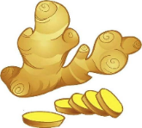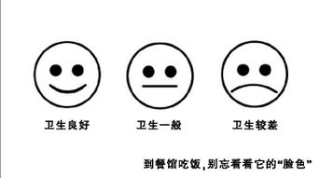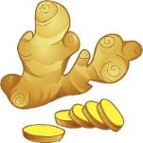

( ) 2. I like swimming.

[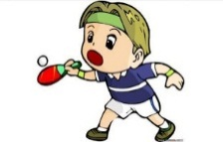](https://image.baidu.com/search/detail?ct=503316480&z=null&tn=baiduimagedetail&ipn=d&word=%E6%89%93%E4%B9%92%E4%B9%93%E7%90%83%E5%8D%A1%E9%80%9A&step_word=&ie=utf-8&in=&cl=2&lm=-1&st=-1&hd=null&latest=null&copyright=null&cs=2130292656,1826745931&os=2553024241,4138005425&simid=4279489681,590134312&pn=7&rn=1&di=990&ln=701&fr=&fmq=1572948498392_R&ic=null&s=undefined&se=&sme=&tab=0&width=null&height=null&face=undefined&is=0,0&istype=2&ist=&jit=&bdtype=0&spn=0&pi=0&gsm=0&objurl=http://www.agri35.com/UploadFiles/img_0_66679169_3264008429_27.jpg&rpstart=0&rpnum=0&adpicid=0&force=undefined)[](https://image.baidu.com/search/detail?ct=503316480&z=null&tn=baiduimagedetail&ipn=d&word=%E6%B8%B8%E6%B3%B3%E5%8D%A1%E9%80%9A&step_word=&ie=utf-8&in=&cl=2&lm=-1&st=-1&hd=null&latest=null&copyright=null&cs=2466013219,4269466624&os=3184978137,689489380&simid=0,0&pn=20&rn=1&di=117260&ln=499&fr=&fmq=1572948198129_R&ic=null&s=undefined&se=&sme=&tab=0&width=null&height=null&face=undefined&is=0,0&istype=2&ist=&jit=&bdtype=0&spn=0&pi=0&gsm=0&objurl=http://www.51yuansu.com/pic2/cover/00/27/81/57fef1ad27ad1_610.jpg&rpstart=0&rpnum=0&adpicid=0&force=undefined) A. B.

( ) 3. Do you like milk?

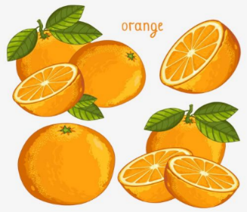[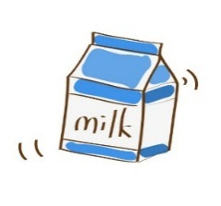](https://image.baidu.com/search/detail?ct=503316480&z=null&tn=baiduimagedetail&ipn=d&word=%E7%89%9B%E5%A5%B6%E5%8D%A1%E9%80%9A&step_word=&ie=utf-8&in=&cl=2&lm=-1&st=-1&hd=null&latest=null&copyright=null&cs=4239174982,1674442070&os=3755440966,1223214307&simid=0,0&pn=7&rn=1&di=2420&ln=673&fr=&fmq=1572948742443_R&ic=null&s=undefined&se=&sme=&tab=0&width=null&height=null&face=undefined&is=0,0&istype=2&ist=&jit=&bdtype=0&spn=0&pi=0&gsm=0&objurl=http://pic.90sjimg.com/design/00/72/74/34/59336b67a3ee2.png&rpstart=0&rpnum=0&adpicid=0&force=undefined) A. B.

( ) 4. At 7, I get up.

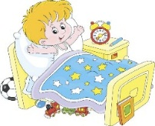 A. B.

( ) 5. He doesn’t like these trousers.

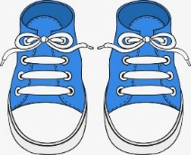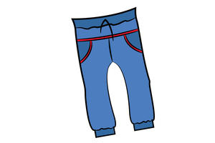A. B.

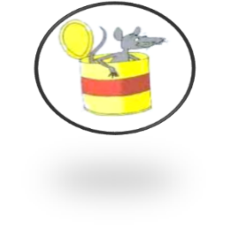三、Read and match. 看图，读句子并连线。（2×5=10）

1. The man is in the van.



2. The rat is in the can.

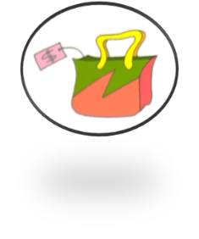

3. Dad is sad.

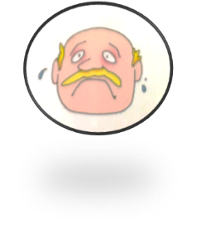

4. The bag has a tag.

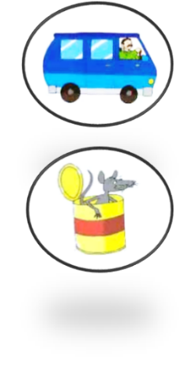

5. The hat is on the cat.

四、Look and classify。请将下列字母分类。（1×10=10）

**a**

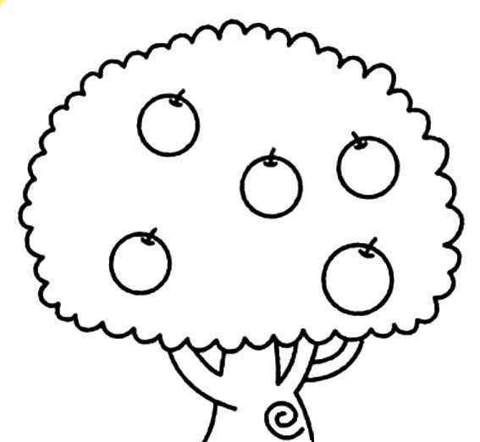

**e**

**b**

**gb**

**qb**

**mb**

**H**

**R**

**D**

**F**

**I**

**A**