棠外附小六年级英语上册 ● 阶段测验（一）
姓名：_________ 班级：__________

听力部分

一、选择你所听到的句子中含有的单词。（10分）
- ( ) A. hundred B. thousand C. million D.billion
2. ( )A.Beijing B. more C.than D.less
3. ( )A. There is B. restaurants C. more than D. many
4. ( )A. There are B. New York C. Beijing D.There’s
5. ( )A. have got B. around C. got D.has got
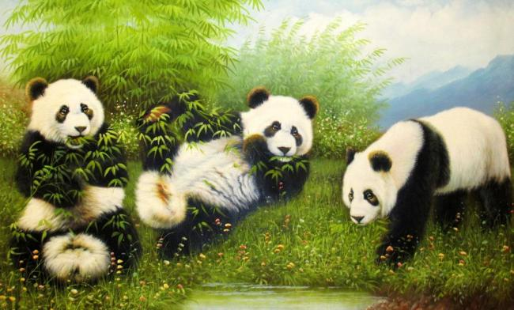
二、根据你所听到的句子，选择相应图片。（10分）
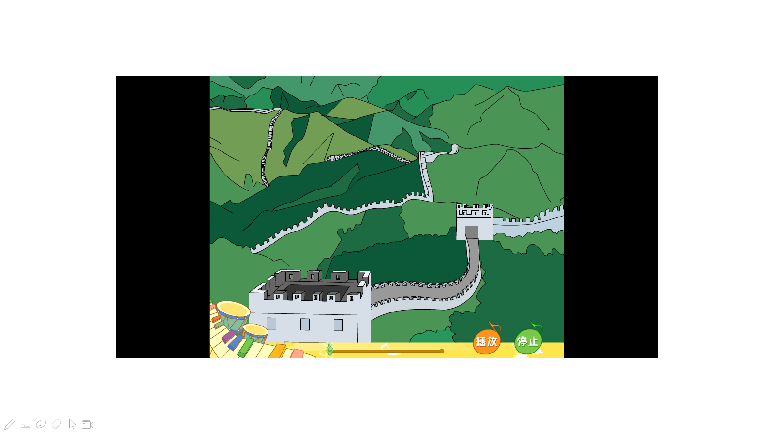
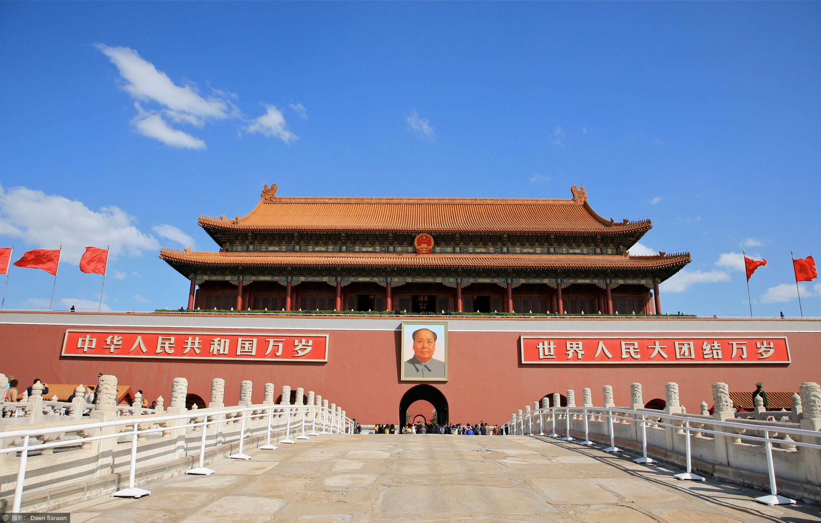
( )1. A. B. C.


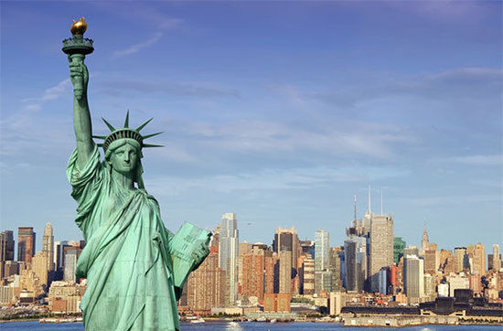
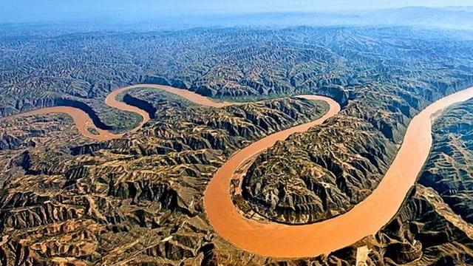

( )2.A. B. C.

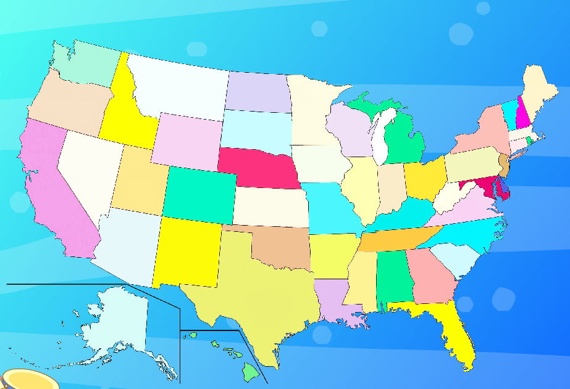
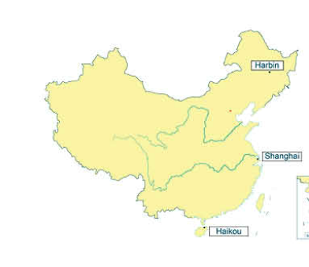
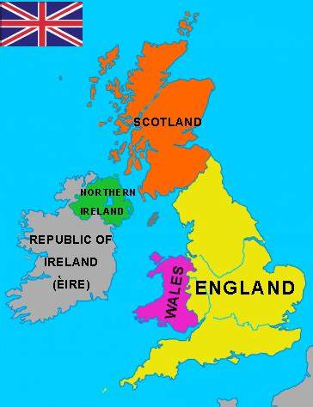

( )3.A. B. C.
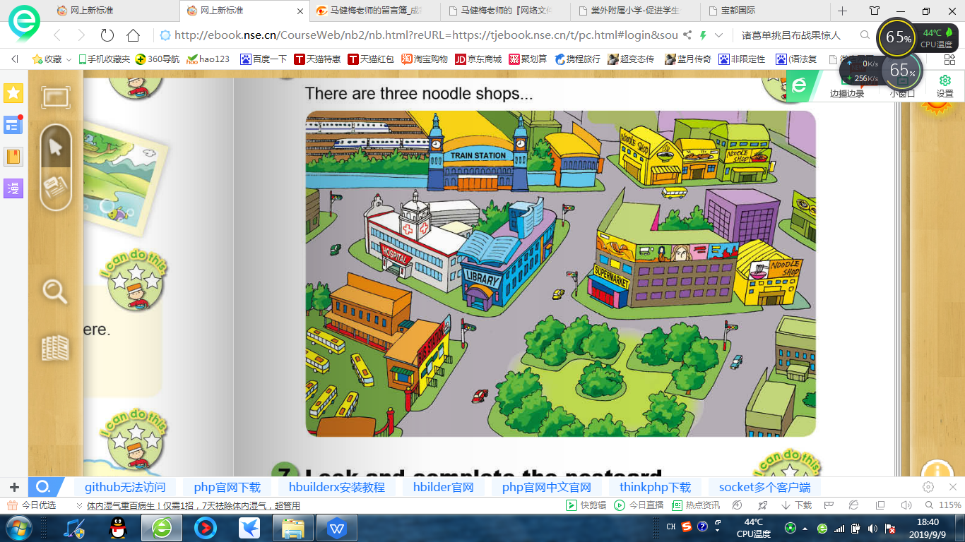

( )4.A. B. C.

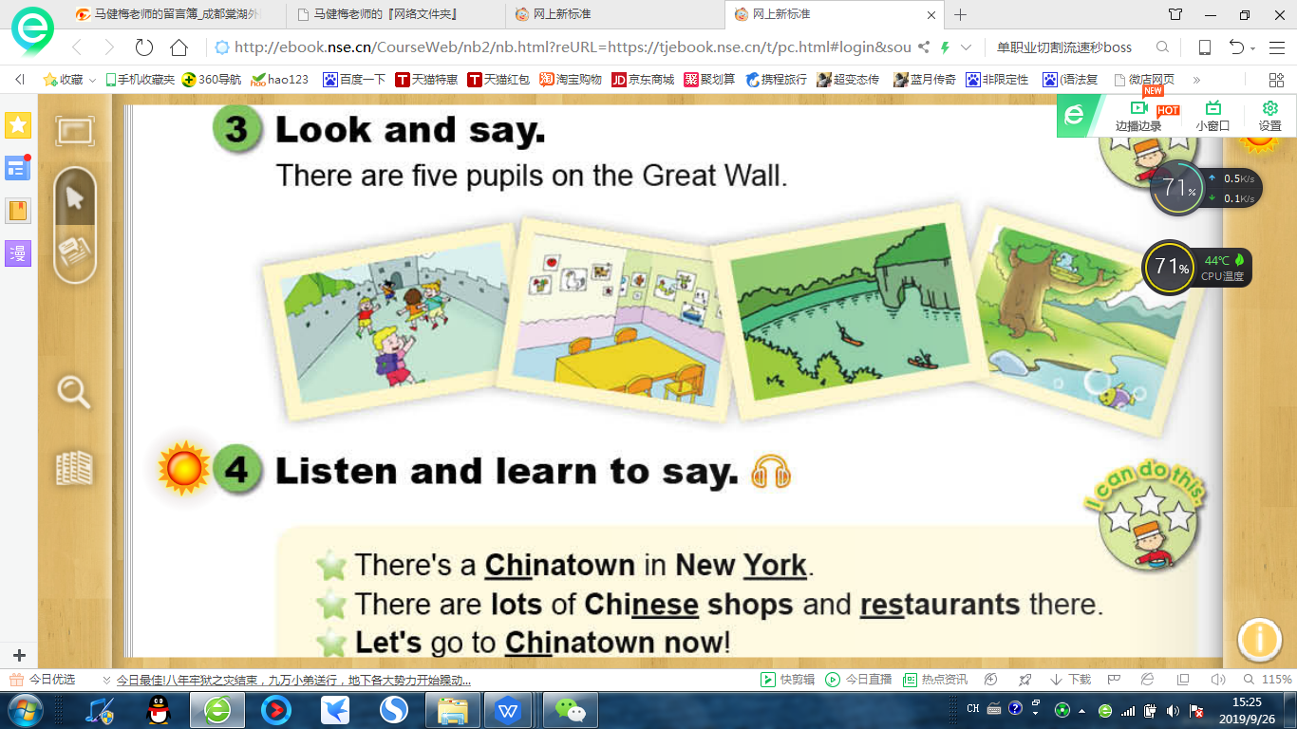

( )5.A. B. C.

三、判断下列句子与所听句子是否一致，正确为T，错误为F。（10分）
( )1. The Great Wall is more thantwenty thousand kilometres long.
( )2. The West Lake is beautiful. It’s in the east of China.
( )3. There are lots of Chinese shops and restaurants there.
( )4. American flags has got fifty stars.
( )5. Chengdu is a modern city. It’s in the southwest of China.
四、根据短文内容，选择正确的答案。（10分）
( )1. What day is it tomorrow?
A. Monday B. Sunday C. Saturday
( )2. We are going to watch a_________match.
- football B. basketball C. volleyball
( )3. It's betweenteam_________ and________ team.
- a Japanese; an American B. a Japanese, a Chinese
C. a Chinese; an English
( )4. The match is going to be at_________o'clock in the afternoon.
A. four B. five C. six
( )5. How are Mr Li and Mr. Wang going to watch the match?
A. By bus B. On foot C. By bike
五、听音，补全短文。（10分）
Look at this beautiful island. There’s a ________ on this island. It’s in the _______. In the ________, there are some mountains. In the ________ there is a ________. There are many trees on the island too. They are in the west. I want to visit this island.

笔试部分
一、单选。（10分）
( )1.The Changjiang river is________ river in China.
A. long B. longer C. longest D. the longest
( )2. The children are playing ________ on the playground.
A. happy B. happyly C. happily
( )3. I am tweleve. You are thirteen, I am one year________than you.
A. younger B. older C. young D. old
( )4. The days get ______ and the nights get______in winter.
A. shorter, longer B. longer, shorter C. short, long
( )5. Tom is_______the USA, now he is _______Shanghai.
A. from, at B. of, in C from, in D. at, in
( )6. We usually stay ______home______Saturday afternoon.
A at,in B at,on C in,at
( )7. The paper is made _________the wood.
A. off B. from C. with D. of
( )8. There _______Chinese dancing in Chinatown.
A. is a B. is C. are D. are many
( )9. There _________rice in the bowl.
A. aren't any B. isn't any C. aren't some D. isn't some
( )10. ________water is there in the glass?
- How much B. How many C. How old D. How long
二、完型填空。（10分）
Hello, I am a 1____ boy. My name is Wu Yifan. Now I' m happy to have a new 2____. Her name is Susan. She is 3____ Canada. She is 12, one year 4____ than me, and 2 cm 5____ than me. She likes going 6____ and 7____ kites. I 8____taking pictures swimming and diving. We are 9____ different countries, but we are good 10____.
( )1. A China B Chinese C music.
( )2.A pen pal B. book C bike
( )3.A for B. of C. from
( )4.A.heavier B. shorter C. older
( )5.Ataller B younger C thinner
( )6.A doing B working C. hiking
( )7. A flying B doing C playing
( )8.A likes B. like C. liking
( )9.A in B. on C. at
( )10.A friend B. friends C classmate
三、阅读。（20分）
The Statue of Liberty
On an island in New York harbor stands a lady. She is holdinga torch high over her head. She is not a real live lady, but a statue. She is called the Statue of Liberty. There are boats to take visitors to and from the island. People climb winding stairs inside the Statue of Liberty and look out over the harbor from the crown on her head. Forty people can stand in her head at one time. It is 151 feet 1 inch from her base to the torch. This statue was a present to the United States from the people of France.
根据短文内容,选择正确答案。
( )1.Visitors can reach the island_______.
A. by train B. by swimming C. by boat D. by climbing
( )2. The torch is______.
A.on the statue's head B. at the top of the stairs
C. in front of the statue D. in the statue's hand
( )3. The stairs of the statue are______.
- inside the statue B. fifteen feet long
C. outside the statue D. over the lady's head
( )4. Inside the lady's head, there is room for______.
A. one person B. forty people
C. two or three people D.one hundred people
( )5. This was a present to the United States from ______.
- China B. Italy C. New York D. France

The Modern Library
I'm Big Big. I want to borrow a book from the modern library of our school. It is my first time to the modern library. When I am in the library, I can't see any assistants but some robots standing in the library. I say to a robot, ‘Hey, give me a book on music. " But the robot doesn’t move. A big boy tells me,"You must say 'Excuse me, please.'first when you want some help from a robot. I do so and the robot brings me the book on music. But I can't get it from the robot's hands. I think for a moment, and then I say a word to the robot. The robot gives me the book. After I get the book, I go back to the classroom happily. Guess! What did I say to the robot? And why do you think so?
根据短文内容,选择正确答案。
( )1. What does Big Big want to do?
A. He wants to go to the park. B. He wants to buy a book.
C. He wants to borrow a book from the library.
( )2. Who works in the library?
A. Teachers B. Robots C. Students
( ) 3. What kind of books does Big Big want?
A. A story book B.An English book C. A music book
( )4. Who told Big Big how to do?
- A big boy B. An assistant C. His teacher
( )5. What did Big Big do after he gets the book?
- He says a word to the robot. B. He goes to the classroom happily.
- He stays at the library.
- 写作。（10分）
你的朋友Simon想来中国做客，请你写一段话向他介绍一下中国。

