棠外附小二年级英语阶段性检测

Class(班级)：_________ Name(姓名)：_________

**Part 1 Listening**

Ⅰ. Listen and tick. (听录音，在你所听到的图片下打“√”。)10%

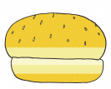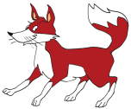

1. ( ) ( ) 2. ( ) ( )

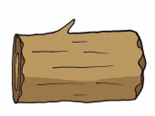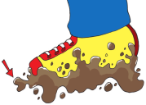

3. ( ) ( ) 4. ( ) ( )



5. ( ) ( )

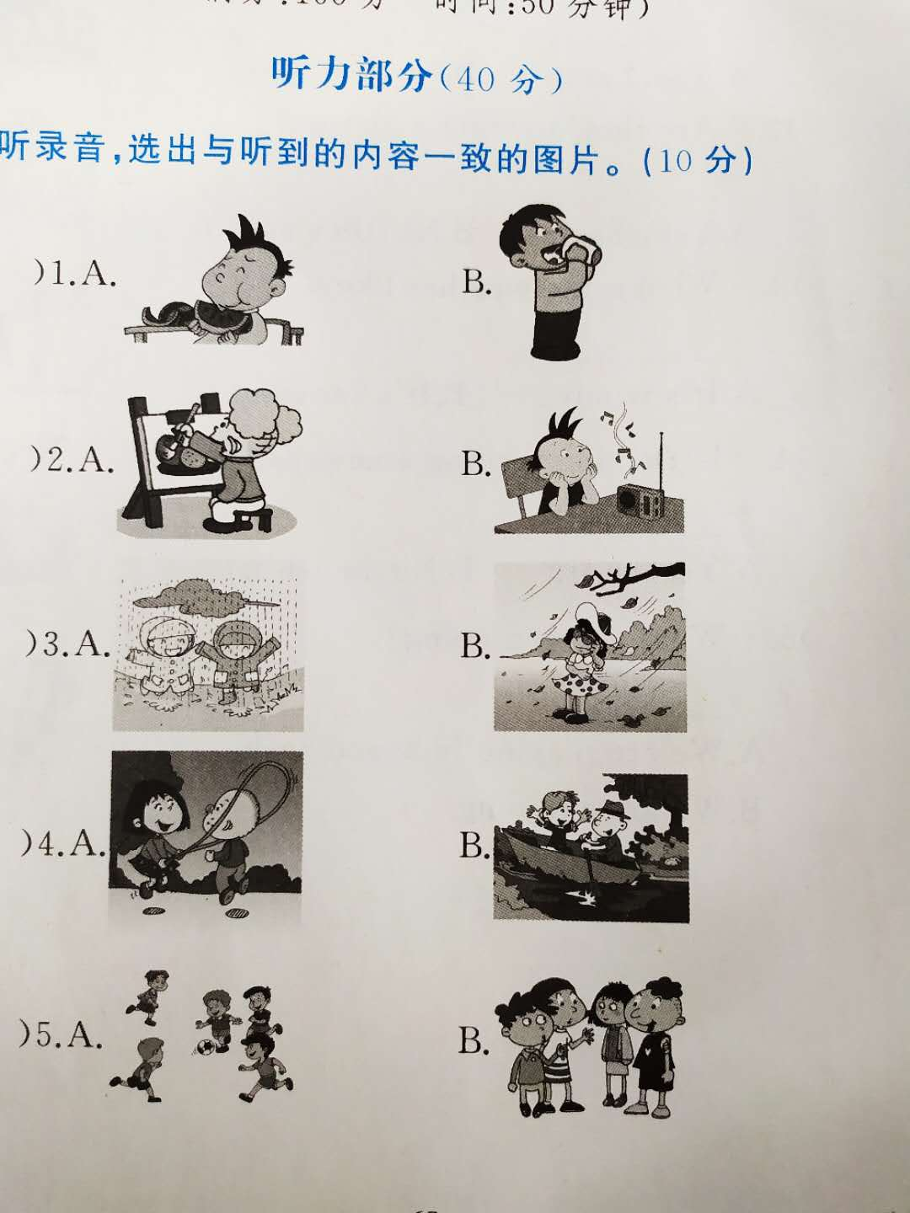Ⅱ. Listen and choose. (听录音，选择正确的图片。) 10%

1. ( ) A. B. 2. ( ) A. B.



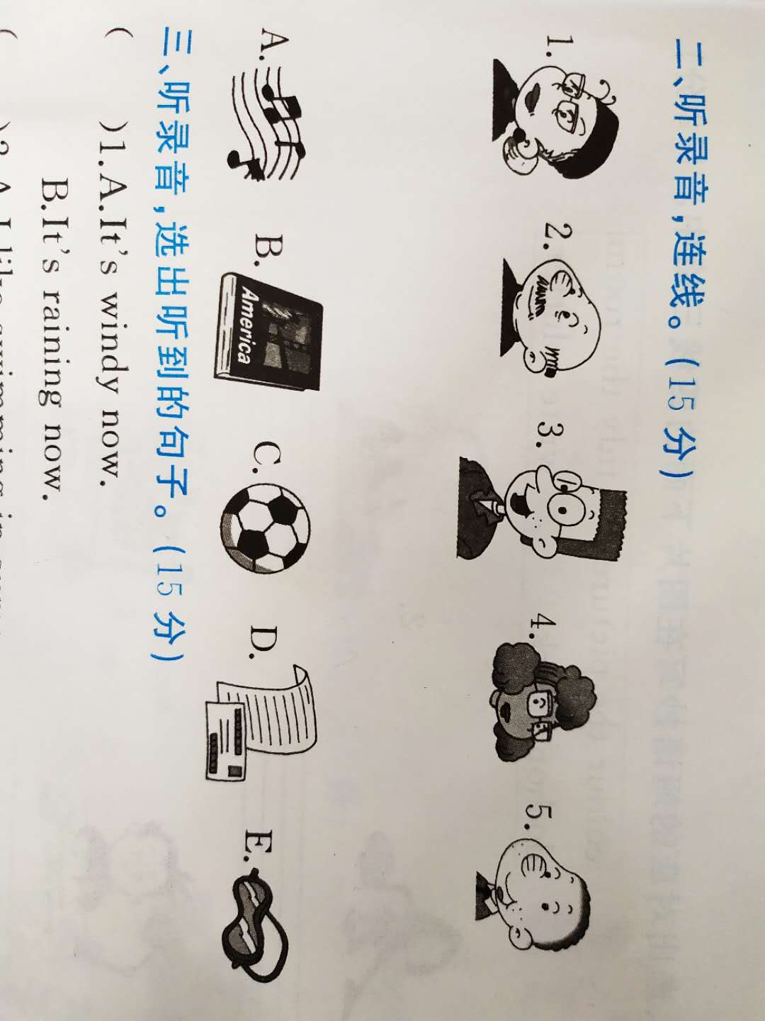

3. ( ) A. B. 4. ( ) A. B.





5. ( ) A. B.

Ⅲ. Listen and match.(听录音，连线。) 10%

Ⅳ. Listen and choose.(听录音，选择你所听到的句子。)10%

( ) 1. A. It’s windy now. B. It’s raining now.

( ) 2. A. I like swimming in summer. B. I like skiing in winter.

( ) 3. A. What are you doing? B. What’s he doing?

( ) 4. A. I’m watching TV. B. I’m not watching TV.

( ) 5. A. Tom is playing with his train. B. Tom isn’t playing with his train.

**Part2 Writing**

Ⅰ. Read and choose. (读一读，选择合适的单词。)10%

( ) 1. 下雨 A. rain B. snow ( ) 2. 有病的 A. ill B. cook

( ) 3. 说话 A. talk B. walk ( ) 4. 伤心的 A. happy B. sad

( ) 5. 画画 A. draw B. write

Ⅱ. Read and choose.(读一读，看图选择对应的短语。)10%

A. do homework B. draw a picture

C. tidy the room D. listen to the radio

E. go swimming

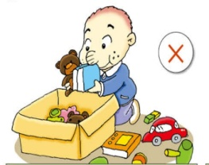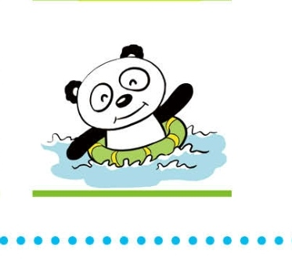

( ) ( ) ( ) ( ) ( )

Ⅲ. Read and choose. (看图选择正确的句子。)10%

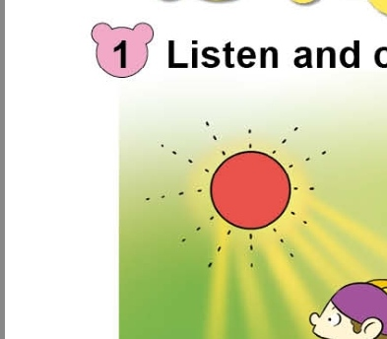( ) 1. A. It’s windy. B. It’s sunny.

 ( ) 2. A. She is playing the drums.

B. She is reading a newspaper.

( ) 3. A. Those girls are playing clapping games.

B. Those girls are playing five-stones.

( ) 4. A. Daming is riding a bike.

B. Daming is flying a kite.

( ) 5. A. Lingling is listening to the radio.

B. Lingling is watching TV.

Ⅳ.Read and choose.(读句子，根据图片选择正确的答语。)10%

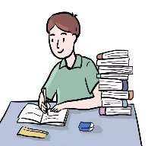( ) 1. –Are you sleeping? --___________

A. Yes, I am. B. No, I’m not.

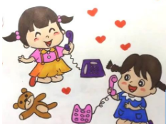( ) 2. –Are they drawing a picture? --__________

A. Yes, they are. B. No, they aren’t.

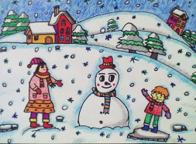( ) 3. –What’s the weather like? --____________

A. It’s windy. B. It’s snowing.

( ) 4. –Is he reading a newspaper? --___________

A. Yes, he is. B. No, he isn’t.

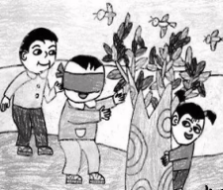( ) 5. –What are you doing? --___________

A. We are playing hide-and-seek.

B. We are skipping.

Ⅴ. Read and choose.(读一读，选择合适的表达。)10%

( ) 1. 当你想问对方正在做什么时，你会说__________________.

A. What are you doing? B. What do you like doing?

( ) 2. 当你想问对方是在吃东西吗，你会说__________________.

A. Are you eating? B. Are you drinking?

( ) 3. 当你告诉对方你通常四点回家，你会说__________________.

A. I usually go home at 4. B. I usually go to school at 4.

( ) 4. 当你想问山姆在哪儿时，你会说__________________.

A. Where is Sam? B. What’s Sam doing?

( ) 5. 当你想让别人动作快一点，你会说__________________.

1. Smile, please. B. Hurry up!

Ⅵ. Read and copy.(读一读，抄一抄。) 10%

1. What are the kids playing?

2. On Sundays, I usually play basketball.