外研社新标准（一年级起）一年级上 Module 6 Unit1教学设计
Name 易丽 Lily Date 2020.12.17
教材及年级名称 |  |  | 外研社版新标准英语（一起）一年级上 | 模块名称 | Module 7 Unit 1  Is it a dog?
Analysis of the Teaching Contents  教学内容分析 |  |  | Unit 1的课文情景是在公园里，Daming 和Sam 看到丛林中有个奇怪的东西，在不断猜测之后，他们感到越来越害怕。此时用“Is it a …?”说出自己的猜测，是因为他们已经看到了这个东西的一部分，有一定的把握，但是不够确定。当我们能大概猜测物品是什么时，用“Is it …?”来询问并确认。
教学过程
Unit 1 教学设计
Teaching Goals of the Unit  课时教学目标 |  | 知识目标：用一般疑问句确认自己的猜测，并做出肯定或否定回答。  - 词汇：new, kite, monkey, monster, help, isn’t  - 句子：Is it a …? Yes, it is. No, it isn’t.  能力目标：  1、全体学生能听懂: Is it a dog? Yes, it is. No, it isn’t。  2、全体学生能初步整体感知：new, kite, monkey, monster, help, isn’t。  3、全体学生能用Is it a …?猜测物品，能用Yes, it is. No, it isn’t。做出肯定或否定回答。
Teaching Difficulty  教学重点与难点 |  | 重点：Is it a …? Yes, it is. No, it isn’t.  难点： “cat, kite”发音， “help” 的使用场景， “Is it a …?”的运用。
Teaching Aids  教学辅助 |  | 图片、实物教具、单词卡片、ppt、音频及动画
Teaching Procedure  教学步骤 |  |  |  |  |  | 二次备课批准
- Greetings.
T: Good morning, boys and girls. How are you today?
- Warm-up:
- Brainstorming
T: What do you see?
- Sing the song “flying a kite” .
- Key word presentation
T: What’s this? /k/ /k/ kite, it’s a …
- Lead-in:
- Set up the context
T: Do you like to fly a kite? Let’s fly a kite with Sam. This is your kite, we’ll see which team can fly the kite higher.
A1,p1: T: Look, what’s this? SS:It’s a kite. T: Yes, Sam has a new kite. Daming is coming. What will Sam say?
- Let’s watch the video. … after the video, T: what does Sam say? What does Daming say?
- Practice game: cat or kite
- T: Why does Daming say that?
A1,p2: T shows p2 and asks: is it a cat or a kite?
- Ss listen and read the text.
- Presentation:
Transition: the next day, Daming and sam go to the park. And they see sth strange. What’s that? Let’s go find it out.
A2, p1: a. T: Look at Sam, is Sam happy? Sam is very scared. What will he say?
b. play the audio and invite one student to say the sentence.
c. show the sentence and drill the sentence once.
p2: T: Look at Daming, he is scared too. And he is guessing. Let’s listen and see how Daming asks a question.
- Play the audio and then invite one student to answer.
- Show the answer the drill the sentence.
- T: so, is it a dog? Let’s listen.
- Students listen and learn “No, it isn’t.”
p3: T points at Sam and the monkey. How does Sam think?
- Invite one student to guess (T points to the sentence on board)
- Play the audio and check, then drill.
p4: T points at the monster: “Look, what’s this?”
- Teach the new word “monster”
- Invite one student to guess (T points to the sentence on board)
- Play the audio and check, then drill.
p5: T point at the Daming and Sam(they are in tears)
- They are super scared. Is it a monster? (the whole class will guess)
- show the answer and teach “help”
- ask students when do they say help in Chinese.
- Show pictures and lead students to say “help”
- T: is it a real monster? Let’s watch the video.
After the video…
p6: guide students to look at the sentence and drill it.
5. Practice:
- Listen and read the text of A2. Underline “Is it a …?”
- Work in pairs and act the story out.
Classroom  Assessment | Ss are divided in 6 teams, a kite for each team. If Ss perform well, they can move their kite up. The team which flies his kite highest is the winner.
Homework： | - Listen and read Page 38 and 39.  2. Draw one animal and the partner guess it by asking “Is it a …?”
Blackboard Design：
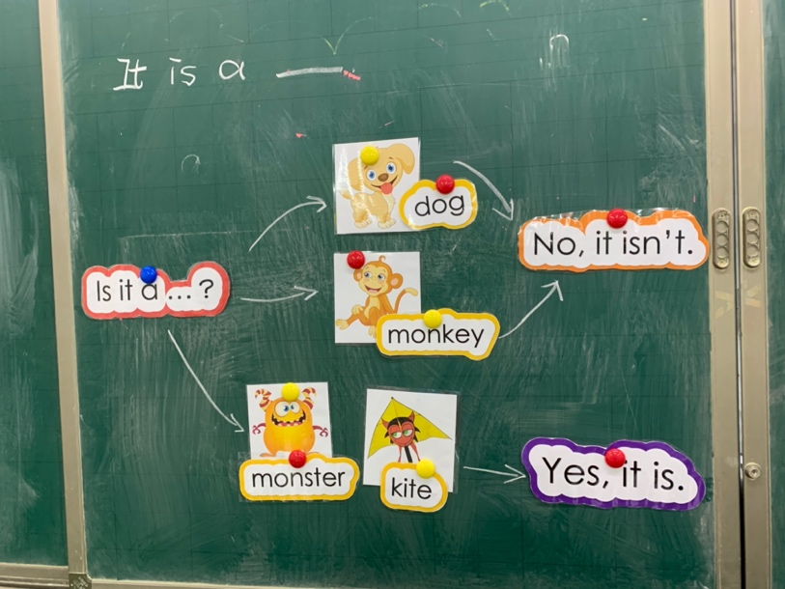

教学反思 Feedback
Most students can use “Is it a …?” to guess the objects they see. But some students can not pronounce the word “isn’t” well. I should drill it more.

