**成都市双流区2023——2024学年度下期期末学生学业质量监测**

**小学五年级 英语试题**

1. Listen, tick or cross. 听录音，根据录音内容判断图片正误，正确的打√，错误的打×。（每小题1分，共10分）

1. 2．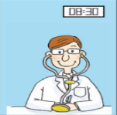 3．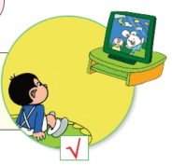 4． 5．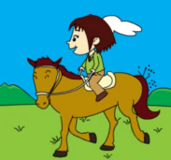

（ ） （ ） （ ） （ ） （ ）

6．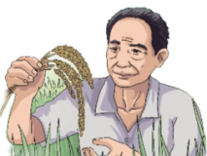 7．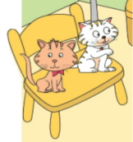8． 9． 10．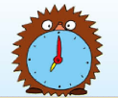

（ ） （ ） （ ） （ ） （ ）

二、Listen and choose. 听录音，根据录音内容选出正确的答案，并把相应的字母填入括号里。（每小题2分，共20分）

（ ）1.  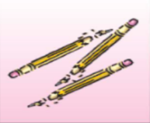 （ ） 2. 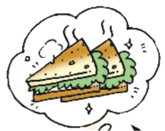 

A B A B

（ ）3. 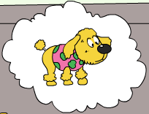  （ ）4.  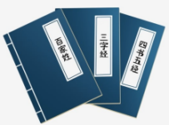

A B A B

（ ）5.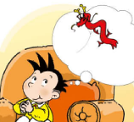  （ ）6. 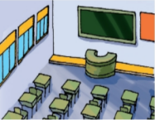 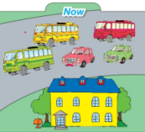

A B A B

（ ）7. 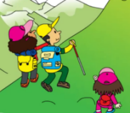  （ ）8. 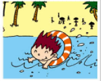 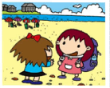

A B A B

（ ）9.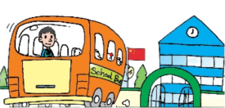. 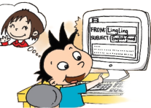（ ）10. 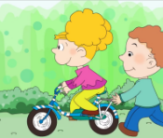 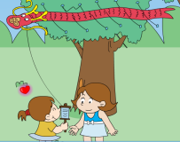

A B A B

三、Listen and number. 听录音，根据录音内容用数字给图片排序。（每小题1分，共5分）

 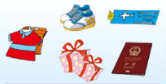  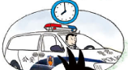 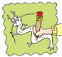

（ ） （ ） （ ） （ ） （ ）

1. Listen and number. 听录音，用数字给句子排序。（每小题1分，共5分）

|  |
| --- |
| ( ) Lingling’s grandma danced in lots of cities many years ago  ( ) Let’s make a birthday card for him.  ( ) Yesterday I watched TV with my grandchildren.  ( ) Don’t worry. I’ll be home on time.  ( ) Yesterday she had an English breakfast. |

五、Listen and write. 听录音，根据录音内容选词填空。（每小题2分，共10分）

library learn information topic film

There are lots of different ways to find about Chinese food. We can get information from the school . All the students have got library cards. We can borrow some books on our . We can read lots of books about the topic. We can find information from as well. This is a good way to find information quickly(快速地). We will do the project in a week. We can a lot from the project.

六、Read and match. 读一读，选一选。（每小题1分，共5分）

（ ）1. Who’s going to the airport with you? A. I lived in Chengdu.

（ ）2. Where did you live five years ago ? B. No, he didn’t.

（ ）3. What did you have for lunch? C. Of course, I will.

（ ）4. Did your grandpa learn English? D. Mum.

（ ）5. will you help me? E. I had fish and chips.

七、Choose the right answers to fill in the blanks.选择正确的答案，并把答案番号填写在题前括号内。（每小题1分，共10分）

( )1. —Who are they?

—_______________

A. They’re my grandparents. B. She’s a doctor.

( )2. — How did you go to school ?

— ________.

1. I went to school by bus. B. I played football.

( )3. —Summer holiday is coming. Where are you going?

— .

A.I’m going to Beijing. B.Let’s go to school.

( )4. Last year Lingling Xinjiang with her parents .

1. visit B. visited

( )5.My uncle is an English teacher. He works in the .

A. school B. fields

( )6.—ThisT-shirt is too big. Have you got a small one, please?

A .Yes, I did. B. Yes, I have.

( )7.—My mum goes to work at eleven o’clock every night.

—That’s very, very .

A. early B. late

( )8.—Where can I find books about science?

—You can find them .

A.at six o’clock B. on Shelf D

( )9. —Hi, Amy! What are these big books?

— .

A.They’re dictionaries. B.It’s a desk.

( )10. —What does your grandpa do?

—_____________.

A . He is a worker. B. She is a dancer.

八、Read and understand.阅读理解。

Read, then tick or cross. 读短文，根据短文内容判断句子正误，正确的打√，错误的打×。（每小题2分，共10分）

**Passage1**

Yesterday was Sunday. Lingling and her friends went to a children’s theatre. They watched funny show. The men wore women’s clothes. The women wore men’s clothes. The actors told lots of jokes. They laughed a lot. After the show they were hungry. They went to a restaurant and ate noodles with tomato and egg. Then they went home by bus. They all had a good day.

( )1.It was Saturday yesterday.

( )2.Lingling went to a children’s theatre with her friends .

( )3.The actors told lots of stories .

( )4.They were hungry.They ate hamburgers and chips.

( )5.They were happy yesterday.

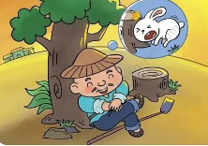

Read and choose. 读一读，选一选。（每小题2分，共20分）

**Passage2**

Many years ago, there was a farmer.One day, he was working in the

field. He saw a rabbit and the rabbit bumped into a big tree. Its head

was broken. The farmer was very happy. He took the rabbit home and cooked

delicious food for dinner.That night, he thought (想),“I don’t need to work hard. I just need to wait for a rabbit near the tree every day.” From that day on. He didn’t work. Every day he sat near the tree. He waited for rabbits to come. But there weren’t any more rabbits coming.

We want to live a happy life. We should work very hard.

( )1.The farmer was in the field when he saw a rabbit.

A.sleeping B.working

( )2.The rabbit bumped into a big tree and its was broken.

A.head B.leg

( )3.The farmer took the rabbit home and cooked delicious food for .

A.breakfast B.dinner

( )4.From that day on, The farmer waited for near the tree every day.

A.rabbits B.tigers

( )5.We want to live a happy life. We work very hard .

A.shouldn’t B.should

**Passage 3**

There is a little girl．Her name is June．She is eleven years old．June always(总是） asks her mother，"Why is my name June？"Her mother says，"Because your birthday is in June．"The little girl is very happy and she likes her name．She thinks her name is very interesting．Every year，on June's birthday，all her friends come to her house and say happy birthday to her．They watch TV，play games and eat the birthday cake together(一起）．And she can get a lot of presents．

( )1．Why is the girl's name June？

A．Because her birthday is in June． B．Because her mother’s birthday is in June．

( )2．What doesn't June do on her birthday？

A．Play games． B．Go to the cinema．

( )3．How old is June？

A．Seven． B．Eleven．

( )4．June thinks her name is

A．interesting B. boring

( )5.Does the girl like her name?

A.Yes, she does. B. No, She doesn’t.

九、Write.仿写句子, 要求至少五句话，字母大小写和标点符号正确，字迹工整。（共5分）

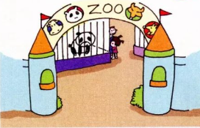 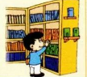

Sunday, library, water, good books, read books

Saturday, zoo, bread and juice, funny animals, take photos

例：

I’m going to the zoo this Saturday. 1. .

I’m going to take bread and juice. 2. .

There are some funny animals at the zoo. 3. .

I want to take lots of photos.. 4. .

I think it will be a happy day. 5. .