**成都市双流区2023—2024学年度下期期末学业质量监测**

**小学四年级 英语试题**

**一、**Listen, tick or cross. 听录音，根据录音内容判断图片正误，正确的打√，错误的打×。（每小题2分，共20分）

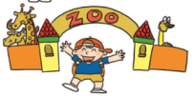121.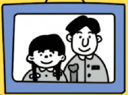 2. 2. 3. 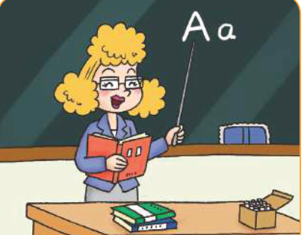 4. 5.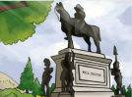

( ) ( ) ( ) ( ) ( )

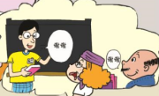6. 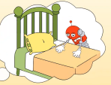 7. 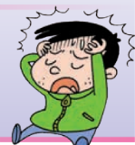 8. 9. 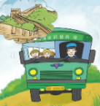 10. 

( ) ( ) ( ) ( ) ( )

**二、**Listen and choose. （每小题2分，共20分）

(一) 听录音，根据录音内容选出相应的图片，并把图片编号填入括号里。

1.( )The classroom was ___. 2.( )It is beautiful now. It _____then.

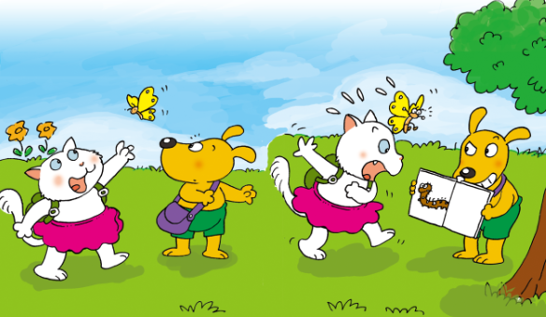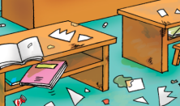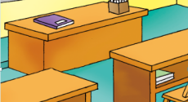

A. B. A. B.

3. ( ) I went to Shanghai by _____ 4. ( )He lived in _______ .

A. B.  A.  B. 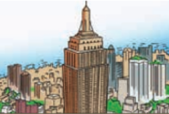

5. ( ) On Monday I’ll _______ . 6. ( ) It’s ____________.

A.  B.  A. 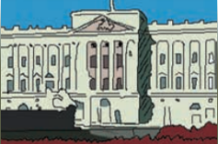 B. 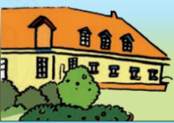

（二）听录音，根据听到的内容和图片提示选择单词或词组，并将其编号填在题前括号里

7. ( ) ______is very famous. 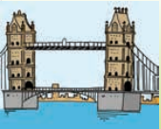 A. Tower Bridge B. Hyde Park

8. ( ) On Saturday we’re going to_____. A.watch TV B.have a picnic

9. ( ) This is my _____. He’s very clever.  A. uncle B. aunt

10. ( ) Sam and I _____yesterday. 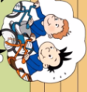A. rowed a boat B. went for a bike ride

1. Listen and number.听录音，根据录音内容用数字给下列图片排序。

（每小题1分，共10分）

（一）

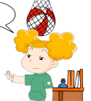 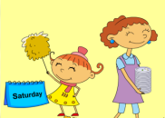  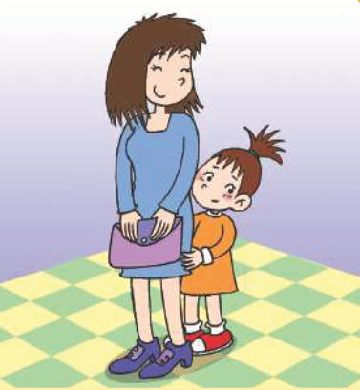 

**( ) ( ) ( ) ( ) ( )**

（二）

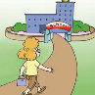  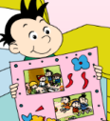 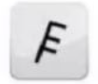 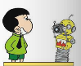

**( ) ( ) ( ) ( ) ( )**

四、Read and choose.看图，选择与图片内容相符的句子 **(**每小题2分，共10分**)**

1. 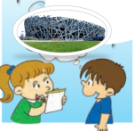2.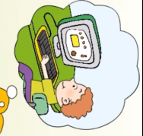 3.  4. 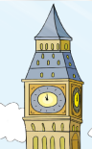 5. 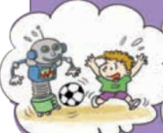

（ ） （ ） （ ） （ ） （ ）

|  |
| --- |
| A. Sam didn’t helped mum.He played on the computer.  B. This is Big Ben. It’s very tall.  C. This is Xiaoyong. He’s very clever.  D. I went to Beijing last year.  E. I’ll play football with robots. |

五、Read and match.读一读，连一连。 **(**每小题1分，共5分**)**

1. Where’s Amy? A.Yes, it was.
2. Did he live in New York? B. She’s in the park.
3. Was it sunny in London yesterday? C. It’s a robot.
4. Did you go to Hangzhou? D. No,he didn’t. He lived in Washington DC.
5. What’s that, Daming? E. Yes.We went to Hangzhou by train.

六、Read and choose. 选择正确的答案。（每小题1分，共5分)

1. ( )We were hungry and thirsty. So we ____some water and cake.

1. Buy B. bought C. eat

2.( )_________you at home yesterday?

1. Was B. Were C.Will

3.( ) —Will you take your kite tomorrow? —_____. But I will take my ball.

A. Yes, I did B. No, I won’t C. Yes, I will

4.( )Amy ____ short then, but she ____ tall now.

A.is; was B. were; was C. was; is

5.( ) — house is it? —It’s the Queen’s house.

A.Whose B. Who C. What

七、阅读：读一读，做一做。（每小题2分，共20分。）

A.读下列短文，判断句子正误。正确的写“T”,错误的写“F”。

Last Saturday, Daming played football with his classmates. Lingling made a cake. Amy finished（完成） her homework and helped her mum. Sam cleaned his room and watched TV. Tom played games with dad. They were very happy.

( ) 1. Lingling cooked noodles last Saturday.

( ) 2. Daming played basketball with his classmates.

( ) 3.Amy did her homework and helped her mum.

( ) 4. Sam cleaned his room and did homework.

( ) 5. Tom played games with dad.

B.阅读短文，选择正确答案。

Hi, I’m David. Summer holiday is coming. I will go to Shanghai with my parents. Shanghai is big and beautiful. First, we will visit my uncle’s family and have a big dinner with them. Then we will take a look at the Bund （外滩）. And we will take some photos there. We will have some delicious food too. How about you? Where will you go this summer holiday?

( ) 1.____ holiday is coming.

1. Summer B. Winter

( ) 2.David’s family will go to_____.

1. Beijing B. Shanghai

( ) 3. David’s family will have a big dinner with his_____ family.

1. aunt’s B. uncle’s

( ) 4. They will take a look at_____ .

1. the Bund B. Shanghai Zoo

( ) 5. Shanghai is very_____ .

1. small and famous B. big and beautiful

八、书写部分：**(**每小题2分，共10分**)** 看图读句, 选词填空。

had a picnic visit my grandma be very hot by train made a poster

1.  Daming 四线三格 图 last weekend.

2.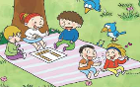 The children 四线三格 图 yesterday.

3.  I went to Shanghai 四线三格 图.



4. On Friday, I’ll 四线三格 图.

5. It will 四线三格 图 tomorrow.