成都市双流区2024—2025学年度下期期末学生学业质量监测
小学六年级 英语样题
（60分钟完卷 卷面满分100分）
听力部分（50分）
一、Listen，tick or cross.听录音，根据录音内容判断图片正误，正确的打√，错误的打×。（每小题2分，共10分）
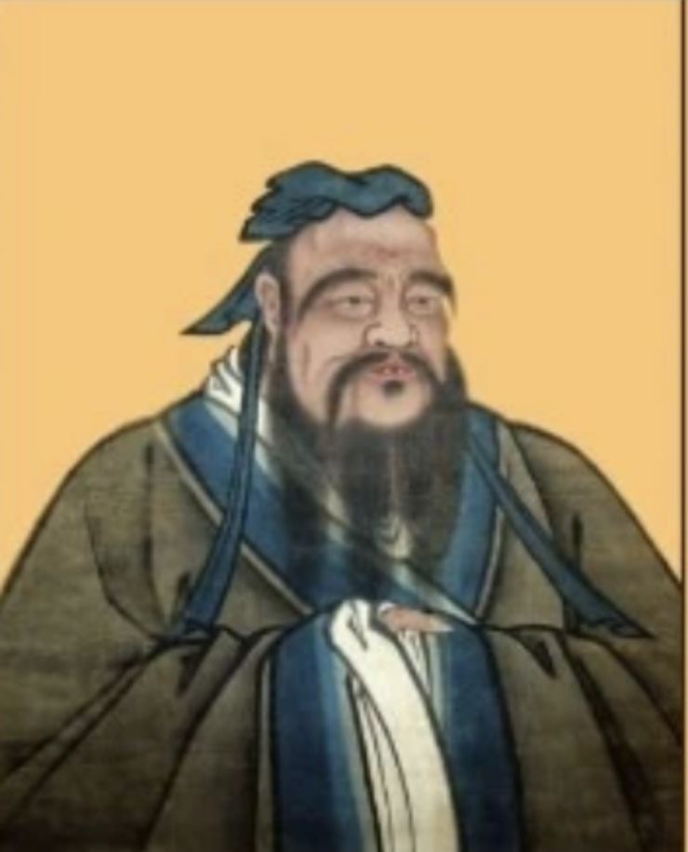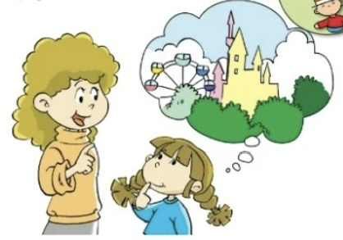

1.（ ） 2.（ ） 3.（ ） 4.（ ） 5.（ ）
二、Listen and choose.听录音，根据录音内容选出正确的答案，并把相应的字母填入括号内。（每小题2分，共10分）
- （ ）A.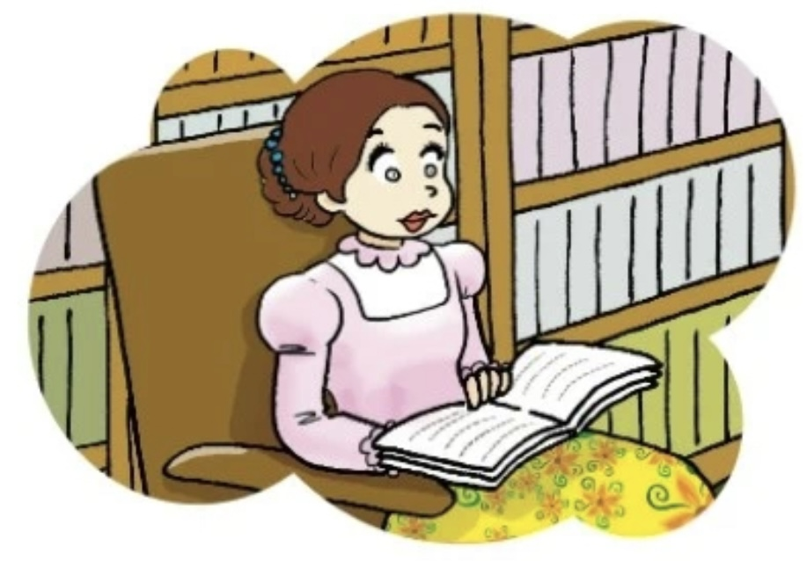 B. 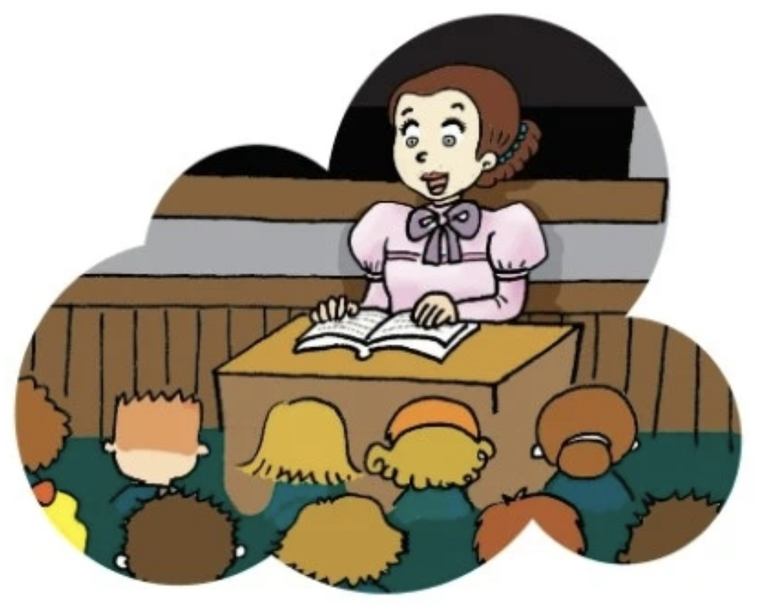 2. （ ）A.  B. 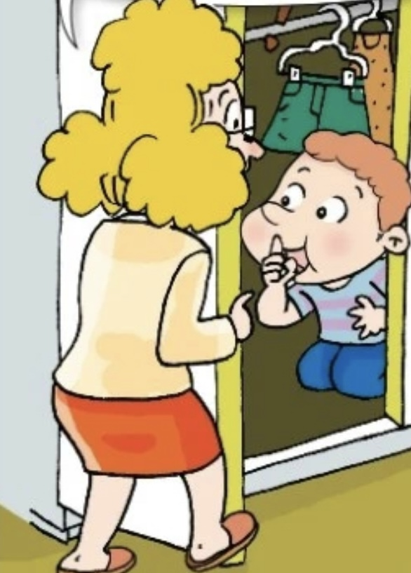

- （ ）A. 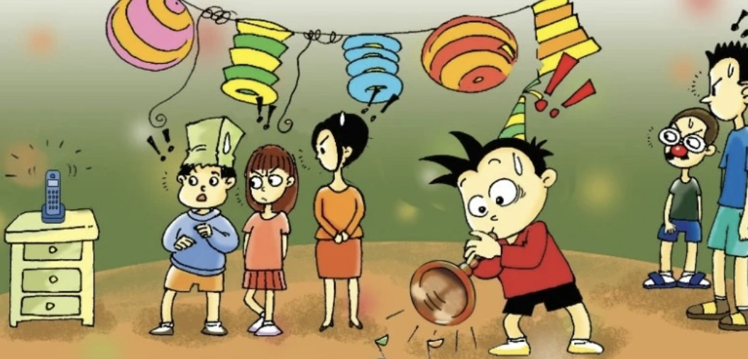 B. 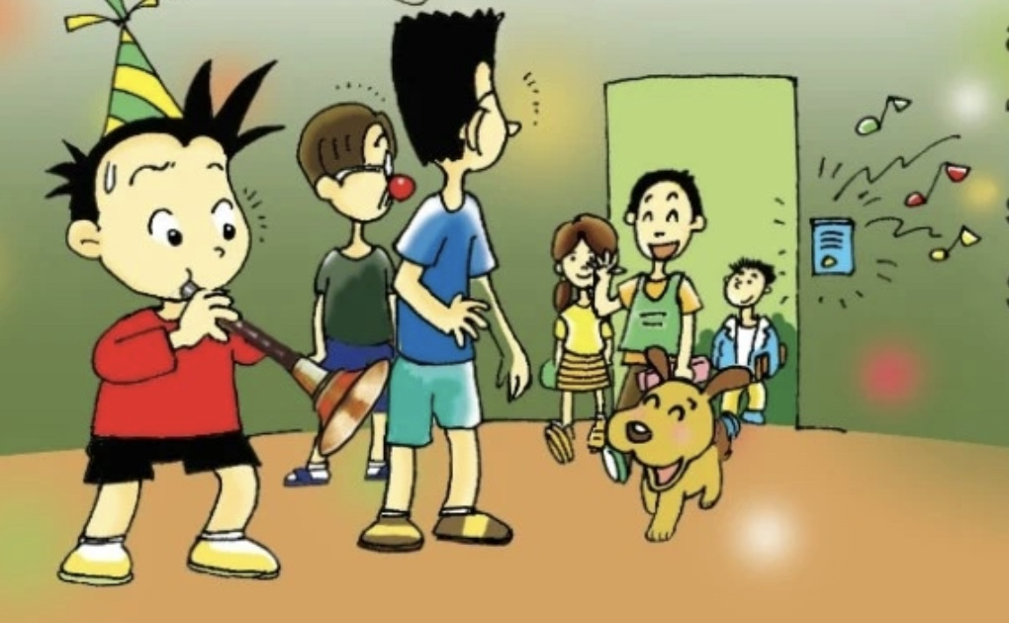 4. （ ）A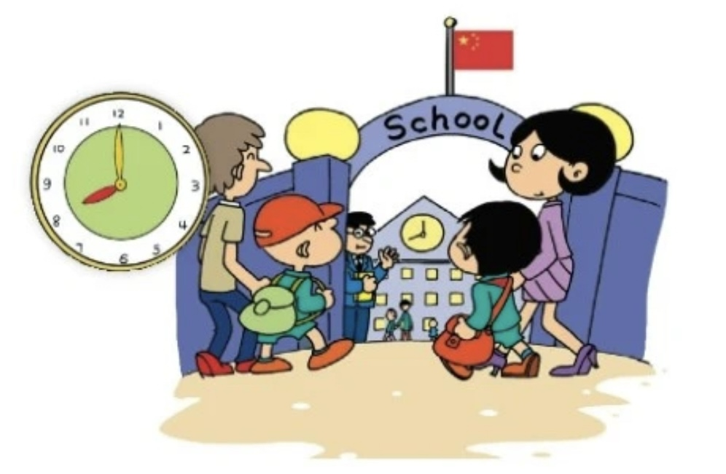 B.

- （ ）A. 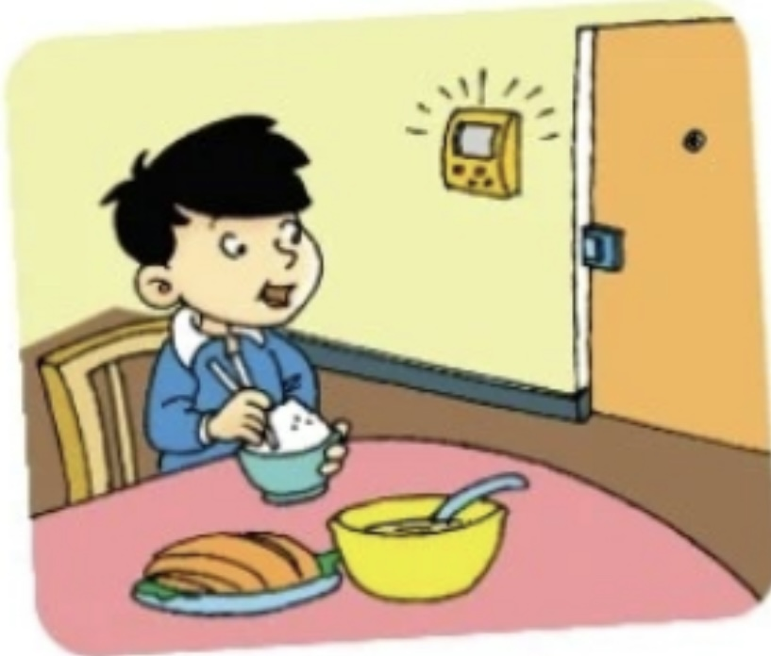 B. 

三、Listen and number. 听录音，根据录音描述的先后顺序用字母A-E给图片排序。（每小题2分，共10分）

C
E
D

A
B

1.
2.
3.
4.
5.

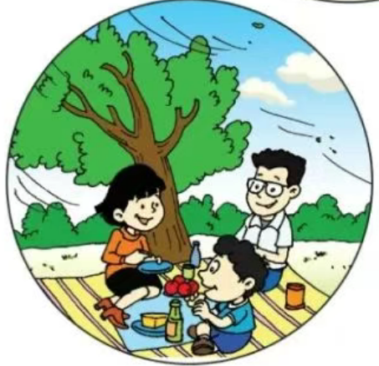

四、Listen and write. 听录音，根据录音内容选词填空。（每空2分，共10分）

different same a lot more spoke practising

At the 1 time, I’m very sad to say goodbye to you. We’re going to 2 schools. My best friends Sam and Amy are going back to the UK. They’re going to a new school there. I am happy for them. Four years ago, they 3 only very little Chinese. Now they can speak 4 . Keep on 5 Chinese in the UK. And come back to China sometime!
- Listen and choose. 听录音，根据录音内容选择你所听到的句子。（每小题1分，共5分）
1.( ) A. It’s half past twelve. B. It’s half past one.
2.( ) A. Helen couldn’t see. B.Helen couldn’t hear.
3.( ) A. Best wishes to you. B. Good luck.
4.( ) A. Why are you so happy？ B.Why are you here?
5.( ) A. I’m going to study Chemistry. B.I’m going to study Geography.
六、Listen and answer. 听录音，根据录音内容选择正确的回答。（每小题1分，共5分）
1. ( ) A. Because I’m happy. B. Because I’m hungry.
2. ( ) A. I want a hamburger. B. Thank you.
3. ( ) A. We are going to the park at eleven. B.We are going to the park by bus.
4. ( ) A . I want a hot dog. B. I want a cola.
5. ( ) A. Thank you. B.No, it won’t.
笔试部分（50分）
七、Choose the right answer. 选择正确的答案，把番号填入括号内。（每小题1分，共10分）
1. ( ) We’re going to ________our primary school and ________ our middle school soon!
A. leaves; starts B. leave; start
2. ( ) —What do you want to eat? — __________.
A. A cola, please. B. Chicken and rice, please.
3. ( ) Keep on __________Chinese in the UK.
A. learning B. learns
4. ( ) I’m writing an email to my friend from __________.
A. earth B. the earth
5. ( ) —I want three hamburgers and a cola. How much is it?
— __________ thirteen dollars.
A. They’re B. It’s
6. ( ) Amy asked Lingling to __________ some caps for the game.
A. brought B. bring
7. ( ) She __________ all over the world last year.
A. travelled B. travels
8. ( ) Yang Liwei was born __________ China __________ 1965.
A. in; in B. at; in
9. ( ) The dog is barking very __________.
A.loudly B. louder
10. ( ) Daming is playing the suona, but the bell __________.
A. is ringing B. rings

八、Reading comprehension.阅读理解。（30分）
Passage1: Read, tick and cross.读短文，判断正误，正确的打√，错误的打×。（每小题2分，共10分）
Fun at the Beach
Hi, everyone. I’m Lisa. Here’s a photo of my friends and me enjoying ourselves at the beach. In this photo, the sun is shining and the wind is blowing. I’m building a big sandcastle (堆沙堡）with my best friend, Lily. Not far away (不远处）, three boys are swimming in the sea. They’re laughing and shouting very loudly. On the left side of the photo, my sister and her friends are talking and eating sandwiches. And look at the girls in pink, they’re listening to music and dancing. Everyone looks so relaxed and happy in this beautiful seaside scene!
11.( ) Lily is Lisa’s best friend.
12.( ) Lily and Lisa are building a big sandcastle.
13.( ) Not far away, three boys are swimming in the sea.
14.( ) Lisa’s sister and her friends are eating apples.
15.( ) The girls in pink are playing five-stones.

Passage 2：Read and choose. 读一读，选一选。（每小题2分，共10分）
Yang Liwei: China’s First Space Hero
Yang Liwei is a famous taikonaut. He was born in 1965 in Liaoning, China. When he was young, he dreamed of flying high in the sky. He worked very hard at school and learned a lot about science. Later, he became a great pilot.
In 2003, Yang Liwei’s big dream came true. He travelled into space in Shenzhou V, becoming the first Chinese person in space! During his 21-hour journey, he saw Earth from above. He also took photos and made a video. When he returned, everyone was very proud of him!
Yang Liwei’s story teaches us that with hard work and dreams, anything is possible! He still helps train new astronauts today, passing on（传承）his knowledge and love for space.

16. ( ) When was Yang Liwei born?
A. In 1965 B. In 2003
17. ( ) What did Yang Liwei do before becoming an taikonaut?
A. He was a teacher. B. He was a pilot.
18. ( ) How long was Yang Liwei’s space journey?
A. 12 hours B. 21 hours
19. ( ) Why is Yang Liwei famous?
A. He was the first Chinese person in space. B. He built the Shenzhou V spaceship.
20. ( ) What does Yang Liwei do now?
A. He trains new astronauts. B. He teaches science at school.

Passage3：Read and choose.选择恰当的语句完善情境对话, 并将对应番号填在横线上。（每小题2分，共10分）
Waitress: Can I help you?
Daming: 21.
Waitress: 22.
Daming: I want a cola, please.
Waitress: That’s one hot dog, a sandwich and a cola.
Daming: 23.
Daming: It’s five dollars and fifty cents.
Daming: 24. ____________________
Waitress: Here’s the change(零钱）. 25. _________

- Anything to drink?
- I want a hot dog and a sandwich, please.
- Enjoy your meal!
D. Here you are.
E. How much is it?

九、Read and write.读一读，写一写。（共10分）
Part1: 据句意选词完成句子（每小题1分，共5分）
26. — __________ (What/ Why) are you laughing? — Because the movie is very funny.
27. In this photo, the wind is blowing and the sun is __________ (shine/shining).
28. — __________ (What/ When) are you going to the park? — At half past twelve.
29. Helen couldn’t see. She is __________ (deaf/blind).
30. It will __________ in Harbin this Saturday. (sun/be sunny).
Part2: Read and write.读一读，写一写, 不少于5句话。（共5分）
小学生活即将结束，请你以My Middle School为题，谈谈你对中学生活的畅想。
作文内容可包含以下要点：毕业在即的心情，对老师、好友的留言与祝福，中学将学到的科目，去学校的交通方式，对中学的憧憬祝愿等。
___________________________________________________________________________
________________________________________________________________________________________________________________________________________________________________________________________________________________________________.

